RAIN OR SHINE:

WE WILL MAKE THIS REGRESSION WORK!

WEATHER TEMPERATURE PREDICTION USING REGRESSION ANALYSIS



Timothy Chatman, Joe Gogins, Eid Shahatit, Aasimah Tanveer, Ayesha Tanveer

Professor: Nandhini Gulasingam

Department of Computer Science, DePaul University

Course: DSC423 - Data Analysis & Regression - Fall 2019

# ABSTRACT

Linear and polynomial regression models were developed in SAS and applied to a weather dataset collected from Szeged, Hungary to predict temperature from relevant predictors. These models were compared and a final model was built to predict temperature. A random sample was taken from the original dataset which was cleansed with null and zero values handled, irrelevant fields dropped, collinearity issue eliminated, interaction variables and dummy variables created from categorical variables. Numeric variables were analyzed to verify that linear regression was the correct technique to use and assumptions were checked throughout analysis to affirm that transformations were not needed. Relationships, correlations, and associations were studied among all the variables. The dataset was split into training and testing set. Model selection methods were used to build multiple models and tests were employed to determine if the models were satisfactory. The performance and accuracy of created models were evaluated using performance indicators and residuals were evaluated for assumption violations. All models performed well, however, residuals indicated a curvilinear relationship between temperature and other variables. Therefore, a cubic polynomial regression model consisting of highest order terms and all lower order terms was built. This model was further tuned using a backward selection process to select significant variables and a final model was created. The model created using cubic polynomial regression outperformed those resulting from linear regression in predicting daily temperate, as indicated through having the lowest error statistics and highest deterministic coefficient, with predicted values within the confidence and prediction intervals.

# TABLE OF CONTENTS:

INTRODUCTION

METHODOLOGY

Data Acquisition

Data Exploration and Pre-Processing

Data Analysis

ANALYSIS, RESULTS, & FINDINGS

General Distribution Analysis

Visualizing Associations, Linearity and Correlations

Full Linear Regression Model

Dataset Split into Training and Testing Set

Model Validation

Final Cubic Polynomial Regression Model

Predictions using the Cubic Polynomial Model

Other Models Created

Model 1

Model 2

Model 3

Model 4

Conclusion

FUTURE WORK

REFERENCES

APPENDIX

Appendix 1: Full Model and Final Selected Model

Appendix 2: Model 1 Output

Appendix 3: Model 2 Output

Appendix 4: Model 3 Output

Appendix 5: General

Appendix 6: Model 4 Output

# INTRODUCTION

Weather is an important area of investigation as it involves all forms of life. We structure our lives around potential weather conditions as if affects our day-to-day as well as whole industries. Weather forecasting is predicting weather conditions of a particular area. The Numerical Weather Prediction (NWP) is an established prediction model that takes present weather conditions to build a model for forecasting weather (Gupta 2016). Regression models are commonly used for predictive analysis, especially concerning weather. Regression analysis estimates the relationship between the dependent and independent variables.

Weather can have a substantial impact on the economy, especially agriculture but other areas as well. The 2005 hurricanes Katrina and Rita caused an extensive shutdown of oil and gas rigs in the Gulf of Mexico resulting in a significant spike in energy prices. Consequently, it is not surprising there has been significant scientific efforts in studying and predicting weather patterns (Jacobson 2009).

In order to perform regression analysis, historical weather data (from 2006 to 2016) from Szeged, Hungary was obtained. Szeged is the third largest city in the European nation of Hungary as shown in appendix 5.1. It is situated near the southern border of the country near Serbia. The climate in Szeged is transitional between an oceanic climate, characterized by cool summers and cool winters, and a continental climate with cold winters, hot summers, and low precipitation. The city also receives an above average amount of sunlight annually.

This research aimed to create the best model to predict the temperature in Szeged beyond 2016 using the historical data from the Szeged 2006 to 2016 dataset, determine which factors influence/have a significant impact on temperature among date & time, weather summary, precipitation type, apparent temperature, humidity, wind speed, wind bearing, visibility, cloud cover, pressure, and daily summary, and finally, use the model to predict the temperature in Szeged with a high confidence. The null hypothesis is that there is no relationship between temperature and other variables in table 1, that is, that β = 0, where β represents the true slope of the relationship between temperature and other variables. The alternative hypothesis is that β ≠ 0 and the temperature is related to one or more variables in table 1.

# METHODOLOGY

The approach consisted of three main phases: data acquisition, data exploration and pre-processing, and data analysis (involving model approach definition, model creation, validation, test and best model selection).

## Data Acquisition

The data was obtained from Kaggle (<https://www.kaggle.com/budincsevity/szeged-weather>) as “WeatherHistory.csv” with hourly/daily summary for Szeged, Hungary between 2006 and 2016. The dataset was obtained as a comma delimited excel file (Appendix 1.1) with 96,453 observations and fields as detailed in Table 1. Temperature was selected as the dependent variable for this study.

**Table 1:** Summary of Dependent and Independent variables

|  |  |  |
| --- | --- | --- |
| Dependent Variable | Description | Data Type |
| Temperature (Celsius) | Temperature in Celsius | Numeric |

|  |  |  |
| --- | --- | --- |
| Independent Variables | Description | Data Type |
| Date and Time | Date & time that data for that row was collected | DateTime |
| Weather Summary | Summary of the weather (clear, cloudy, foggy, etc.) | Text |
| Precipitation Type | Type of precipitation (rain, snow) | Text |
| Apparent Temperature (°C) | Apparent temperature in Celsius | Numeric |
| Humidity (%) | Relative Humidity in a percentage | Numeric |
| Wind Speed (km/h) | Wind Speed in km/h | Numeric |
| Wind Bearing (degrees) | Direction that the wind is headed in degrees | Numeric |
| Visibility (km) | How far you can see in front of you in kilometers | Numeric |
| Cloud Cover (%) | Percentage of sky that was covered by cloud (0-1) | Numeric |
| Pressure (millibars) | Air pressure in millibars | Numeric |
| Daily Summary | Weather Summary (reference to the time of a day) | Text |

## 

## Data Exploration and Pre-Processing

The data was first examined in Microsoft Excel. The fields and data types were noted. Research was performed to obtain the description of fields. Temperature was identified as the dependent variable. Since it had a numeric data type, it was decided that linear regression will be used to analyze the data. A random sample of 3000 observations was created using Python to make the data easier to handle. The data was then cleansed by removing observations that contained null and zero values. Fields that were not part of the analysis were dropped. The potential predictors were examined and daily summary was dropped as it was redundant and did not provide additional useful information for analysis. Dummy variables for the categorical fields, namely summary and precipitation type, were created (Table 2.1 and Table 2.2). Interaction variables were also created for wind speed and wind bearing.

Data was explored using SAS procedures to gain insights into the data, affirm that linear regression was appropriate, and verify assumptions to determine if transformations or other regression techniques are needed. Descriptive statistics (Appendix 1.2) for all the numeric variables were examined to make sure they fell within acceptable range and skewness was carefully looked at. Histogram (Appendix 1.3) was obtained for temperature to have a pictorial view of the distribution and identify skewness and outliers. Boxplots were created (Appendix 1.4.1 and 1.4.2) to study the distribution of temperature by precipitation type and summary and note any anomalies or outliers. Scatter plots and Pearson correlation coefficient matrix were generated to note association trends, strengths, linearity and collinearity between the variables.

**Table 2.1:** Dummy Variables for Summary

|  |  |  |  |  |  |
| --- | --- | --- | --- | --- | --- |
| **Summary** | **DPCld**  **(dpc)** | **DMCld**  **(dmc)** | **DOver**  **(do)** | **DFog**  **(df)** |  |
| Clear | 0 | 0 | 0 | 0 | Base Control Variable |
| Partly Cloudy | 1 | 0 | 0 | 0 | DPCld = 1 for Summary = Partly Cloudy. It is zero otherwise. |
| Mostly Cloudy | 0 | 1 | 0 | 0 | DMCld = 1 for Summary = Mostly Cloudy. It is zero otherwise. |
| Overcast | 0 | 0 | 1 | 0 | DOver = 1 for Summary = Overcast. It is zero otherwise. |
| Foggy | 0 | 0 | 0 | 1 | DFog = 1 for Summary = Foggy. It is zero otherwise. |

**Table 2.2:** Dummy Variable for Precipitation Type

|  |  |  |
| --- | --- | --- |
| **Summary** | **DPrTyp** |  |
| Snow | 0 | Base Control Variable |
| Rain | 1 | DPrTyp = 1 for Precipitation Type = Rain. It is zero otherwise. |

## Data Analysis

Linear regression analysis was used to build a full regression model and study the effect of predictors on temperature. The research began with a null hypothesis which assumed that all beta coefficients are zero and that there is no association between temperature and other variables. An alternate hypothesis was also formulated saying that there is at least one that could predict the outcome of temperature.

In the beginning linear regression was run to generate a full model to predict temperature based on humidity, wind speed, wind bearing, visibility, pressure, precipitation type and summary. The model was checked for significance of parameters, assumptions based on residual analysis (constant variance, independence, linearity and normality), and diagnostics (outliers, influential points, multicollinearity). The goodness of fit was determined based on R2, adj-R2, f-value, p-value, and error term. Analyses of the residuals provided an indication of possible improvements on a linear regression model fitted to the data (Kobrin, 2011). The significance of the predictors was also noted.

The dataset was split into training and test dataset. Five models were built based on training dataset with different selection and regression methods. The models were then checked for significance of parameters, assumptions based on residual analysis (constant variance, independence, linearity and normality), diagnostics (outliers, influential points, multicollinearity), the goodness of fit was determined based on R2, adj-R2, f-value, p-value, and error term. Outliers, influential points and multicollinearity were handled. The models were then rerun and diagnostics and assumptions were checked again. Key performance indicators namely R2, adj-R2, cp, f-value, p-value, error term, residuals, goodness of fit were used to compare the models. Models were validated using 5-fold method. Training models were compared against the training models, testing models were compared against the testing models and training models were compared against the testing models.

The best model was chosen based on significance of predictors, high f-value, high adj-R2, low p-value, low error term and assumptions satisfied based on residual analysis. Once the final model was chosen from the five approaches, the effect of each of the significant predictors as well as interaction terms were determined, assumptions and diagnostics checked, and predictions with sample cases from the original 96,435 observations dataset were generated. The predictions were then evaluated to determine if they fell within the confidence and prediction interval limits.

**Table 3:** Summary of model approaches

|  |  |  |  |  |  |
| --- | --- | --- | --- | --- | --- |
|  | **Final** | **Model 1** | **Model 2** | **Model 3** | **Model 4** |
| Apparent temperature predictor? | No | Yes | Yes | No | Yes/No |
| Selection method | Polynomial | Backwards | Stepwise | CP | Polynomial |
| Interaction terms? | Yes | No | No | No | Yes |
| Transformation? | Yes | No | No | No | Yes |

# ANALYSIS, RESULTS, & FINDINGS

## General Distribution Analysis

While exploring the data, descriptive statistics revealed that the climate in Szeged is transitional with cold winters and hot summers with a broad range of temperatures (-20°C to 38.86°C). 50% of the temperature values in the dataset were above 12°C and 50% were below 12°C. The middle 50% spread of temperature is 14°C as defined by inter quartile range. The average yearly temperature in the city was 12°C, which is not extreme at all (Appendix 1.2).

A histogram of temperature was generated (Appendix 1.3) which showed that the distribution of temperature is unimodal and symmetrical with tails on left and right due to potential outliers. The mean of the distribution (12°C) is the same as the median (when rounded) also indicating a normal distribution that is not skewed. The curve was platykurtic with a flat top and heavy tails.

Boxplots were used to study the distribution of temperature by precipitation type (Appendix 1.4.1) and summary (Appendix 1.4.2). The study showed that Szeged gets more rain than snow. Based on the observation that the box that represents IQR is bigger for rain than snow. Also, it rains when the temperatures are above 0°C and it snows when temperatures are below that. The skies are clear or cloudy when the temperatures are between 5°C to 20°C. When the temperatures go below freezing, it gets foggy. There were no outliers shown on the box plots.

## Visualizing Associations, Linearity and Correlations

Scatter plots (Appendix 1.5) were used to visualize associations between temperature and other variables. The plots showed strong positive linear association between temperature and apparent temperature with upward trend, negative linear association between temperature and humidity with downward trend, weak associations between temperature and other variables like wind speed, wind bearing, visibility and pressure. Additionally, the scatterplots showed strong associations shown due to interaction variable built between wind speed and wind bearing.

Pearson correlation coefficients were also computed (Appendix 1.6) and it was determined that there was a perfect positive correlation between temperature and apparent temperature, moderate negative correlation between temperature and humidity, low to almost no correlation between temperature and wind speed, wind bearing and others. Additionally, there was moderate to strong correlation shown due to interaction variable that was built between wind speed and wind bearing.

## Full Linear Regression Model

### Analysis

Linear regression was run to generate a full model to predict temperature based on humidity, wind speed, wind bearing, visibility, pressure, precipitation type and summary. The model was checked for significance of parameters, assumptions based on residual analysis (constant variance, independence, linearity and normality), and diagnostics (outliers, influential points, multicollinearity). The goodness of fit was determined based on R2, adj-R2, f-value, p-value, and error term.

This model was generated after dropping the apparent temperature, data & time, daily summary and cloud cover. Apparent temperature was dropped because there was a near perfect correlation between temperature and apparent temperature shown by Pearson Correlation Coefficient. The scatter plots showed that the temperature and apparent temperature had a perfect linear association with upward trend. Additionally, both these variables had the same association with other variables. Therefore, apparent temperature was dropped from the model. Including this in the model would have resulted in apparent temperature predicting most of the variation in temperature. Research showed that apparent temperature was calculated based on temperature as shown in the Appendix 6.18. Date & time variable was excluded from this analysis and will be used as predictors in future when time series analysis will be performed. Daily summary was a detailed narrative of the weather summary. Since summary was used as a predictor, daily summary was removed. Cloud cover variable had all values as zeros in the dataset. So, this was dropped.

The attributes that were chosen for analysis were: humidity, wind speed, wind bearing, visibility, pressure, weather summary, and precipitation type. Dummy variables were created for summary and precipitation type as shown in Table 2.1 and 2.2. Since wind speed and wind bearing are related, an interaction variable WindSpeed_WindBearing = WindSpeed*WindBearing was created to study the combined effect of the two variables on temperature.

The full model equation is as follows:

Temperature = 322.35388 - 28.00263 Humidity - 0.34326 WindSpeed - 0.00332 WindBearing + 0.08325 Visibility - 0.29147 Pressure + 10.56129 DPrTyp + 0.46519 DPCld - 0.31621 DMCld - 1.21662 DOver - 0.03982 DFog + 0.00037429 WindSpeed_WindBearing

Where:

PrTyp = 1 (Rain) and 0 (Snow)

DPCld = 1 (Summary = Partly Cloudy) and 0 otherwise

DMCld = 1 (Summary = Mostly Cloudy) and 0 otherwise

DOver = 1 (Summary = Overcast) and 0 otherwise

DFog = 1 (Summary = Foggy) and 0 otherwise

### Findings

Based on the regression analysis, there were significant predictors (Appendix 1.7) that had a significant effect on temperature as shown by the p-values less than the alpha threshold value of 0.05. The model had good R2 of 0.67 where 67% variability in temperature could be explained by its relationship with the significant predictors, a high F-value of 535.33, a small p-value of <0.0001, and low error of 5.573. Therefore, the goodness of fit was okay.

The residual analysis (Appendix 1.8) showed the points scattered randomly around the zero line for all variables except temperature. There were no glaring patterns spotted in the residuals of most variables. Constant variance and independence were satisfied for the most part. The normality assumption was satisfied because the residual plot showed an almost 45-degree line. Based on the scatter plots, there was a linear association between temperature and a couple of other variables.

Residuals and diagnostics showed outliers and influential points (Appendix 1.9) which were removed. Multicollinearity was spotted due to interaction model and it was ignored (Paul Allison, 2012).

The effects of predictors were studied. Humidity, wind speed, wind bearing and pressure caused a drop in temperature. More visibility meant higher temperatures. Rain increased the temperature by 10.56 °C compared to snow. On a cloudy day, the temperature decreased by 0.31°C compared to a clear day. On a foggy day the temperature decreased by 0.03°C.

### Conclusion

The null hypothesis was rejected since humidity, wind speed, wind bearing, visibility, pressure, precipitation type, and summary had beta coefficients ≠ 0 and p-values less than alpha value of 0.05. Alternate hypothesis that said that there is at least one predictor that is significantly associated with the Y-variable i.e. temperature was chosen. There is strong support for the model with high F-value, low P‐value (< 0.0001) and high R2 of 0.67. The analysis also showed that some predictors that were used in the full model were insignificant based on their p-value. The residuals also showed a glaring butterfly pattern for the predicted variable, temperature. Therefore, data was split into training set and testing set, model selection methods were employed in order to determine the best model.

## Dataset Split into Training and Testing Set

An 80-20 train to test split was performed using the surveyselect procedure (Appendix 1.10) resulting in 2301 train cases and 575 test cases. Training set temperature was computed to run model selection on training set only (Appendix 1.11). Models were created based on multiple selection methods namely adjusted-R2, backward, forward, stepwise and cp as shown in Table 3. The models were then checked for significance of parameters, assumptions based on residual analysis, diagnostics (outliers, influential points, multicollinearity), the goodness of fit, R2, adj-R2, f-value, p-value, and error term.

All models performed well, however, residuals indicated a curvilinear relationship between temperature and other variables. Therefore, a cubic polynomial regression model consisting of highest order terms and all lower order terms was built.

**Table 4:** Models generated based on training set

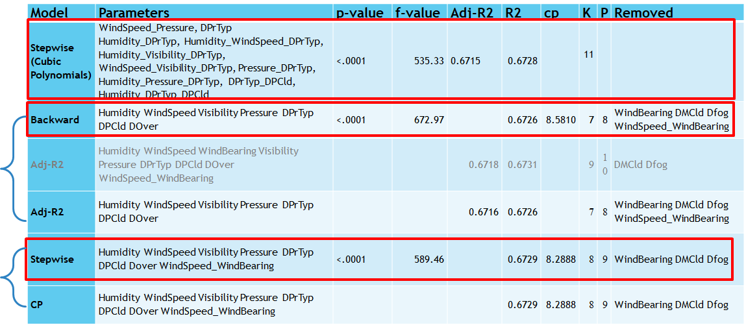

## Model Validation

Key performance indicators namely R2, adj-R2, cp, f-value, p-value, error term, residuals, goodness of fit were used to compare the models. Training models were compared against the training models, testing models were compared against the testing models and training models were compared against the testing models. “Model 3 - Cubic Polynomial Model” outperformed all models with highest R2, Adj-R2, satisfied assumptions, and low error (as shown in Table 5). For the training set, Model 3 was best (Appendix 1.12) because goodness of fit was okay, residuals were OK, R2, Adj-R2 are higher than M1 and M2 and RMSE is lower. Model 3 was best for the testing set as well (Appendix 1.13) because R2, Adj-R2 were higher than Model1 and Model2. Additionally, Model 3 had lowest RMSE and MAE. The training set performed better than testing set based on the based on RMSE, R2 and Adj-R2. A comparison of residuals also showed that Model 3 had the assumptions satisfied better than the other two models (Appendix 1.14).

A fivefold cross validated test was also conducted to compare the models and Model 3 was the best based on higher R2 and Adj-R2, and lower ASE and RMSE (Appendix 1.15).

**Table 5:** Model Comparison based on performance indicators (green colored cells indicate the best values)

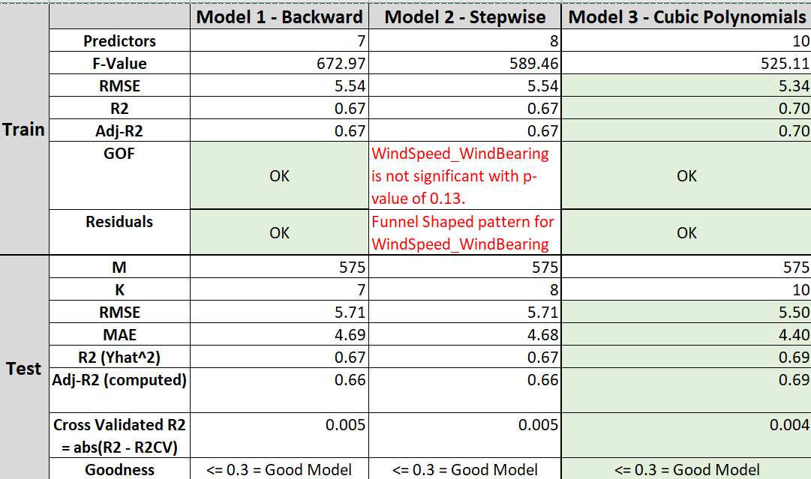

## Final Cubic Polynomial Regression Model

### Analysis

The full model that was generated previously showed that wind bearing and summary for partly cloudy, mostly cloudy and foggy were insignificant. The residual analysis also showed a butterfly pattern for temperature. This indicated a curvilinear relationship. A curvilinear relationship is a type of relationship between two variables that has a pattern of correspondence or association between the two variables that change as the values of the variables change (increase or decrease) (Mike Allen, 2017). It was noted that the relationship of temperature to other variables is not straightforward to understand and detect statistically using linear regression because the relationship with predictors below 0°C and above 0°C is different. Therefore, a cubic polynomial model was built. The predictors were selected based on stepwise method. The model was checked for significance of parameters, satisfaction of assumptions based on residual analysis (constant variance, independence, linearity and normality), and diagnostics (outliers, influential points, multicollinearity). The goodness of fit was determined based on R2, adj-R2, f-value, p-value, and error term.

Model equation for cubic polynomial model:

Temperature = -4.98032 + 0.00015200 WindSpeed_Pressure + 726.79361 DPrTyp + 517.18851 Humidity_DPrTyp - 0.32224 Humidity_WindSpeed_DPrTyp + 0.46109 Humidity_Visibility_DPrTyp - 0.02103 WindSpeed_Visibility_DPrTyp - 0.67695 Pressure_DPrTyp + 0.48059 Humidity_Pressure_DPrTyp + 3.60283 DPrTyp_DPCld - 3.88969Humidity_DPrTyp_DPCld

Where:

PrTyp = 1 (Rain) and 0 (Snow)

DPCld = 1 (Summary = Partly Cloudy) and 0 otherwise

### Findings

Based on the regression analysis, there were significant predictors (Appendix 1.16) that had a significant effect on temperature as shown by the p-values less than the alpha threshold value of 0.05. The model had good R2 of 0.6963 where 69.63% variability in temperature could be explained by its relationship with the significant predictors, a high F-value of 525.11, a small p-value of <0.0001, and low error of 5.34369. Therefore, the goodness of fit was okay.

The residual analysis (Appendix 1.17) showed the points scattered randomly around the zero line for all variables. The glaring pattern that was displayed by the full model in the predicted Y variable was reduced to a great extent when cubic polynomials were used. Constant variance and independence were satisfied for the most part. The normality assumption was satisfied because the residual plot showed an almost 45-degree line. Based on the scatter plots, there was a linear association between temperature and a couple of other variables.

Diagnostics showed no outliers and influential points. Multicollinearity was spotted due to cubic polynomial model and it was ignored (Allison, 2012).

Effect of predictors on temperature were noted. Humidity, wind speed wind bearing and pressure caused a drop in temperature. More visibility meant higher temperatures. Rain increased the temperature compared to snow. Precipitation type and humidity had the highest effect on temperature.

Listed are some other effects of independent variables on temperature:

* Wind Speed * Pressure: For an increase in wind speed by 1 km/hr and an increase in pressure by 1 millibar, the temperature will increase by 0.000152 °C
* Precipitation Type * Partly Cloudy: On a partly cloudy day with rain, the temperature will increase by 3.60283°C compared to a non-partly cloudy snowy day
* Humidity * Visibility * Precipitation Type: A 1% increase in humidity on a rainy day with a 1km increase in visibility will increase the temperature by 0.46109 °C compared to a snowy day.
* Humidity * Pressure * Precipitation Type: A 1% increase in humidity on a rainy day with an increase in pressure by 1 millibar will increase temperature by 0.48059 °C compared to a snowy day.
* Humidity * Wind Speed * Precipitation Type: A 1% increase in humidity on a rainy day with an increase in wind speed by 1 km/hr will decrease temperature by 0.32224 °C compared to a snowy day.
* Wind Speed * Visibility * Precipitation Type: A 1 km/hr increase in wind speed on a rainy day with a 1km increase in visibility will decrease the temperature by 0.02103 °C compared to a snowy day.
* Pressure * Precipitation Type: A 1 millibar increase in pressure on a rainy day will decrease the temperature by 0.67695 °C compared to a snowy day
* Humidity * Precipitation Type * Partly Cloudy: A 1% increase in humidity on a partly cloudy rainy day will decrease the temperature by 3.88969 °C compared to a snowy day.

### Conclusion

The null hypothesis was rejected since a combination of humidity, wind speed, wind bearing, visibility, pressure, precipitation type, and summary had beta coefficients ≠ 0 and p-values less than alpha value of 0.05. Alternate hypothesis that said that there is at least one predictor that is significantly associated with the Y-variable i.e. temperature was chosen. There is strong support for the model with high F-value, low P‐value (< 0.0001) and high R2 of 0.69. This model was chosen as the final model and the temperature was predicted based on this.

## Predictions using the Cubic Polynomial Model

We used the model to predict temperature in Szeged based on independent variables (Appendix 1.18) to answer the following questions:

What would be the temperature in Szeged on a rainy and partly cloudy day when the humidity is 46%, wind speed is 10.40 km/hr, visibility is 11.27 kms, air pressure is 1016.47? The model predicted the temperature to be 22.34°C. The temperature fell between the confidence and prediction intervals.

What would be the temperature in Szeged on a snowy and overcast day when the humidity is 78%, wind speed is 1.85 km/hr, visibility is 11.13 kms, air pressure is 1035.23? The model predicted the temperature to be -4.65°C. Again, the temperature fell between the confidence and prediction intervals.

What would be the temperature in Szeged on a rainy and partly cloudy day when the humidity is 99%, wind speed is 0.8855 km/hr, visibility is 3.46 kms, air pressure is 1009.99? The model predicted the temperature to be 8.23°C. Again, the temperature fell between the confidence and prediction intervals.

We concluded that this is a good model because the predicted values fell between the confidence and prediction intervals.

## Other Models Created

### Model 1

Model 1 was generated after dropping date & time, daily summary, and cloud cover using the predictors weather summary, precipitation type, apparent temperature, humidity, wind speed, wind bearing, visibility, and pressure. The full output is included in Appendix 2.

The full fitted model had the following equation based on the parameter estimates shown in Appendix 2.1:

Temperature(Y) = 23.39506 + -0.09593*dpt + -0.02183*dpc + -0.15321*dmc + -0.16403*do + -0.43548*df + 0.86925*ApparentTemperature + -1.66478*Humidity + 0.07684*WindSpeed + -0.00067793*WindBearing + -0.00956*Visibility + -0.01973*Pressure + e

Where dpt = 1 is rain otherwise snow, dpc = 1 is partly cloudy otherwise clear, dmc = 1 is mostly cloudy otherwise clear, do = 1 is overcast otherwise clear, and df = 1 is foggy otherwise clear.

The full model with all of the predictors had a very high adjusted R2 of 0.9910 which is nearly 1. This means that the predictors of dpt, dpc, dmc, do, df, ApparentTemperature, Humidity, WindSpeed, WindBearing, Visibility, and Pressure explain 99% of the variability in temperature. The RMSE is very low at 0.92067 and there is a high F-value of 28911.8 with a significant p-value where p is <.0001. The VIF values were all less than 10 for the variables. However, not all of the dependent variables had a p-value less than the accepted of 0.05. dpt with a p-value of 0.1740, dpc with a p-value of 0.7175, and visibility with a p-value of 0.0817 all had values that were not significant variables. While the performance metrics showed a good model, insignificant predictors needed to be removed. The residual plots for the non-dummy variables (as dummy variable residual plots cannot be analyzed) all had generally random patterns which satisfied constant variance and independence assumptions for real data except that of apparent temperature and the predicted value plots. These both had butterfly shaped patterns.

The data was successfully split into a train and test set using an 80:20 split (Appendix 2.2). The train set became 2302 observations labeled train_test_weather. A full model was run on the train set resulting in the following equation (Appendix 2.3):

Temperature (Y) = 23.23417+ -0.11488*dpt + -0.00250*dpc + -0.14305*dmc + -0.15182*do + -0.45869*df + 0.86851*ApparentTemperature + -1.74530*Humidity + 0.07246*WindSpeed + -0.00067289*WindBearing + -0.00909*Visibility + -0.01945*Pressure + e

Where dpt = 1 is rain otherwise snow, dpc = 1 is partly cloudy otherwise clear, dmc = 1 is mostly cloudy otherwise clear, do = 1 is overcast otherwise clear, and df = 1 is foggy otherwise clear.

Here, the adjusted R2 was identical to the full, pre-split value of 0.9910 which is almost perfect at 1. The RMSE is very low at 0.92958, the F-value is high at 23077.7, and is significant with a p-value less than 0.0001. All the VIF values were less than 10 indicating there were no outward multicollinearity issues. Again, however, not all of the predictors are significant in the model with the p-value for dpt being 0.1503, dpc’s p-value being 0.9708, visibility having a p-value of 0.1436, and do sitting on the borderline of significance at 0.0552. As was the case with the previous regression that was run, all residual plots satisfied constant variance and independence assumptions instead of apparent temperature and predicted value plots which had a butterfly pattern. The normality assumption was also satisfied.

In order to choose the predictors for the final model, both backward (Appendix 2.4) and stepwise (Appendix 2.5) selection procedures were run on the training set. The backwards selection procedure removed the dpc, dpt, and visibility variables and allowed the dmc, do, df, ApparentTemperature, Humidity, WindSpeed, WindBearing, and Pressure variables to remain. All the remaining predictors had significant p-values of less than 0.05. The final adjusted R2 remained the same at 0.9910. The stepwise model chose Apparent Temperature, WindSpeed, Humidity, Pressure, WindBearing, df, dpc and dpt, however dpt had an insignificant p-value of 0.1222. The final model predictors were chosen from the backward selection model since all of the predictors were significant. This arrangement of predictors was run and the following equation generated (Appendix 2.6):

Temperature (Y) = 22.22507 + -0.13679*dmc + -0.12575*do + -0.35253*df + 0.86602*ApparentTemperature + -1.77256*Humidity + 0.07166*WindSpeed + -0.00067704*WindBearing + -0.01861*Pressure

Where dmc = 1 is mostly cloudy otherwise clear, do = 1 is overcast otherwise clear, and df = 1 is foggy otherwise clear.

At this stage, the adjusted R2 remained the same at 0.9910. The RMSE was low at 0.92990, the F-value was high 31709.6 with a significant p-value of less than .0001. All of the p-values for the variables were under the alpha threshold of p = 0.05 meaning all the predictors in this model were significant. Because of the high R2, high F-value, low error in RMSE and overall model and predictor significance, these predictors were chosen for the final model. Residual with constant variance, independence, and normality assumptions were rechecked and remained the same as the previous regression procedures in this model. To further enhance the model, points which were both outliers and influential points were dropped, as indicated by the residuals and Cook’s D visualizations respectively (Appendix 2.7). After this drop, the final, fitted model equation was (Appendix 2.8):

Temperature (Y) = 22.30024 +-0.13580*dmc + -0.12408*do + -0.33012*df + 0.86526*ApparentTemperature + -1.81129*Humidity + 0.07107*WindSpeed + -0.00064778*WindBearing + -0.01865*Pressure + e

Where dmc = 1 is mostly cloudy otherwise clear, do = 1 is overcast otherwise clear, and df = 1 is foggy otherwise clear.

The adjusted R2 remained strong at 0.9910 after the influential point and outlier drop. The RMSE was still low at 0.92657, the F-value was high and significant at 31788.9. When looking at the residuals (Appendix 2.9) to confirm the model still satisfies the needed assumptions, all the plots except for predicted value and apparent temperature were without patterns and satisfied the constant variance and independence assumptions. The apparent temperature and predicted value plots showed a butterfly pattern that was addressed in models 4 and 5 with a cubic polynomial function. The normal probability plot showed a generally straight line satisfying the normality assumption. Again, in the final model, only predicted value and apparent temperature had butterfly patterns and the other plots satisfied the constant variance, independence, and normality assumptions.

Looking at the effect that each variable has on temperature, apparent temperature had the largest effect on temperature with a standardized estimate of 0.96290. When the effects of the significant predictors are examined in the final model, all else being equal, if apparent temperature increases by 1°C, the temperature will increase by 0.86526 °C. For an additional increase in humidity by 1%, temperature decreases by 1.81129 °C. If wind speed increases by 1 km/h, the temperature decreases by 0.07107 °C. If wind bearing increases by 1 degree, temperature decreases by 0.00064778°C. If pressure increases by 1 millibar, temperature decreases by 0.01865°C. Compared to a clear day, all else being equal: on a mostly cloudy day the temperature will decrease by 0.13580°C, on an overcast day the temperature will decrease by 0.12408°C, and on a foggy day, the temperature will decrease by 0.33012°C

A fivefold cross validated test was also conducted to give metrics as to how accurately the predictive model was performing. “In cross validation, one historical observation is dropped from the fitting process and is predicted using the regression fit based on the remaining observations” (Neumann, 2003).The RMSE was 0.2321, AIC was 1801.45365, ASE (train) and ASE(test) were both 0.84872 which all indicate low error (Appendix 2.10).

Lastly, predictions based on the model were generated by pulling three test cases from the original 96,435 observation file that were not used in the model (Appendix 2.11). The first test case asked to predict the temperature in °C if the weather summary was mostly cloudy, the apparent temperature was 11.183 °C, humidity was 0.8%, the wind speed was 10.616 km/hr, wind bearing was 163 degrees and the pressure was 1008.71 millibars. A predicted temperature of 12.2497 °C was generated which was within the confidence mean limits of 12.1785°C and 12.3210°C. The second test case asked to predict the temperature in °C if the weather summary was overcast the apparent temperature was 5.77 °C, humidity was 0.93%, the wind speed was 23.2162 km/hr, wind bearing was 340 degrees and the pressure was 1004.85 millibars For this case, a predicted temperature of 8.2478 was generated which was within the confidence mean limits of 8.1254°C and 8.3702°C. The third test case also predicted temperature if the weather summary was foggy, the apparent temperature was 10.911 °C, humidity was 0.86%, the wind speed was 22.3951 km/hr, wind bearing was 311 degrees and the pressure was 1004.61 millibars. A predicted temperature of 12.5858 °C was generated which was within the confidence mean limits of 12.1785°C and 12.3210°C. This last case generated a prediction of 12.5858 °C which was within the confidence interval of 12.4204°C and 12.7513°C.

This model had a final adjusted R2 of 0.9910 which is interpreted as 99.10% of variability in temperature is explained by the predictors mostly cloudy, overcast, foggy, apparent temperature, humidity, wind speed, wind bearing, and pressure. The model passed the goodness of fit test with a low error, satisfied most assumptions, high F-value, and significant p-value that allowed the null hypothesis, which says that there are no predictors that have an effect on temperature, to be rejected. From the performance metrics this seemed to be a good model, however, it was noted during analysis that apparent temperature may have an unproportionally large impact on temperature which may indicate a multicollinearity issue. Upon further investigation, it was found that temperature is needed to calculate apparent temperature which is why much of the variability in temperature could be explained by apparent temperature. Thus, including apparent temperature in the final model was not accurate method for creating a model to predict temperature. Additionally, the butterfly pattern in apparent temperature and predicted value needed to be handled with a cubic polynomial method to satisfy all of our needed assumptions for a good model. For these reasons, this model was not chosen as the best model.

### Model 2

We then ran the full regression model and found that the R-Square came out to be 0.9908 and the Adj. R-Square was the same but there were over 50 different outliers and significant points. We removed one, observation 319, and there were much fewer outliers and observations. We thought to remove one more outlier with observation 134 which removed most of the outliers and significant points where we felt comfortable with moving forward. The full regression model had the following equation:

Temperature (Y) = 2.80564 + 0.87592 ApparentTemperature - 1.37159 Humidity + 0.08427 Windspeed - 0.00067357 WindBearing - 0.00557 Visibility - 0.02743 DPT + 0.02051 DPC - 0.08852 DMC - 0.06687 DO - 0.38045 DF

Where DPT = 1 is rain otherwise snow, DPC= 1 is partly cloudy otherwise clear, DMC = 1 is mostly cloudy otherwise clear, DO = 1 is overcast otherwise clear, and DF = 1 is foggy otherwise clear.

Next, we split the data into training and test sets (80/20) which used 2,344 observations. A full model was run on the train set resulting in the following equation:

Temperature (Y) = 2.79667 + 0.87688 ApparentTemperature - 1.34142 Humidity + 0.08297 Windspeed - 0.00072439 WindBearing - 0.00611 Visibility - 0.02914 DPT + 0.01749 DPC - 0.08746 DMC - 0.02909 DO - 0.38233 DF

Where DPT = 1 is rain otherwise snow, DPC= 1 is partly cloudy otherwise clear, DMC = 1 is mostly cloudy otherwise clear, DO = 1 is overcast otherwise clear, and DF = 1 is foggy otherwise clear.

The adjusted R2 remained strong at 0.9905, the RMSE was still low at 0.94165, the F-value was high and significant at 24384.2. When looking at the residuals to confirm the model still satisfies the needed assumptions, all the plots except for predicted value and apparent temperature were without patterns and satisfied the constant variance and independence assumptions. The apparent temperature and predicted value plots showed a butterfly pattern as well but the normal probability plot showed a generally straight line satisfying the normality assumption. The model passed the goodness of fit test with a low error, satisfied most assumptions, high F-value, and significant p-value that allowed the null hypothesis, which says that there are no predictors that have an effect on temperature, to be rejected.

To choose the predictors for the final model, both Stepwise and Backward selection procedures were run on the training set. The Stepwise selection procedure removed the DMC, DO, DPT, and Visibility variables and allowed the ApparentTemperature, Humidity, WindSpeed, WindBearing, DF, and DPC variables to remain. All the remaining predictors had significant p-values of less than 0.05. The final adjusted R2 remained the same at 0.9905. This arrangement of predictors was run and the following equation generated:

Temperature (Y) = 2.61218 + 0.87438 ApparentTemperature -1.32923 Humidity + 0.08448WindSpeed -0.00056296 WindBearing+ 0.09798DPC - 0.32969 DF

Where DPT = 1 is rain otherwise snow, DPC= 1 is partly cloudy otherwise clear, DMC = 1 is mostly cloudy otherwise clear, DO = 1 is overcast otherwise clear, and DF = 1 is foggy otherwise clear.

The Backwards selection model chose ApparentTemperature, Humidity, WindSpeed, WindBearing, DF, and DPC and removed the DMC, DO, DPT, and Visibility variables similar to Stepwise selection. The final model predictors were chosen from the Backwards selection model since all of the predictors were significant. This arrangement of predictors was run and the following equation generated (same as Stepwise):

Temperature (Y) = 2.61218 + 0.87438 ApparentTemperature -1.32923 Humidity + 0.08448WindSpeed -0.00056296 WindBearing+ 0.09798DPC - 0.32969 DF

Where DPT = 1 is rain otherwise snow, DPC= 1 is partly cloudy otherwise clear, DMC = 1 is mostly cloudy otherwise clear, DO = 1 is overcast otherwise clear, and DF = 1 is foggy otherwise clear.

Looking at the effect that each variable has on Temperature, Apparent Temperature had the largest effect on Temperature with a standardized estimate of 0.97474. When the effects of the significant predictors are examined in the final model, all else being equal, if Apparent Temperature increases by 1°C, the temperature will increase by 0.87547 °C. For an additional increase in humidity by 1%, temperature decreases by 1.43624 °C. If wind speed increases by 1 km/h, the temperature increases by 0.08414 °C. If wind bearing decreases by 1 degree, temperature decreases by 0.00064785°C. Compared to a clear day, all else being equal: on a mostly cloudy day the temperature will decrease by 0.00357°C, on a partly cloudy day, the temperature will increase by 0.09708°C, and on a rainy day, the temperature will increase by 0.01490°C. Both models have the same results so I chose the Selection model.

### Model 3

The first task was to clean the data by dropping FormattedDate, Daily Summary, Apparent Temperature, Cloudcover. This is because those variables are not significant. This is because when looking at Pearson coefficients table as well as scatter plots and residual plots, the conclusion is that there is no effect on temperature. The other variables had a higher correlation value that who can see in Appendix 4.3. There is no point in having them in the final model. Many outliers were also dropped from the data because it made the histogram look more normal. When analyzing the histogram, it is normal, possibly slightly skewed left but not very much. Also, outliers were dropped as well as non-significant variables because there is not a big difference when removing them. It is important to mention that pressure was removed because the air pressure would not be significant. Formatted date was also removed because there is no reason to have that. Same reasons for removing the daily summary because it is just replicated all the data from the time period. Cloud cover also was extremely insignificant. Values for those variables were the lowest out of all the variables. However, Apparent temperature however was extremely significant. However, it should be removed because it was so close to the temperature that it would have been too accurate and I would be unable to find what other variables affect the temperature. If the outliers and variables were kept the model would not been accurately trying to predict the temperature. Cleaning the data also helped the look of the scatter plots which shows different things. There are almost 3000 observations, because of that the data has many observations at different points. You can see that variables have associations between each other except the dummy variables. This is because dummy variables have 0 or 1. For the boxplot, (Appendix4.2) it was chosen to compare the dummy precip and temp to show that if it rains the temp is higher but when there is no precipitation the temp is usually lower. This also correlated with humidity. When temperature was compared with humidity it is clear that the lower the humidity the higher the temp, otherwise, there is no relationship. When running correlations there are only strong relations with temperature and dprec_type and humidity (which is negative). Based on the validation test, the most affecting variables on temp are precipitation and humidity. This means those variables impact temperature more than other variables. With all the variables and observations left after cleaning the data concluded that there was no collinearity with the variables.

After running a histogram and boxplot a scatterplot (Appendix 4.1) was ran on all variables even the dummy variables. This is to show any correlation between the variables and the temperature. It is essential to see if there were any positive strong linear relationships. “Positive relationships have points that are inclined upwards to the right. As *x* values increase, *y* values increase. As *x* values decrease, *y* values decrease” (Zou, 2003). After running correlation, it is clear that not many variables had strong correlations with temperature. This test is to see if anything would be over .7 or under -.7, (Appendix 4.3) noting was in the range even after more outlier observations got dropped. I know that the correlation for apparent temperature would have been extremely close to one but the data would be falsely accurate without showing other predictors. If it was kept the r values would have been higher but that’s not necessarily good because it would have shown that apparent temperature is close to the temperature which does not show anything. In the boxplots the separated different types of precipitation and came to the conclusion that when it snowed temp was down and when it rained the temperature was greater than 0 Celsius every time. After analyzing values, a full reg vif model was performed. The model showed that there is some linearity, but it is not perfect. You can see it in the appendix. In total 20 outliers were removed. All the significant points had been kept because many observations were significant and removing all of them would be unproductive. If every single outlier and influential point was removed, the chart would show an even straighter line that have a higher adjusted R^2. The RSME would also drop depending on how many observations were to remove. Next a survey select was performed to see when to split the data into training and test 80 20 how the dataset would react. After multiple selection methods were ran; in total four were ran to compare and see which one would best predict temperature (adjrsq, backward, stepwise, and cp) the best method to use in the final model was cp. (Appendix 4.6 and 4.7) Based off what was seen about the variables that most influenced temperature humidity, precipitation and type of precipitation (snow or rain) , wind speed wind bearing. The humidity was strong with -.6584 Dprec .56 visibility at .41 DPC .29 and DF at -.33. After running a full model, it is clear that the data needs more work (Appendix 4.4) the data is linear, but on the left side, it is different. Validating the model was next; by performing a 5 fold. (Appendix 4.8) The only variables that mattered were humidity, windspeed, visibility, and precipitation type. If the model was redone, visibility should be removed because how far you can see does not affect the temperature that much. However, to predict temperature it is concluded based on the parameter estimates would be (temp)Y= 21.84 + Humidity*(-27.7) + WindSpeed (-.19) + Visibility (.14) + dpREC_Type (12.47). (Appendix 4.7)

Overall, this model is not the best model compared to the final. This model has a lower R2 than the final model. It also does not have the best predicting variables used as opposed to the final model. This model would benefit from going more in depth on why individual variables affect predicting temperature. If it were done again, it should have more values of all variables and trying to drop other variables and keep others. The model can have a higher R2 and lower RMSE if more work was done.

### Model 4

Model 4 was different from the other model because extra steps were taken the data preprocessing and data exploration phase.

As stated in Methodology certain observations had nulls in certain columns or had values that did not make sense. Because every observation is valuable, every observation was kept for this model in the data preprocessing stage. In the Pressure column there were 43 observations that had 0. Because there cannot be zero air pressure on Earth, these were filled in with the median of all the non-zero Pressure observations which was 1016 millibars. The same was done with the one Humidity observation that was 0. It’s median of all non-zero values was 0.78%. According to a Medium article called ‘6 Different Ways to Compensate for Missing Values in a Dataset’, filling in these values with the mean or median is easy and fast but a con being that it doesn’t account for the uncertainty in the imputations. Even with these cons, keeping all the rows was important so the decision was still made. There were ten observations with a PrecipType value that was null. Instead of dropping the entire observation, a place holder text value called ‘None’ was put for its PrecipType (Appendix 6.1). Originally there were more unique values than 5 for the Summary category. Instead of dropping all observations that did not contain, the top 5 most frequent every row was kept. This resulted in there being 14 unique values for Summary when the dataset was loaded into SAS (Appendix 6.2). Perhaps the most significant change in the data preprocessing phase was the addition of the month and year column and therefore dropping the FormattedDate column before data exploration. Without running any model, one can know that month will be significant in determining temperature so it was added. By extracting the month and year from the FormattedDate column, the month and year columns were added to the dataset and according to their histograms they were about evenly distributed (Appendix 6.3, 6.4). All these changes were done using Pandas in Python.

After doing these changes to the data, descriptives (Appendix 6.5, 6.1, 6.2, 6.6) and various graphs (histograms, Pearson corr, box plots) were run to test for assumptions and for general data exploration. Cloud Cover still had zeros across the board so it was dropped. Daily Summary had long text variables so it was dropped. The distribution of the dependent variable Temperature was still normal so there was no need for transformation. The independent variables ApparentTemperature, WindBearing, Pressure and as stated above Month and Year were normally distributed as well so no transformations were needed. Multiple transformations were done to Visibility to try to satisfy the Normality assumption but they made them worse, so Visibility was left alone (Appendix 6.9). However, there were problems with Humidity, WindSpeed (Appendix 6.7, 4.8) so some transformation needed to be done to satisfy the normality assumption. The histogram of Humidity showed it had a left tail and therefore the square root of the arcsine of Humidity was done (Appendix 6.10). The histogram of WindSpeed showed a strong right tail and therefore the square root of WindSpeed transformation was performed (Appendix 6.11). These particular transformations were found from a Statistic Solutions article called “Transforming Data for Normality”.

Based a boxplot of Temperature by Summary it seems that the IQR for each boxplot besides ‘Dry’, ‘Dry and’, ‘Foggy’ and ‘Humid an’ seems to be between 0 and 20 degrees Celsius and about 80% of the values of temperature fall at various intervals between 0 and 20 degrees Celsius (Appendix 6.12). This means ‘Dry’, ‘Dry and’, ‘Foggy’, and ‘Humid an’ might help predict temperature outside of that range. Dummy variables were made for all the unique Summary values. Looking at the boxplot of Temperature by PrecipType, the min value of Temperature when it was raining is 0 and the max is 40 while the min value of Temperature when it snows is -20 and the max is 0 (Appendix 6.13). Dummy variables were made for Rain and Snow with None being the control variable Looking at the Temperature by Month, Temperature is at its max between June and July and its lowest between December and February. From February to June at the beginning of the next month’s IQR box starts at the median of the previous Boxplot which means a gradual rise in average Temperature. A similar pattern is seen from August to December but with a gradual decline in Temperature (Appendix 6.14). Dummy variables were made for all twelve months and then four more dummy variables were made for the seasons with 12, 1, 2 being Winter, 3, 4, 5 being Spring, 6, 7, 8 being Summer and 9, 10, 11 being Fall. An interaction term was made between WindBearing and WindSpeed because the direction and speed of the wind have a relationship. Based off of graphs, there did not seem to be outliers to investigate in the data exploration stage (the current dataset at this point can be seen at Appendix 6.15).

After making the dummy variables, a Pearson correlation table and sgscatter plot was made to test the linearity and multicollinearity assumptions. The predictors whose absolute value of the correlation coefficient above 0.5 is ApparentTemperature, Arcsin of Humidity, Rain, Snow, Winter, Summer and with Visibility being close with 0.40417. This means there is a good to strong linear correlation between these variables and Temperature. At 0.99274 there seemed to be a near perfect correlation between Temperature and ApparentTemperature (Appendix 6.16). This immediately raised red flags. While looking at the shapes of the scatter plots, Temperature and ApparentTemperature’s graph had the exact same shape in relation to the other variables (Appendix 6.17). This means there is an issue of Multicollinearity because all the predictors could predictor Apparent Temperature, just as well as it could predict Temperature. This means even without running a model with ApparentTemperature as a predictor one can tell that it’s standardized beta coefficient will be high but that the other beta coefficients of everything else cannot be trusted.

The near perfect correlation made sense after learning that the Apparent Temperature is calculated using the Temperature, Humidity, Wind Speed in meters/second at an elevation of 10 meters, and the Net radiation absorbed per unit area of body surface (Appendix ATemp Formula). It can be implied that if someone has the Apparent Temperature, then they at least have to have the Humidity, Wind Speed in meters/second at an elevation of 10 meters, and the Net radiation absorbed per unit area of body surface. So by subtracting the Temperature from the Apparent Temperature, one can obtain the information that would be added or subtracted to the Temperature to obtain the Apparent Temperature and since it is implied that the person collecting the data already has all that information, an extra column was added to the dataset taking the absolute value of the Apparent Temperature minus the Temperature to obtain that information. This column was called Difference of Temp and ATemp. After looking at the histogram of this column, even if you ignored the zeros, which make up close to 60% of the entries in this column, the histogram has a heavy right tail (Appendix 6.18). A sqrt root transformation was applied to this column for normality’s sake and it was called SqrtDiff (Appendix 6.19). There were some interesting things to see from the scatter plot of Temperature by SqrtDiff (Appendix 6.20). From Temperatures, 10 to about 26 degrees, it seems to be no difference between the ApparentTemperature and the Temperature and from 26 degrees and above, there were only two times that the sqrt difference was zero. Then from -20 to 10 degrees, besides from around 1 to 3 degrees, the squared difference is above 0.5. The graph has a weird tree shape with the trunk being between 1 to 3 degrees. The shape of this graph is weird but based on the interval of 10 degrees to 26 degrees have a zero difference, this will be a good predictor. Not sure if this has something to do with weather in Hungary or if it shows a bias in the data. (The current dataset at this point can be seen at Appendix 6.21).

A full model was run with Sqrt Difference, ArcSineHumidity, Sqrt WindSpeed, Wind Bearing, SqrtWindSpeed*Wind Bearing interaction term, Visibility, Pressure, Year, all Summary dummy variables, Rain, Snow, all Season, and all months which totals to 39 predictors. The model immediately took out the variables that could have been control variables. For example, it took out Fall because it could have been the control variable if Summer, Winter, and Spring are all 0. It did the same with May because if it’s Spring and it’s not March or April, then it can be implied that it is May. Same with August, November, and December so this ended with there being 34 predictors for this model. This is something that should’ve been taken into account before the model was ran, but luckily SAS fixed it. Looking at the diagnostics of this first model, you can see that the adjusted R squared is 0.8737 and the R squared is 0.8752. With these statistics you can determine the overall performance of the model. This model can explain about 87% of the variability of Temperature. The reason that the R squared is bigger than the adjusted R squared is because R squared is increased with each additional x variable whether it's significant or not, but the Adjusted R squared will only increase only if the x variable that is added is significant. The x variables that are significant (a < 0.05) are Sqrt Difference, arcsinHumidity, Visibility, Pressure, Dry, Rain, Snow, Spring, Winter, Summer, January, February, March, April, June, September, and October, which is 17 out of the 34. This means that knowing that it is a clear day or July, or Mostly Cloudy is not significant to knowing the Temperature in this model. Looking at the goodness of fit, the F value is 611.38 with a P-value less than 0.0001 which means we can reject the null Hypothesis and conclude that there is at least one x variable that has a significant effect on Temperature. The RMSE is 3.44582 and this is something we look to minimize because if it is 30 degrees Celsius it’s 86 degrees Fahrenheit and increase to 33.45 degrees Celsius makes it 91 degrees Fahrenheit. If one tells someone it’s 86 degrees F verse 92 degrees F, the preparation like clothes worn and activities for the day wouldn’t differ as much than if someone is told it will be 85 degrees Fahrenheit vs 95 degrees Fahrenheit. So, with that said an RMSE above 5 is unacceptable. An RMSE around 3.5 is acceptable but it should be reduced as much as possible. Checking the assumptions for Multicollinearity, if you look at the dummy variables VIF Rain, Snow, PartCloud, OverCast, MostCloud, Foggy, Clear, and the interaction term Wind Speed by Wind Bearing, these are the only variables with a VIF above 10 but we can safely ignore these cases of multicollinearity. Looking at the NPP of the normal cumulative distribution vs CDF of Studentized Residuals you can see that the normality assumption is satisfied. Looking at the NPP for the predictors there are tails at the beginning of the plot that drag off to the bottom. This is possibly due to an outlier. The assumption of Constant Variance and Independence is satisfied when you look at the residual vs x variable plots. However, looking at the residual for the predicted value, one can tell that there is a strange behavior happening when the temperature is below zero, but besides that the assumptions are satisfied. After looking at the Cook’s D and student residuals for each observation, it looks like entry 191(-5.739 SR and 0.013 Cook’s D) which has a Temperature of -20 degrees Celsius is an outlier that may disrupt the model’s ability to predict. Even though as stated above, this model has a harder time predicting the Temperature when the degrees are less than zero. No outliers were taken out at this point. (Appendix 6.22).

Three different Selection Methods were done to determine what predictors should be used in the final model: StepWise, Rsquared, and Cp. All the previous predictors were used for all of these models, even the ones that SAS said were redundant which in retrospect should've been dropped. Looking at the StepWise model, the RMSE is 3.44257, the F Value is 991.38, the RSquared is 0.8749, the Adjusted RSquared is 0.8740. The Predictors it chose were, SqrtDiff, arcsinHumidity, WindBearing, Visibility, Pressure, Breezy_and_Overcast, Clear, Dry, Dry_and, PartlyCloudy, Rain, Snow, Summer, Fall, January, February, April, May, June, September, October. All of these were significant (a < 0.05) except for Rain, PartlyCloudy, Dry_an, and Breezy_and_Overcast which were no higher 0.07. The only VIF’s higher than 10 were Rain and Snow but they are being ignored. The residuals look exactly the same as the full model’s (Appendix 6. 23). Looking at the R-Squared selection method, the RMSE is 3.44582, the F Value is 611.38, the RSquared is 0.8752, the Adjusted RSquared is 0.8737. The Predictors it chose were everything and so it is identical to the full model. Which makes sense because like stated before more predictors increase the R squared so looking back a different selection method like Adjusted R squared Selection should've been chosen. Looking at the Cp selection methods the RMSE is 3.44109, the F Value is 947.29, the R-Square is 0.8750, the Adjusted R-Squared is 0.8741. The Predictors it chose were sqrtDiff, arcsinHumidity, sqrtWindSpeed, WindSpeed*WindBearing, Visibility, Pressure, Breezy_and_OverCast, Clear, Dry, Dry_and, PartCloud, Rain, Snow, Summer, Fall, January, February, April, May, June, October, and November. They were all significant besides Breezy_and_OverCast, Dry_and, PartlyCloudy which were max 0.07 (Appendix 6.24). The residuals and npp plot for this model looked the same as the full model. In all of these selection methods, observation 191 seemed to be an outlier and so it was taken out of the dataset because its temperature value is the min as well as everything else mentioned. If we were to pick a model based off these selection methods, Cp would be the best but there was a problem. Looking at the residual plots of predicted it seemed to satisfy constant variance and independence except for values under zero. This was a problem and after further investigating these plots and researching the behaviors of water, it makes sense that this happens because water freezes at 0 degrees Celsius and below so the graphs appeared to have a x asymptote at 0 degrees. At first, two variables were made to indicate if the temperature was above 0 or under 0 but that did not make sense because how would someone know what the temperature is when we are predicting it. A stepwise selection model was still run anyway with these new columns but the diagnostic and assumptions were not different than the full model without those extra columns so they were dropped.

Because of this weird behavior, a cubic polynomial regression model was made to see if it could improve the model. All of the predictors from the full model were added to the cubic model except the interaction term of Wind Speed and Wind Bearing because it would be redundant to add it since it will be calculated in this model anyway. The Month variable was also added. This stepwise selection cubic polynomial model gave back 45 various first, second, and third order terms (Appendix 6.25). We used glmselect for this polynomial model and one of its advantages is that it allows one to generate the first, second, or higher order terms and run the selection procedure at the same time however two of its disadvantages are that it can’t include options such as VIF, r, and influence and it can create these higher order terms but does not write them to SAS dataset permanently. So, because of this, after the model gave the significant predictors, that was copied and added on as a new section of the dataset. Then a regular regression model was done with these terms to find out the extra information needed to determine if it is a good model. Looking at this model you can see that the RMSE 2.88391, the F value is 685.18, the R Squared is 0.9126, the Adjusted R Squared is 0.9113. There were 45 predictors and all 45 of them are significant. These diagnostics are all improvements compared to the other models talked about in the previous few paragraphs. The residuals look better as well which mean the constant variance and independence assumptions are confirmed. Looking at the VIF values, all the ones with values higher than 10 have some kind of dummy variable in their makeup. The only issue is Normality but polynomial regression is very sensitive to outliers so if you look at the npp of the predicted it will look like there are tails that trail of the straight line (Appendix 6.26).

The dataset was split 80|20 into Train and Test and made a new column with the Temperature of the row called train_y for the train data to try to predict. we ran a regression with the training data. The RMSE was 2.87546, the F value was 516.21, the R Squared was 0.9133, the Adjusted R Squared was 0.9116. The Residuals looked the same as the final model (Appendix 6.27). Then a regression was done the test set to see the predicted values for the test set. Then the RMSE, MAE, R2, R2_cv were calculated for the test set. The RMSE was 2.94054, the MAE was 2.33042, the R2 was 0.90853. The CV_ R2 was 0.00477 (Appendix 6.28). This information will be used to compare this model to other models in this report.

In closing for this model, if you look at the final equation for this model, if given more time, a prediction for this model would have been done with a prediction interval. For example, let's say that it was raining in July 2012 and the sky was Partly Cloudy. The relative humidity was 0.75% and wind speed was 12 km/h with a wind direction 140degrees. The visibility is 6 km and the Air pressure is 1000 millibars and the absolute value of the extra information to determine Apparent Temperature is 2.3. Before anything is inputted into the equation, the sqrt of the difference, sqrt of arcsin of Humidity, and sqrt of Wind Speed must be found. The sqrt of the arcsin of Humidity is 0.92. The sqrt of difference is 1.52. The sqrt of Wind Speed is 3.464. Now we can plug this into the equation then the Temperature would be 27.45 degrees. Then to find the confidence intervals you would add and subtract the RMSE. So, we can say with 95% confidence that this Temperature is between 24.57 and 30.33 degrees Celsius. We would have used SAS to do this calculation but because the code was locked in it could not have been done.

## Conclusion

Analysis revealed that most predictors had beta coefficients that were not zero and p-values less than alpha value of 0.05. Therefore, the null hypothesis (that said that all beta coefficients are zero) was rejected and the alternate hypothesis (that said that there is at least one significant predictor of temperature) was accepted.

The five models that were built were good because they included significant parameters, passed the goodness of fit test, and had assumptions of constant variance, independence, linearity and normality satisfied. A side by side comparison is shown in Table 4.

The models that used the apparent temperature had the highest R2, F-value and lowest error due to the strong correlation between temperature and apparent temperature (apparent temperature was calculated from temperature and other variables). Excluding apparent temperature and using cubic polynomial regression yielded a better model to predict temperature.

**Table 4:** Summary of Performance and Validation statistics

|  |  |  |  |  |  |  |
| --- | --- | --- | --- | --- | --- | --- |
|  | | **Final Model** | **Model 1** | **Model 2** | **Model 3** | **Model 4** |
| **Train** | | | | | | |
|  | RMSE | 5.34 | 0.92657 | 0.92657 | 5.9566 | 2.87546 |
| R2 | 0.70 | 0.9911 | 0.9911 | 0.6353 | 0.9133 |
| Adj- R2 | 0.70 | 0.9910 | 0.9910 | 0.6246 | 0.9116 |
| GOF | OK | OK | OK | OK | OK |
| Residuals | OK | OK | OK | OK | OK |
| **Test** | | | | | | |
|  | RMSE | 5.50 | NA | NA | 5.94471 | 2.94054 |
| MAE | 4.40 | NA | NA | 35.112 | 2.33042 |
| R2 | 0.69 | NA | NA | 0.6193 | 0.90853 |
| Adj- R2 | 0.69 | NA | NA | 0.618 | NA |
| Cv- R2 | 0.004 | NA | NA | 0.00762 | 0.00477 |
| **5-Folds Split** | | | | | | |
|  | Selection Method | Stepwise | Backward | Backward | NA | NA |
| Select Criterion | Stepwise | Backward | Backward | NA | NA |
| AIC | 9591.19 | 1801.453 | 1801.45 | NA | NA |
| ASE (Train) | 28.57930 | 0.84872 | 0.84872 | NA | NA |
| ASE (Test) | 29.89267 | 0.84872 | 0.84042 | NA | NA |

# FUTURE WORK

Many improvements can be made to the selected regression model to increase the integrity of the model. Instead of dropping the time and date variable, a time series analysis could be implemented to better understand how conditions are impacted by month, year, and even seasons and observed to see how these predictions compared to the actuals. Seasons itself can be another predictor in the model which can be defined based on the month.

In the study, outliers and influential points were removed based on getting flagged in diagnostics. Additional research could be performed to verify that the data for those observations is not in error (Schutte, 1994).

Additional background research into other predictors that impact temperature such as pollution, global warming indexes, and yearly sunlight can also be added to consider in the model. Realtime and more current data beyond 2016 can also be used after being captured from darksky.net which is where the publisher of our dataset pulled data from. This model can be compared and contrasted with the Numerical Weather Prediction (NWP) method to see which is more accurate.

We can also apply this model to Chicago weather as it is more relevant to us. With additional computation resources, the regression can be run on the full 96,435 observation dataset. This would allow us to see how generalizable our model is and observe if the model is overfit in any way. A greater number of observations also reduces error and creates a more robust model, which, in turn, would enhance our performance statistics.



# REFERENCES

Ed Statistics Solutions 2016: Transforming data for normality

Gupta, Sanyam, Indumathy K, and Govind Singha, 2016. *Weather Prediction Using Normal Equation Method and Linear regression Techniques,* International Journal of Computer Science and Information Technologies, Vol. 7.

Jeremy M. Schutte and Daniel M. Violette, XENERGY Inc. 1994. *The Treatment of Outliers and*

*Influential Observations in Regression-Based Impact Evaluation*.

Jennifer L. Kobrin, Sandip Sinharay, Shelby J. Haberman, and Michael Chajewski. 2011. *An*

*Investigation of the Fit of Linear Regression Models to Data from an SAT Validity Study*. Research Report 2011-3

Li, H., Deng, X., Kim, D. and Smith, E. (2014). Modeling maximum daily temperature using a

varying coefficient regression model. *Water Resources Research*, 50(4), pp.3073-3087. https://www.apps.stat.vt.edu/deng/wrcr20846.pdf

Mike Allen, The SAGE Encyclopedia of Communication Research Methods. 2017: Curvilinear Relationship

Neumann, D., Rajagopalan, B. and Zagona, E. (2003). Regression Model for Daily Maximum

Stream Temperature. *Journal of Environmental Engineering*, 129(7), pp.667-674. https://pdfs.semanticscholar.org/8e07/e08e55311ca8e4046dfec12fb778cc10c212.pdf

Paul Allison, 2012: When you can safely ignore multicollinearity

Piñeiro, G., Perelman, S., Guerschman, J. and Paruelo, J. (2008). How to evaluate models:

Observed vs. predicted or predicted vs. observed. *Ecological Modelling*, 216(3-4), pp.316-322. https://www.researchgate.net/publication/230692926_How_to_Evaluate_Models_Observed_vs_Predicted_or_Predicted_vs_Observed.

Richard Williams, University of Notre Dame. 2015: Multicollinearity

Teresa Jacobson, Josh James & Neil C. Schwertman, Journal of Statistics Education. 2017: An

Example of Using Linear Regression of Seasonal Weather Patterns to Enhance Undergraduate Learning

Zou, K., Tuncali, K. and Silverman, S. (2003). Correlation and Simple Linear Regression.

*Radiology*, 227(3), pp.617-628. https://courses.lumenlearning.com/suny-natural-resources-biometrics/chapter/chapter-7-correlation-and-simple-linear-regression/

# APPENDIX

# APPENDIX 1: Full Model and Final Selected Model

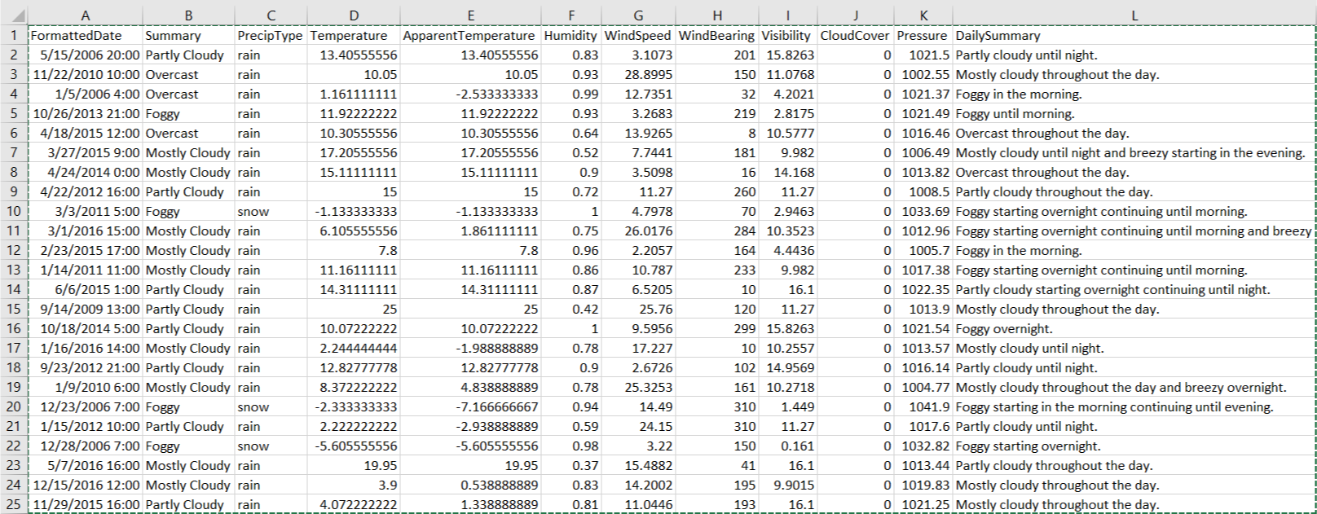

Appendix 1.1: Dataset Sample

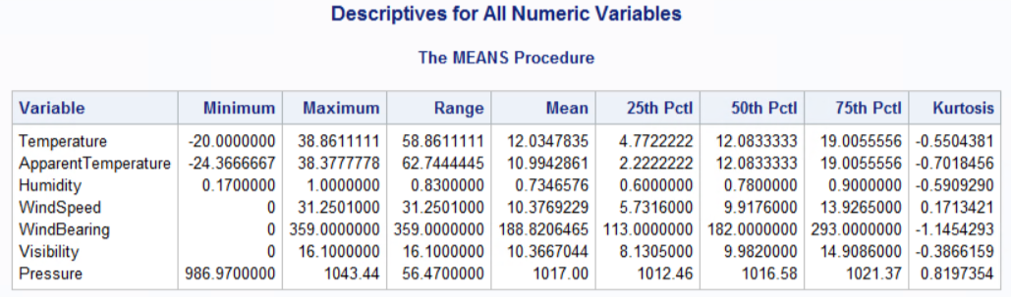

Appendix 1.2: Exploring the Numeric Variables with Means Procedure

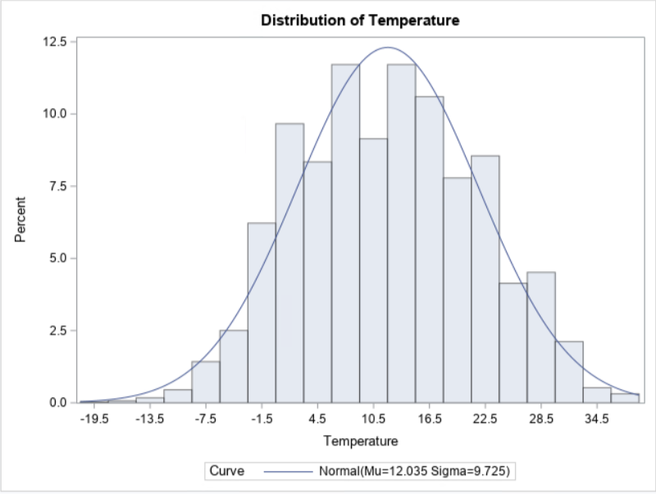

Appendix 1.3: Histogram showing the distribution of temperature

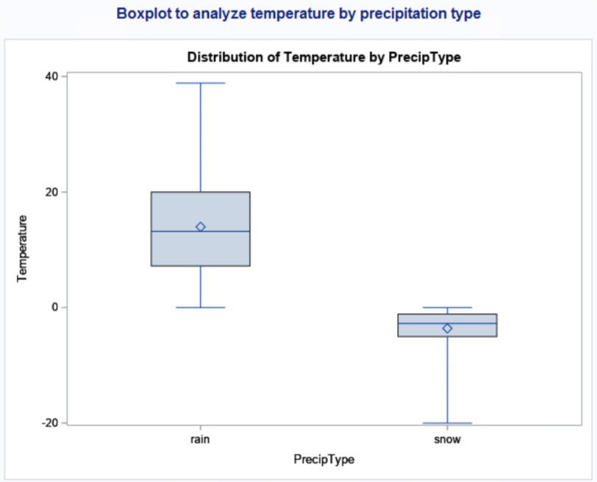

Appendix 1.4.1: Box plot showing the distribution of temperature by Precipitation Type

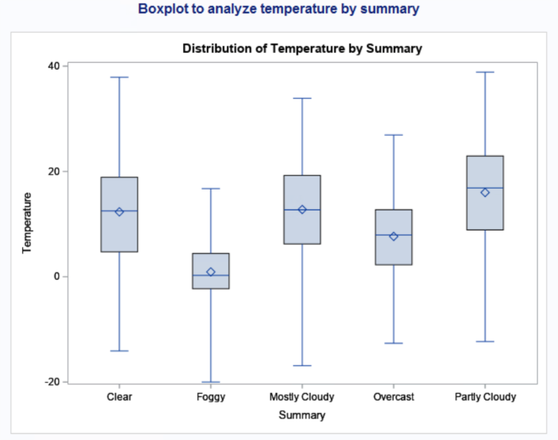

Appendix 1.4.2: Box plot showing the distribution of temperature by Summary

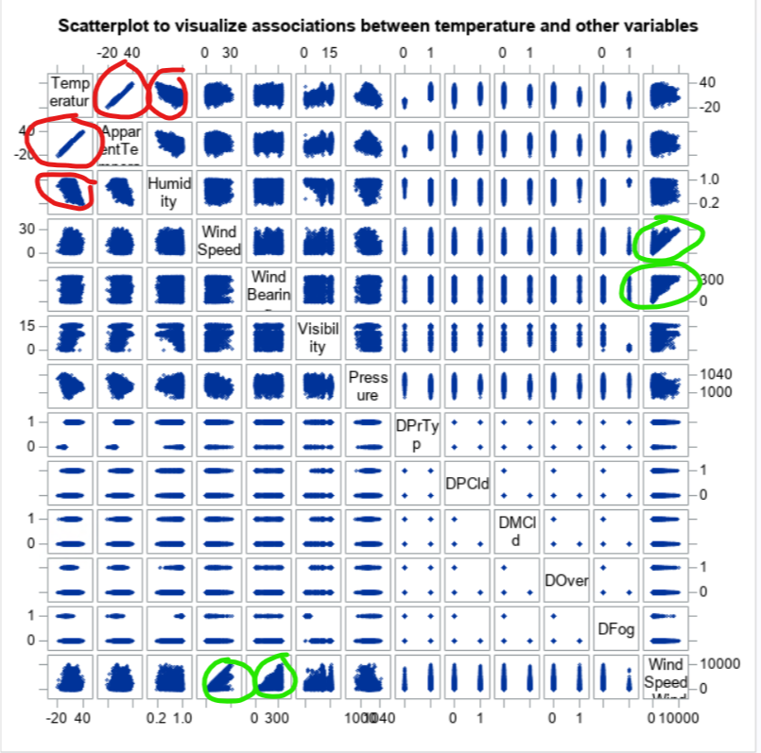

Appendix 1.5: Scatter plot to visualize associations, strength, trend, linearity

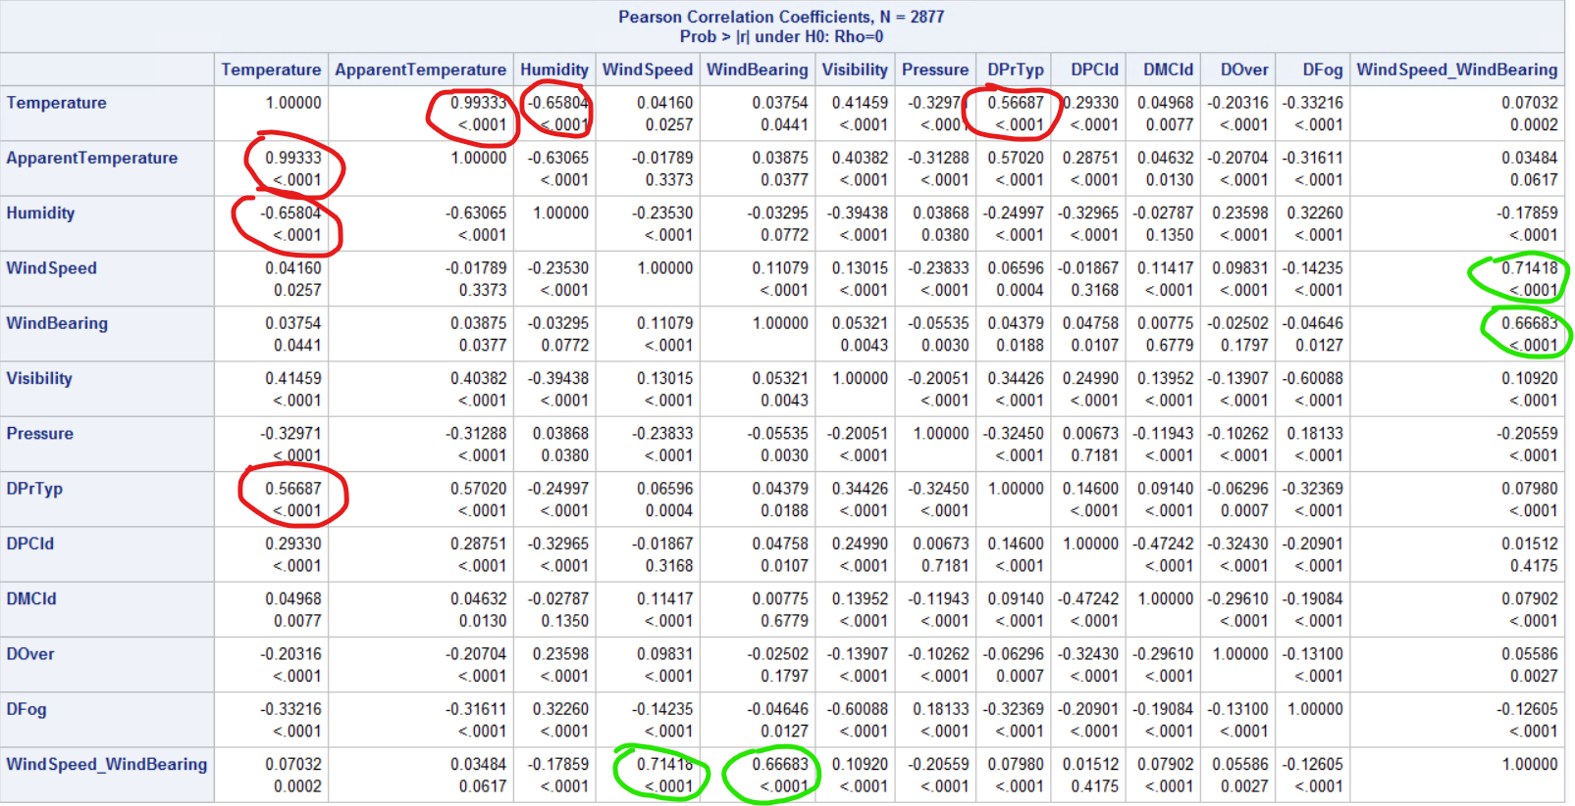

Appendix 1.6: Pearson Correlation Coefficients to show correlation between variables.

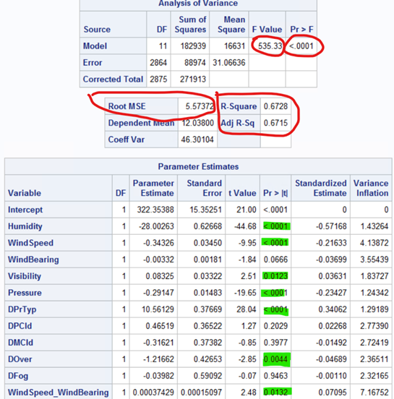

Appendix 1.7: Full Regression Model Output Showing F-value, p-value, RMSE, R2, Adj- R2, and significant predictors.

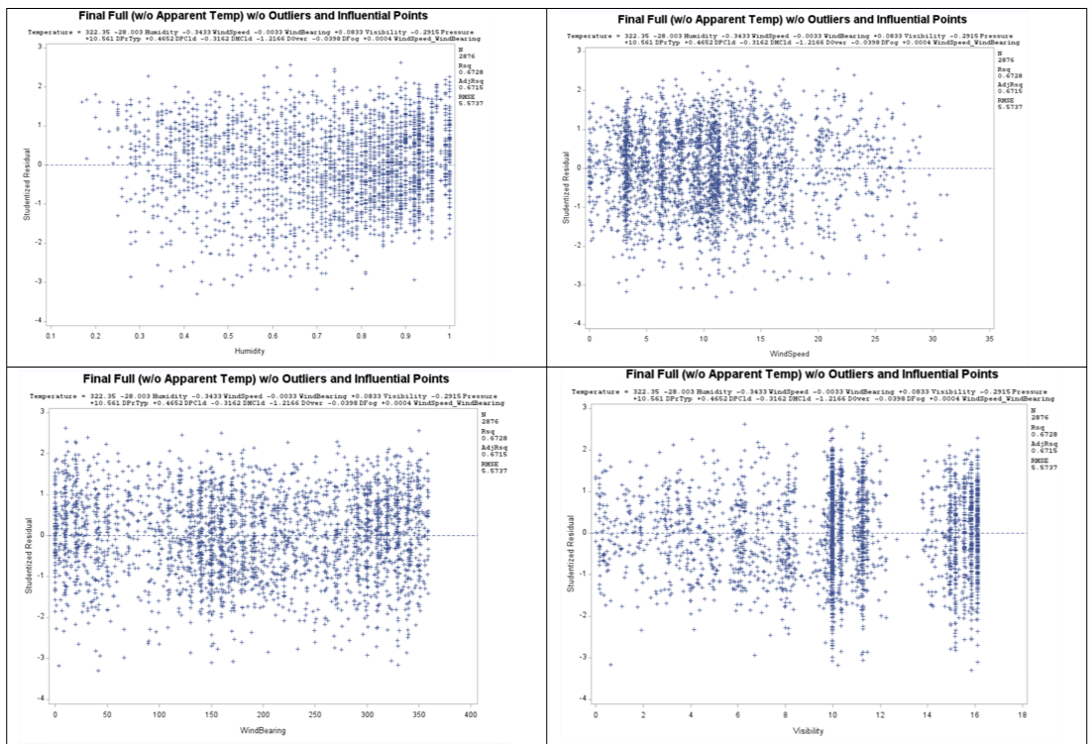

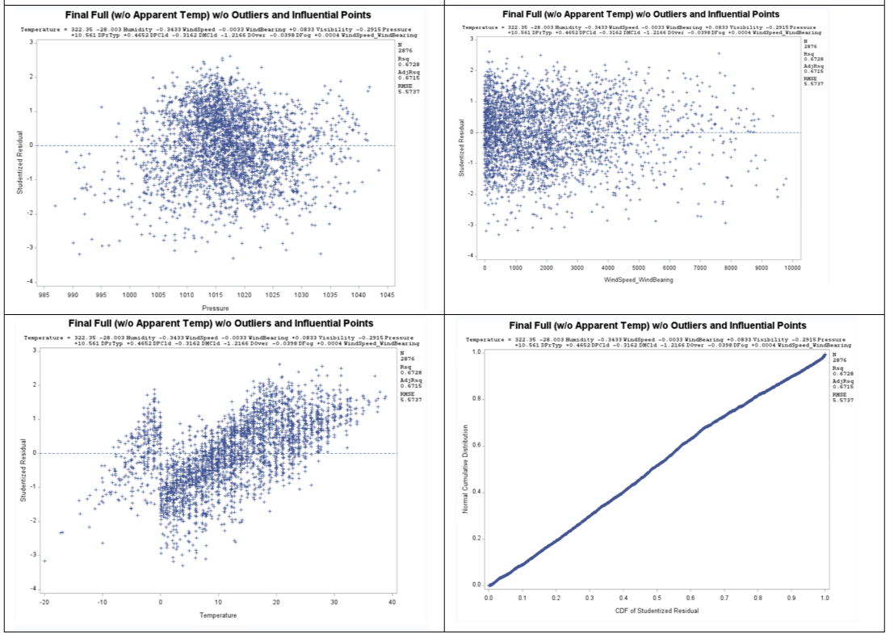

Appendix 1.8: Full Regression Model Residual Outputs.

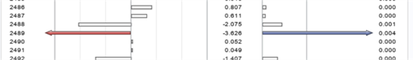

Appendix 1.9: Full Regression Model showing outliers and influential points.

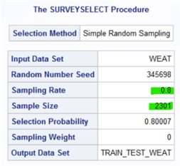

Appendix 1.10: SurveySelect Procedure Output showing sampling rate, size and seed

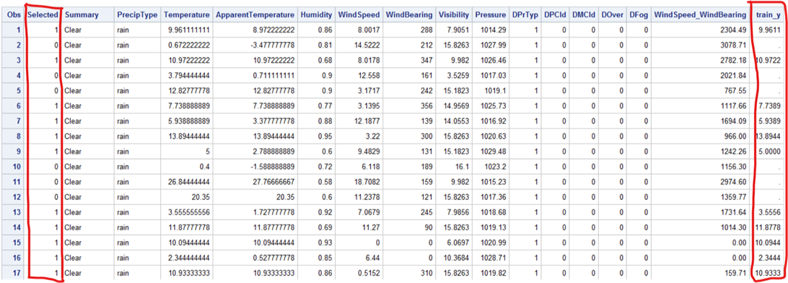

Appendix 1.11: SurveySelect Procedure Output showing observations selected for training set

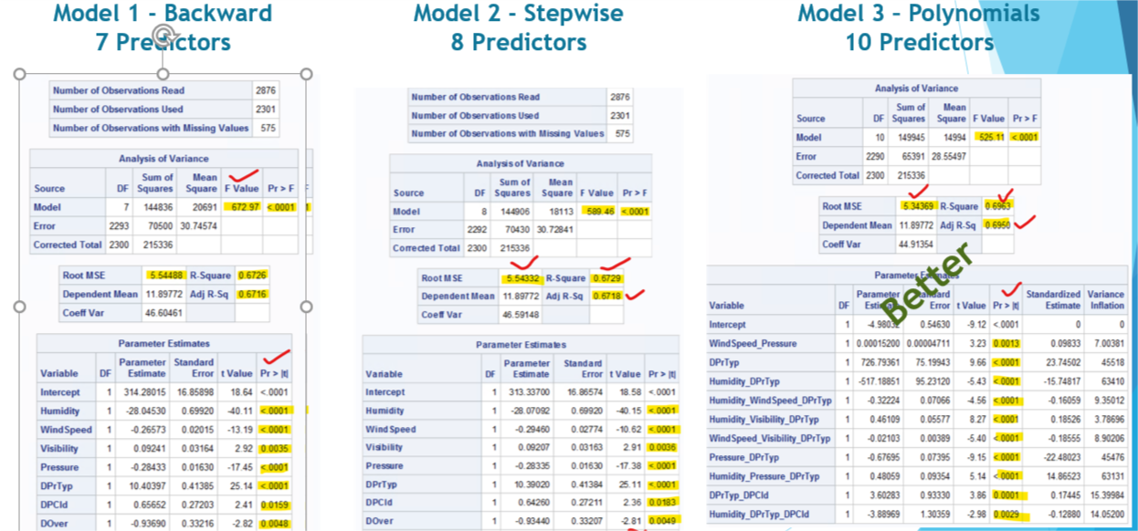

Appendix 1.12: Training Model Comparison

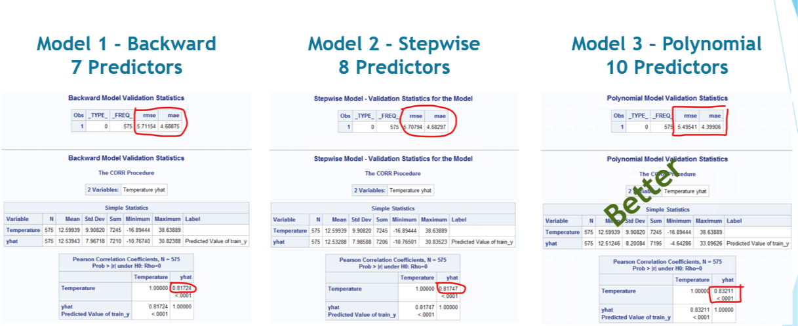

Appendix 1.13: Testing Model Comparison

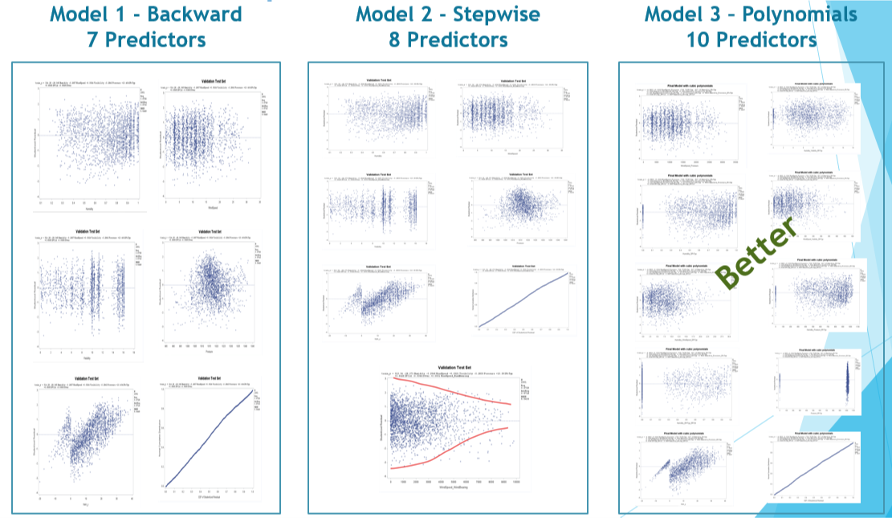

Appendix 1.14: Residuals Comparison

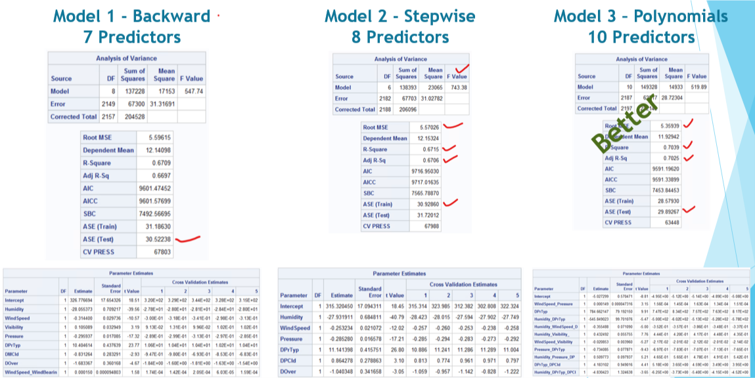

Appendix 1.15: Training Model Comparison based on 5-Fold method

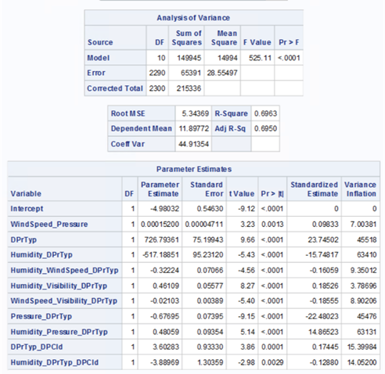

Appendix 1.16: Final Regression Model Output Showing F-value, p-value, RMSE, R2, Adj- R2 and significant predictors.

|  |  |
| --- | --- |
|  |  |
|  |  |
|  |  |
|  |  |
|  |  |

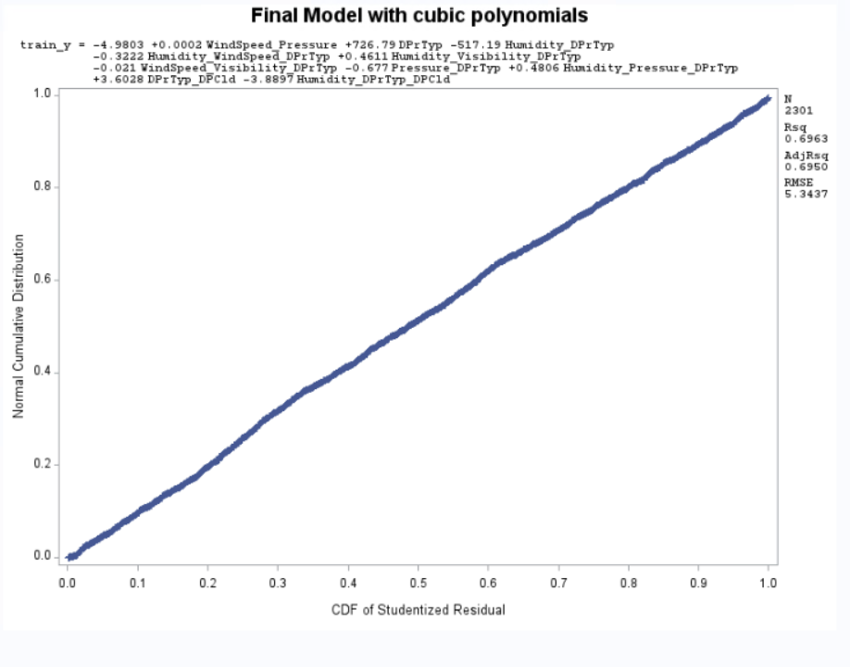

Appendix 1.17: Residuals for Final Cubic Polynomial Model

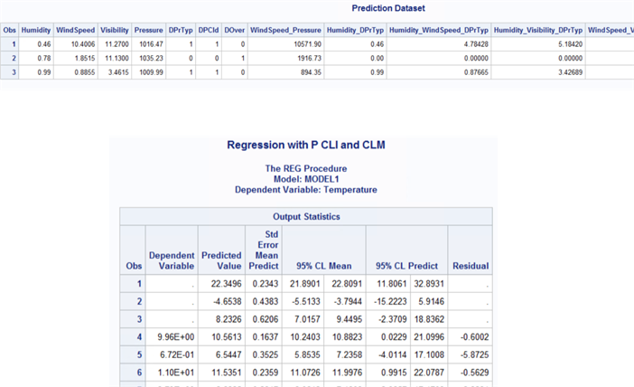

Appendix 1.18: Temperature predictions

# APPENDIX 2: Model 1 Output

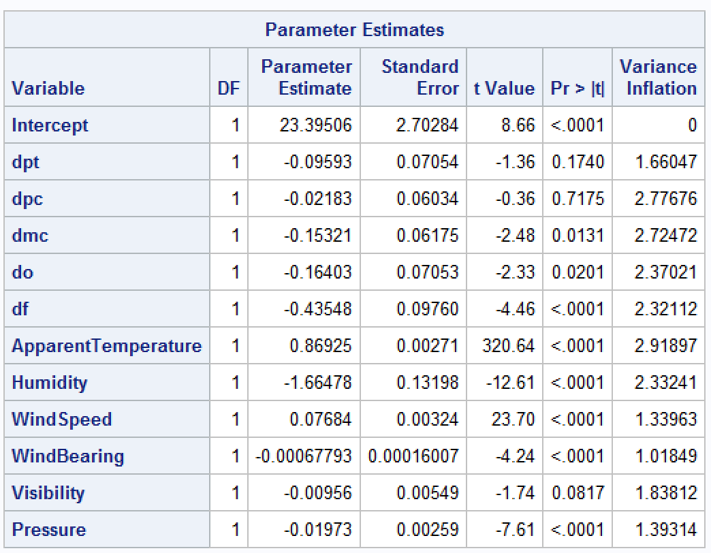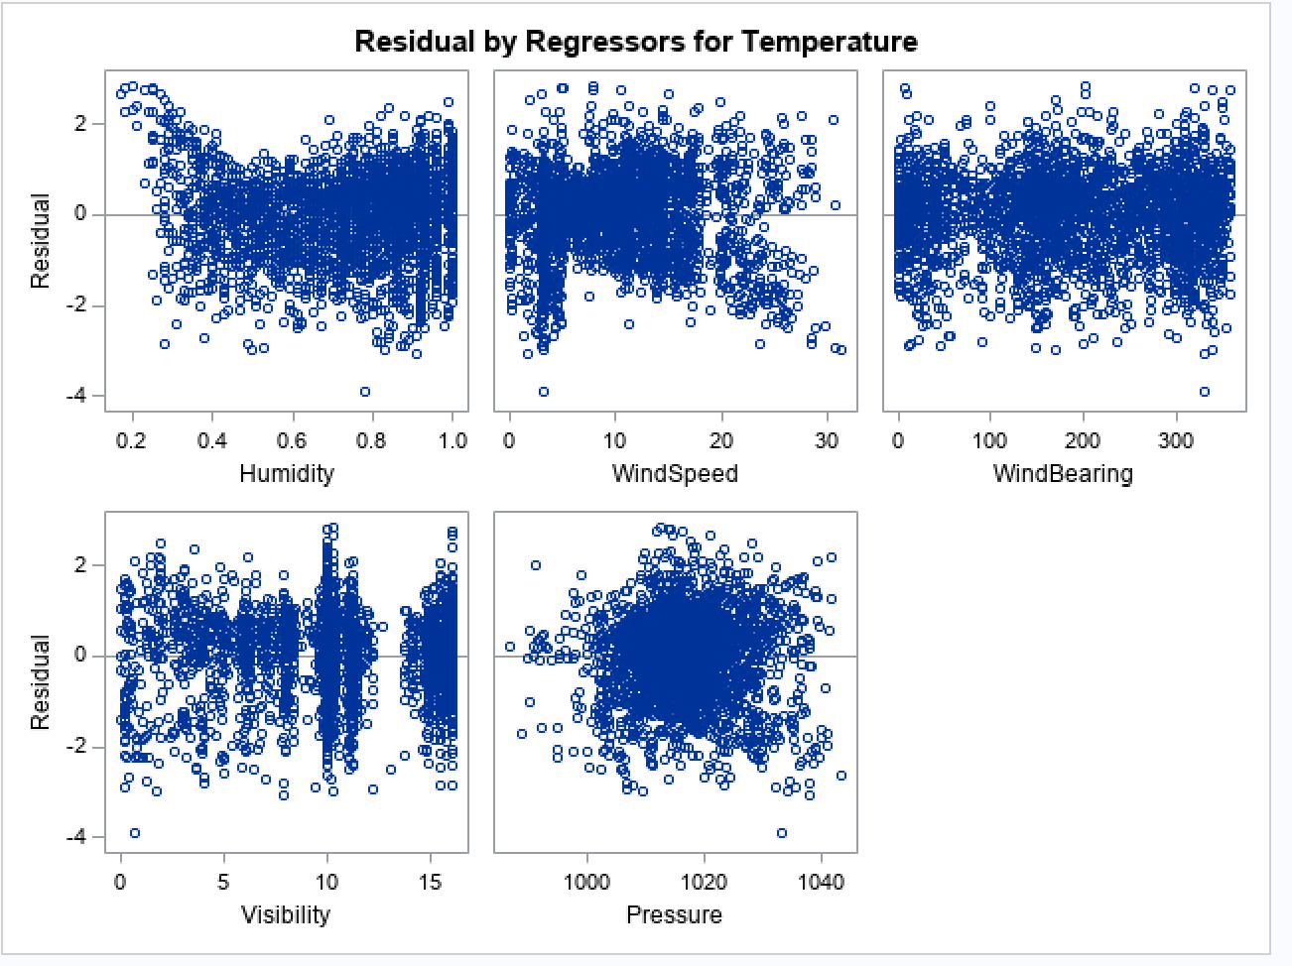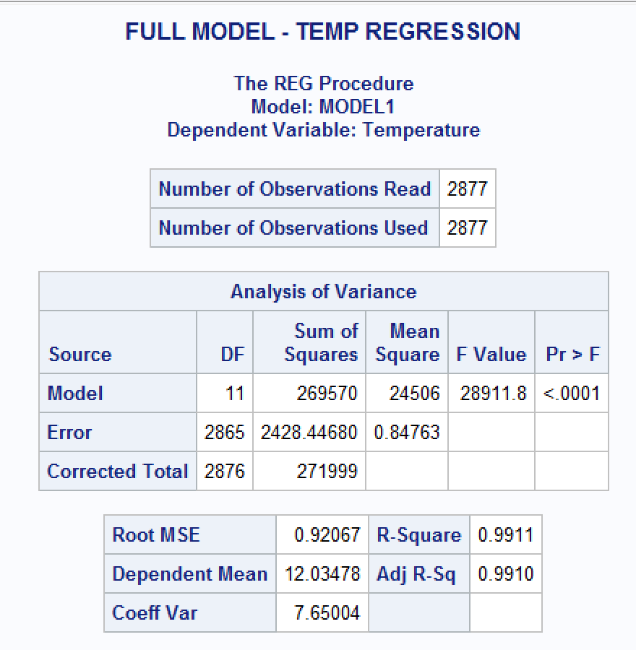

Appendix 2.1: Full regression model showing F-value, p-value, RMSE, R2, Adj- R2, significant predictors, and residual plots

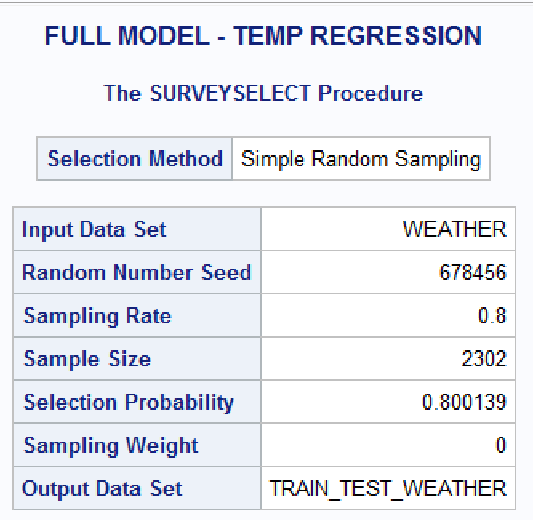

Appendix 2.2: SurveySelect Procedure Output showing sampling rate, size and seed as part of splitting of dataset into test and train

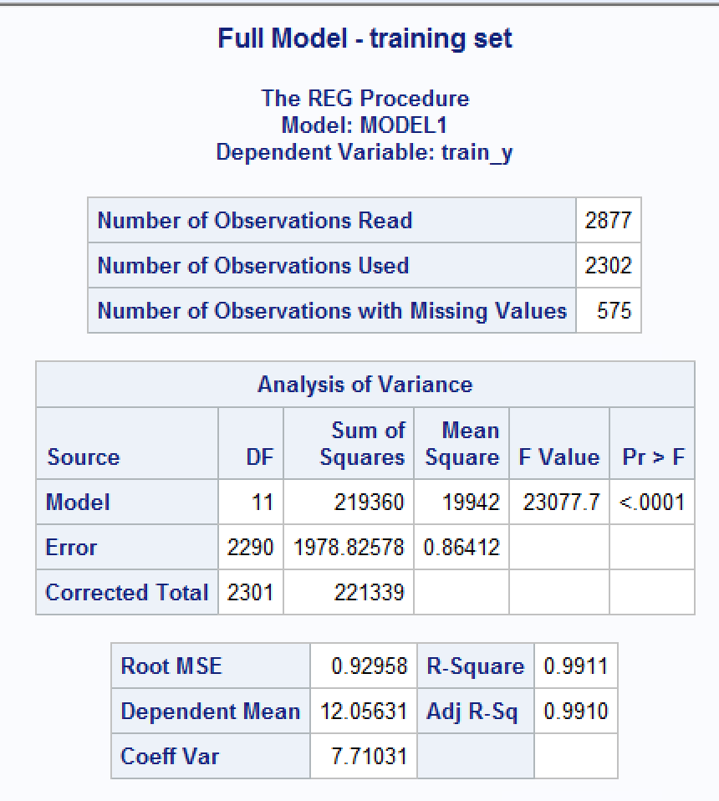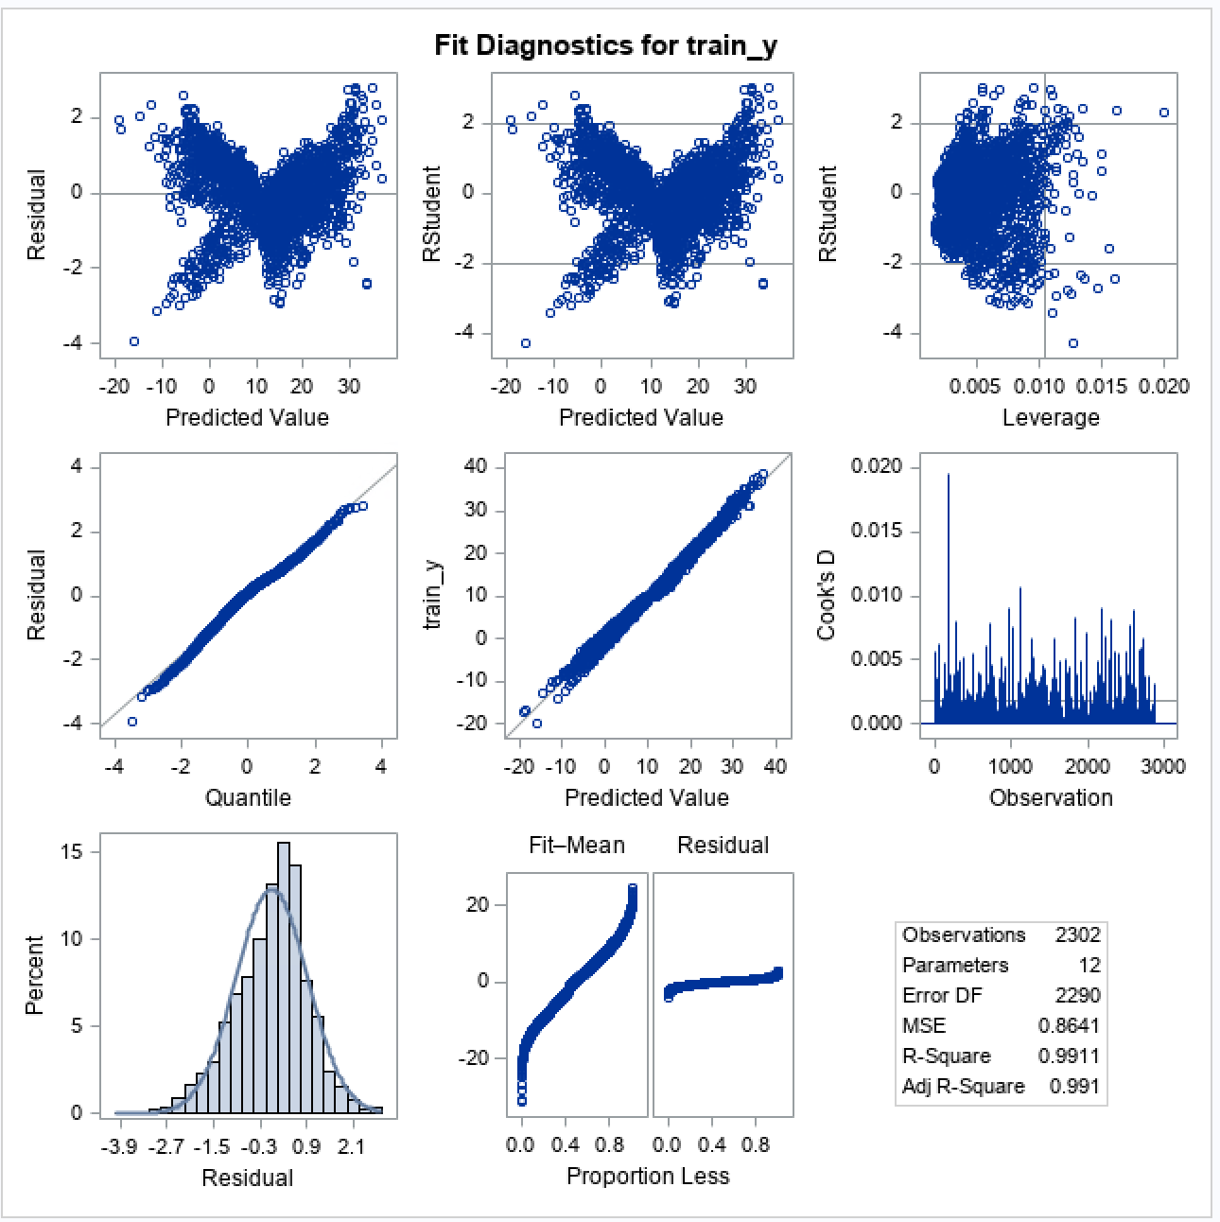

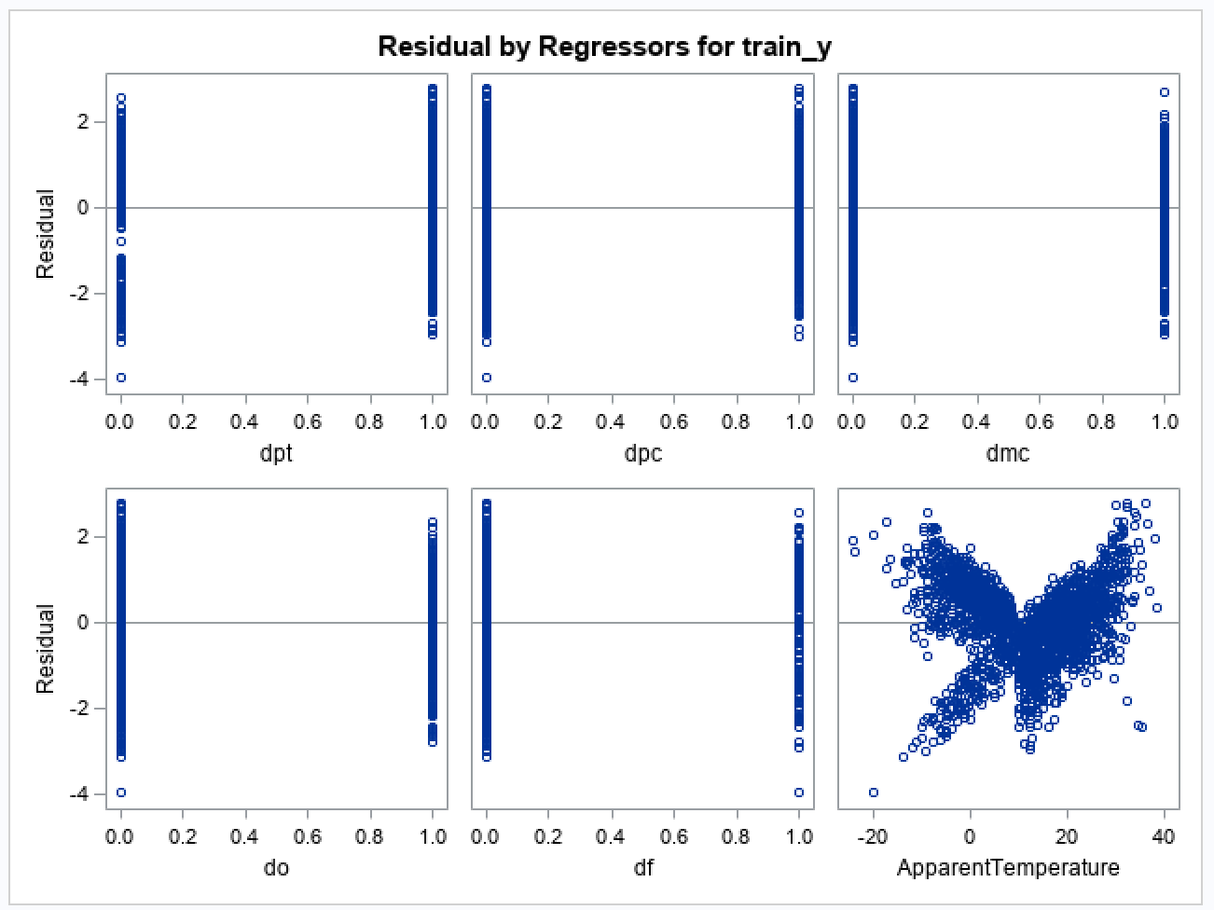

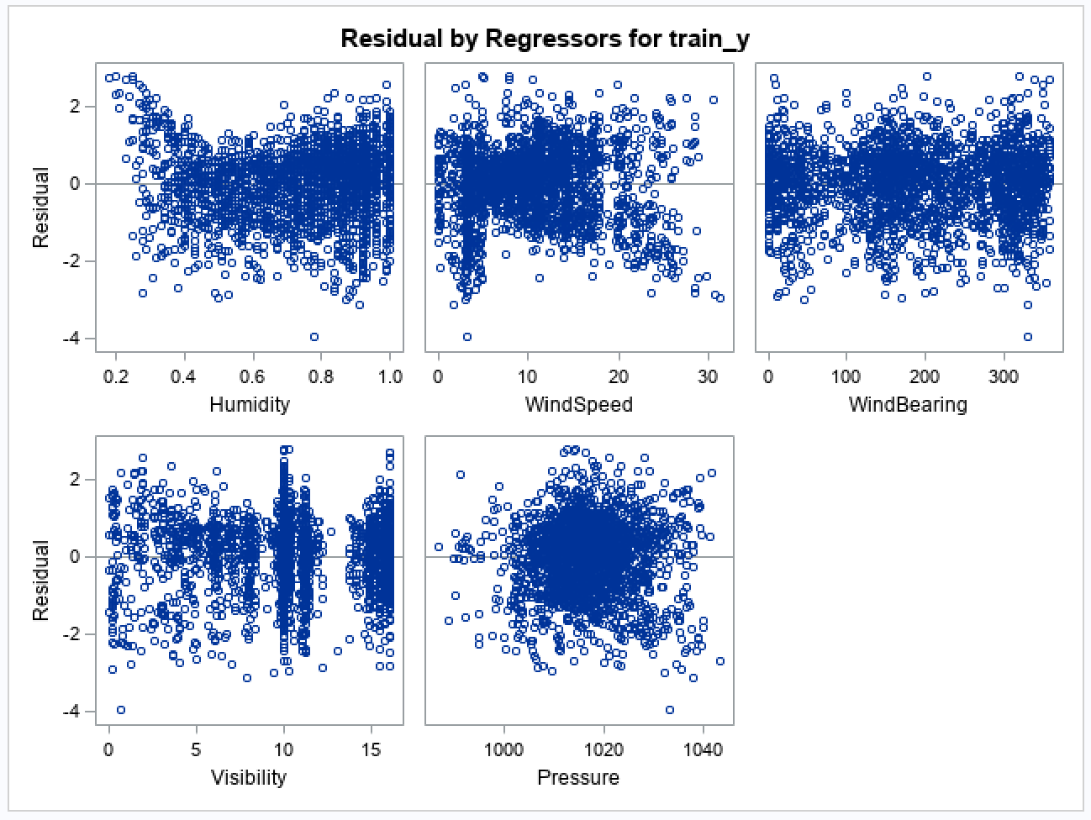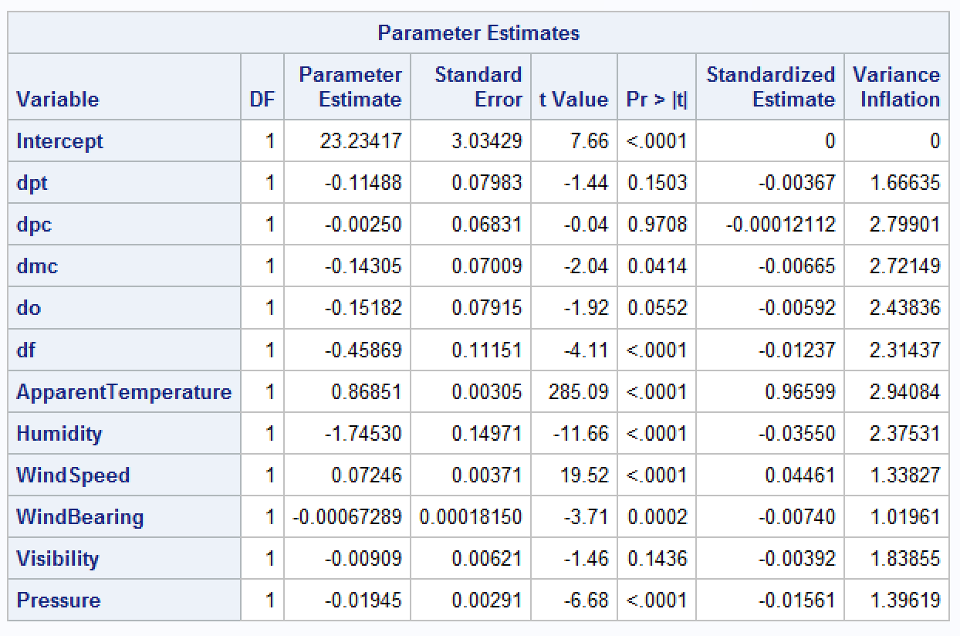

Appendix 2.3: Full regression model output of training set showing F-value, p-value, RMSE, R2, Adj- R2, significant predictors, and residual plots

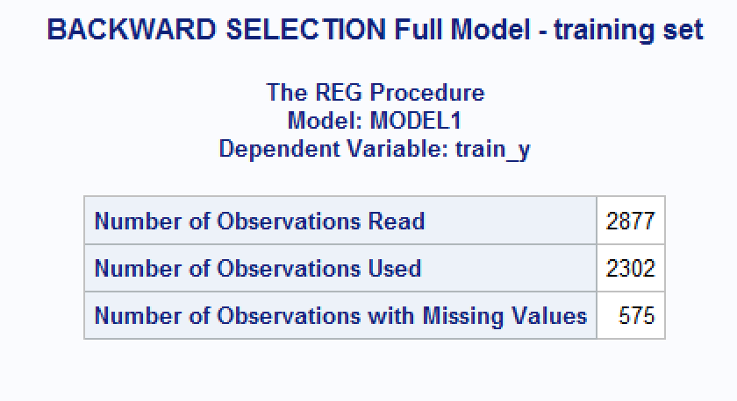

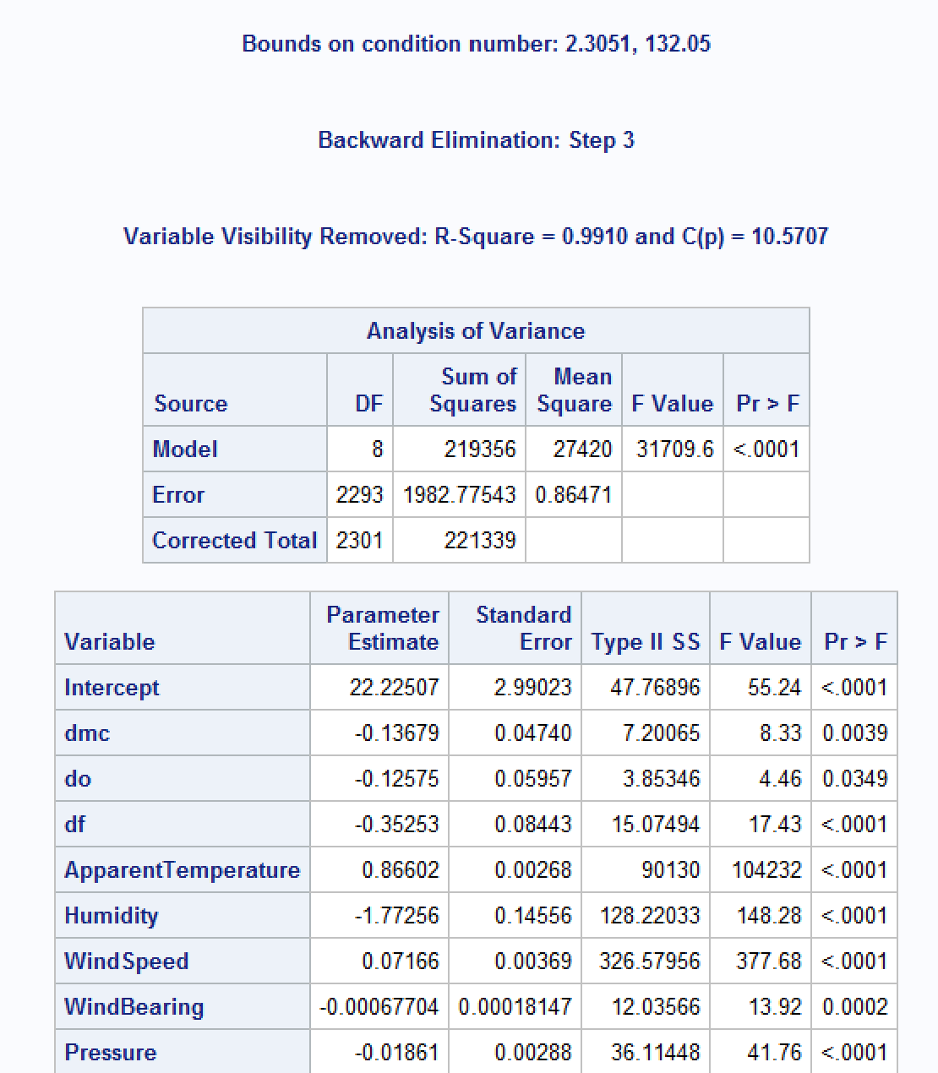

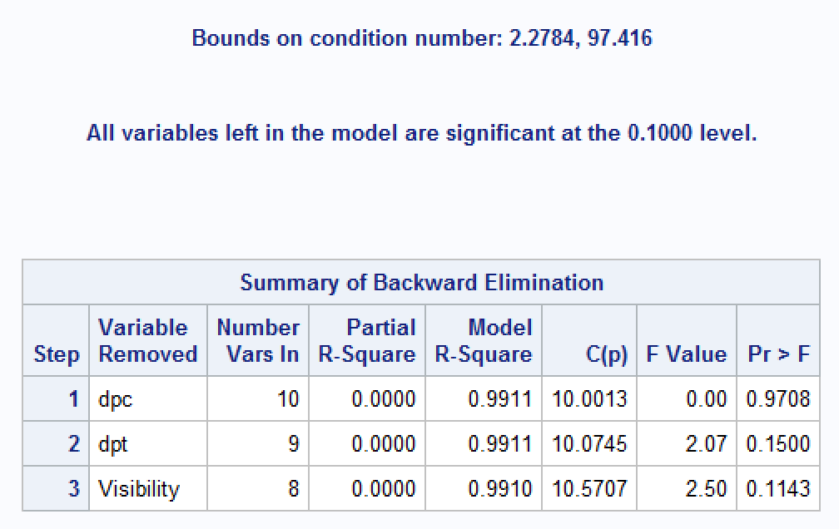

Appendix 2.4: Backwards selection procedure and summary of backward elimination

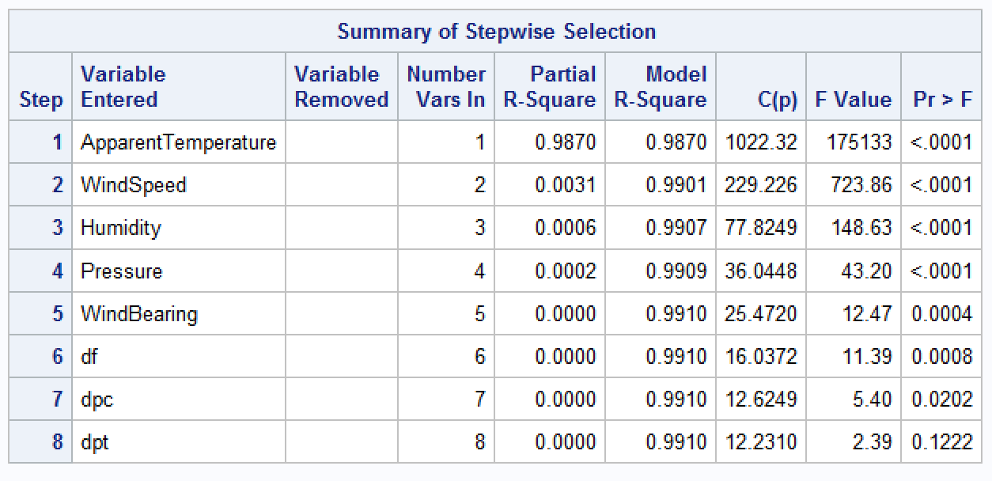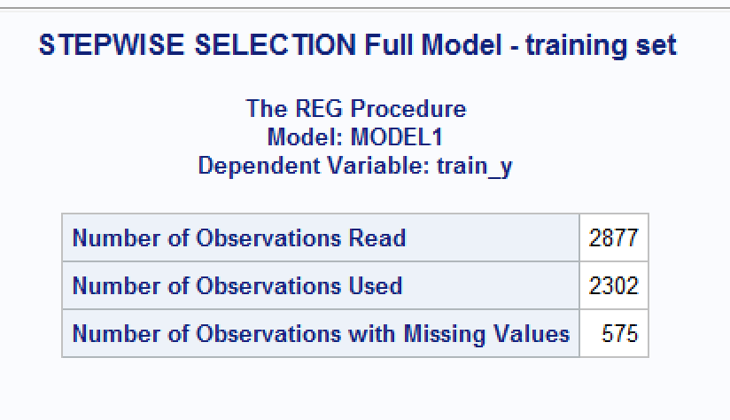

Appendix 2.5: Stepwise selection procedure and summary of stepwise selection

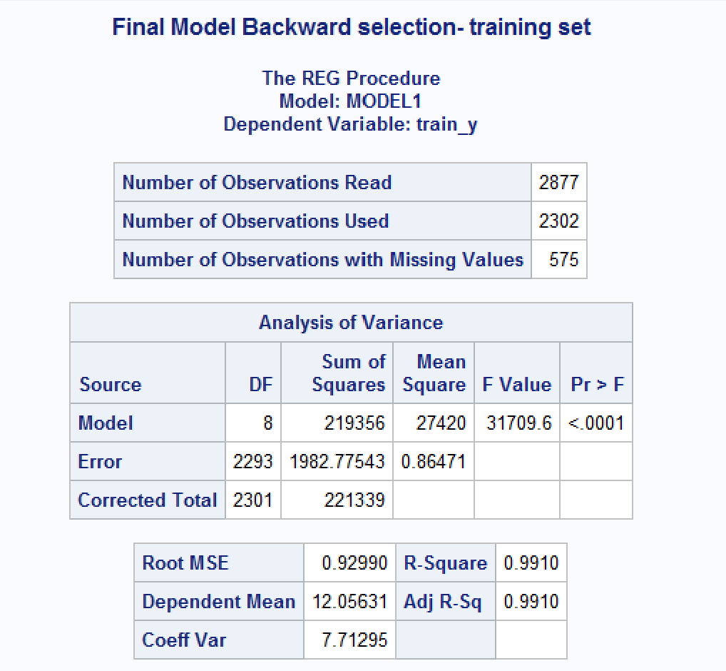

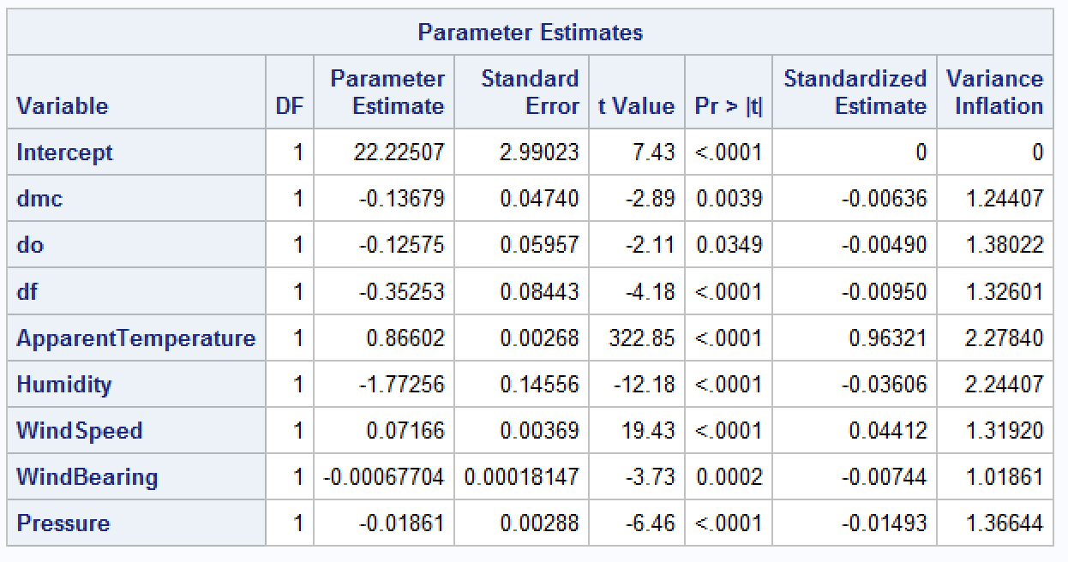

Appendix 2.6: Fitted final regression model with predictors chosen showing F-value, p-value, RMSE, R2, Adj- R2, significant predictors



Appendix 2.7: Outlier and influential point indicated by residual arrow (red) and Cook’s D (blue)

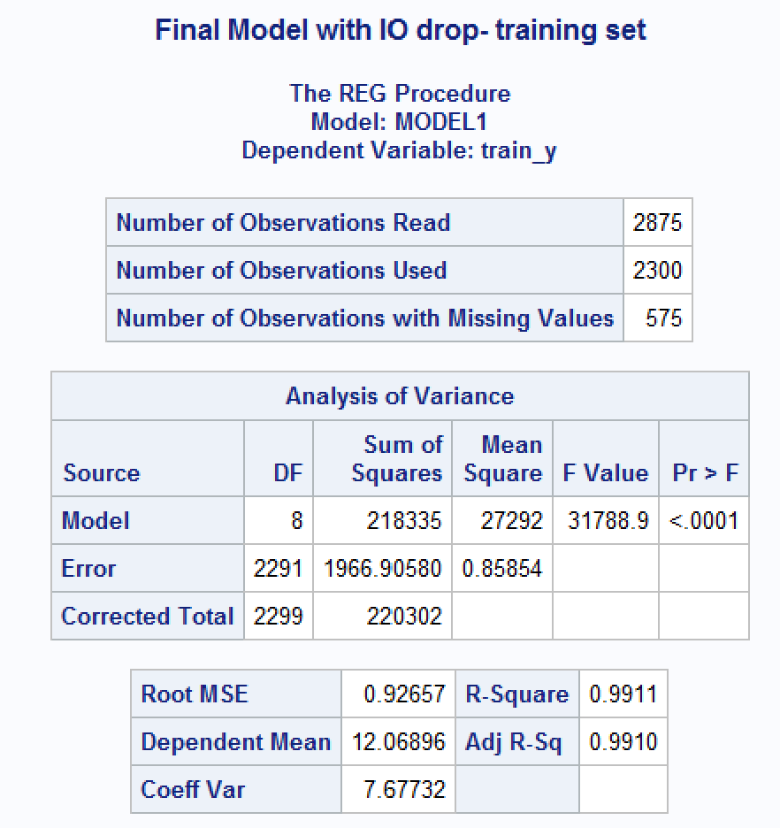

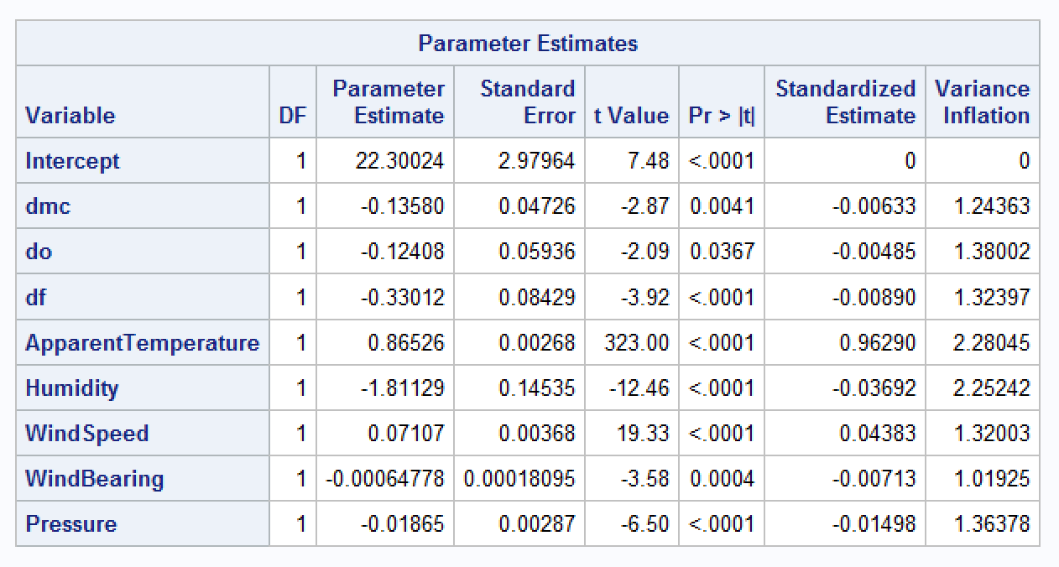

Appendix 2.8: Fitted final regression model after influential points and outliers dropped with predictors chosen showing F-value, p-value, RMSE, R2, Adj- R2, significant predictors

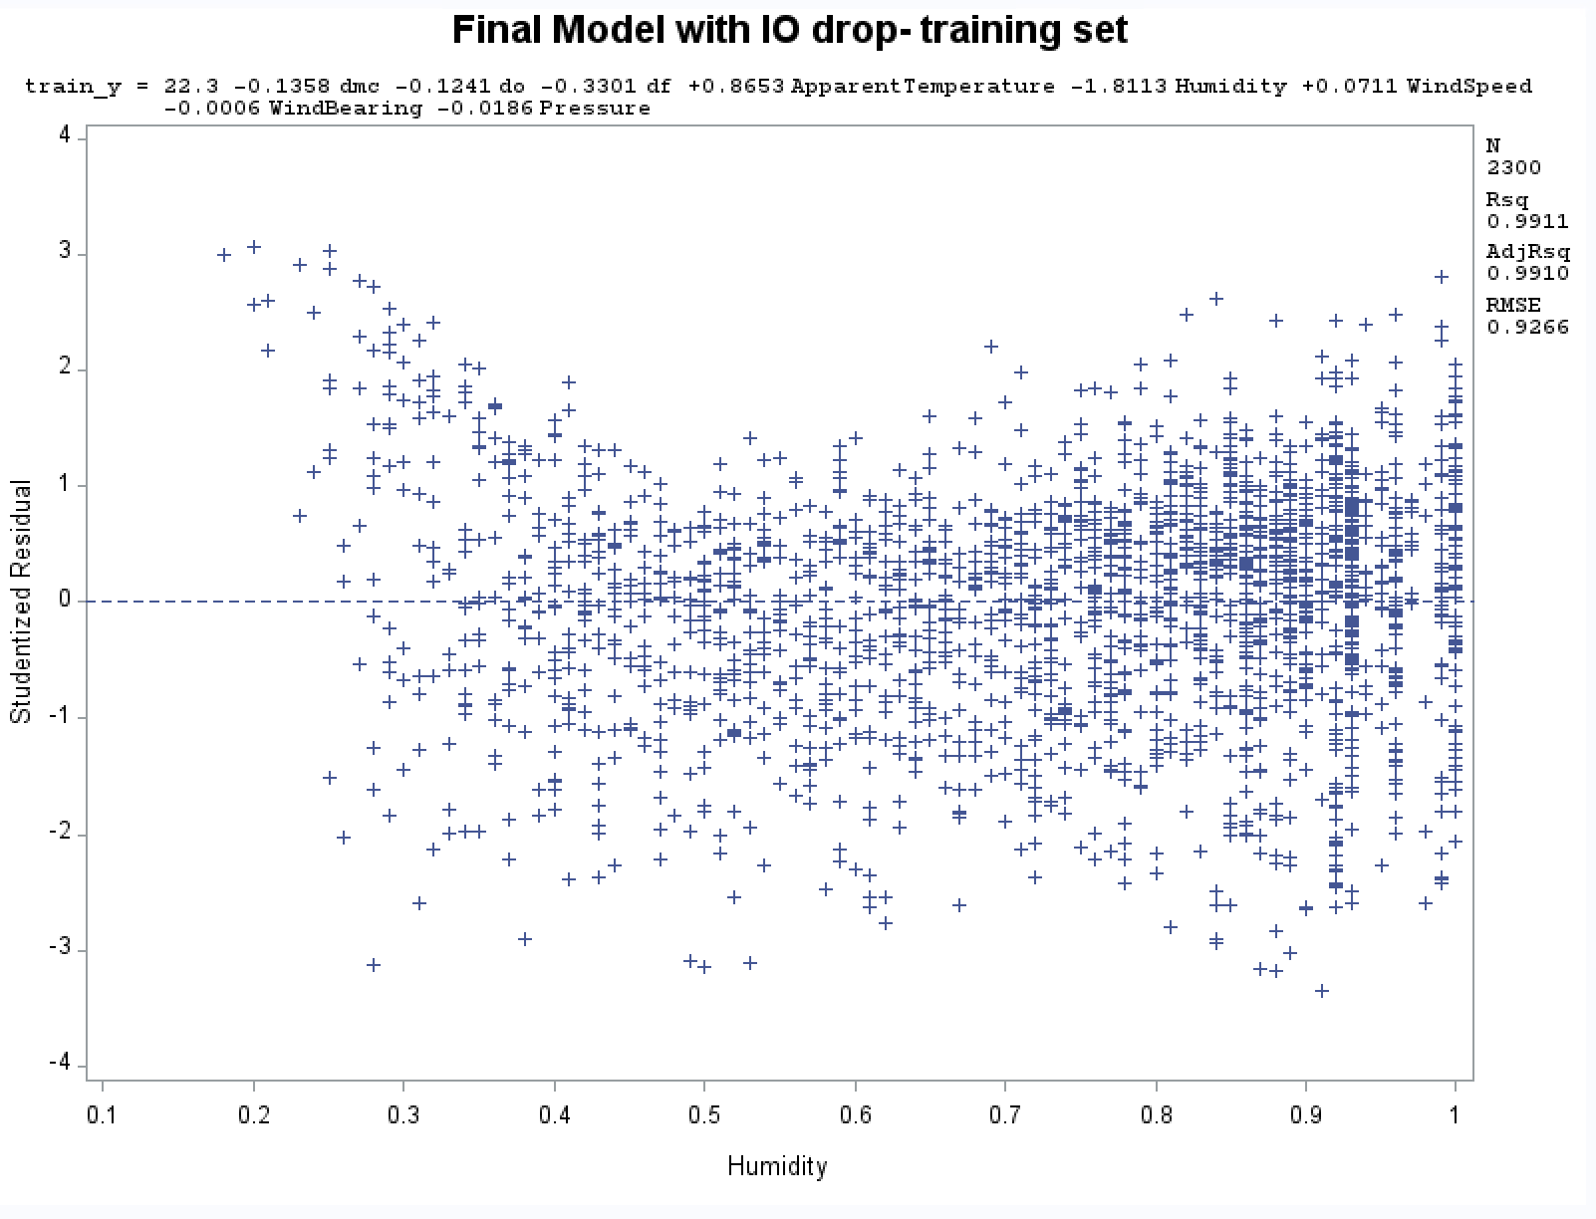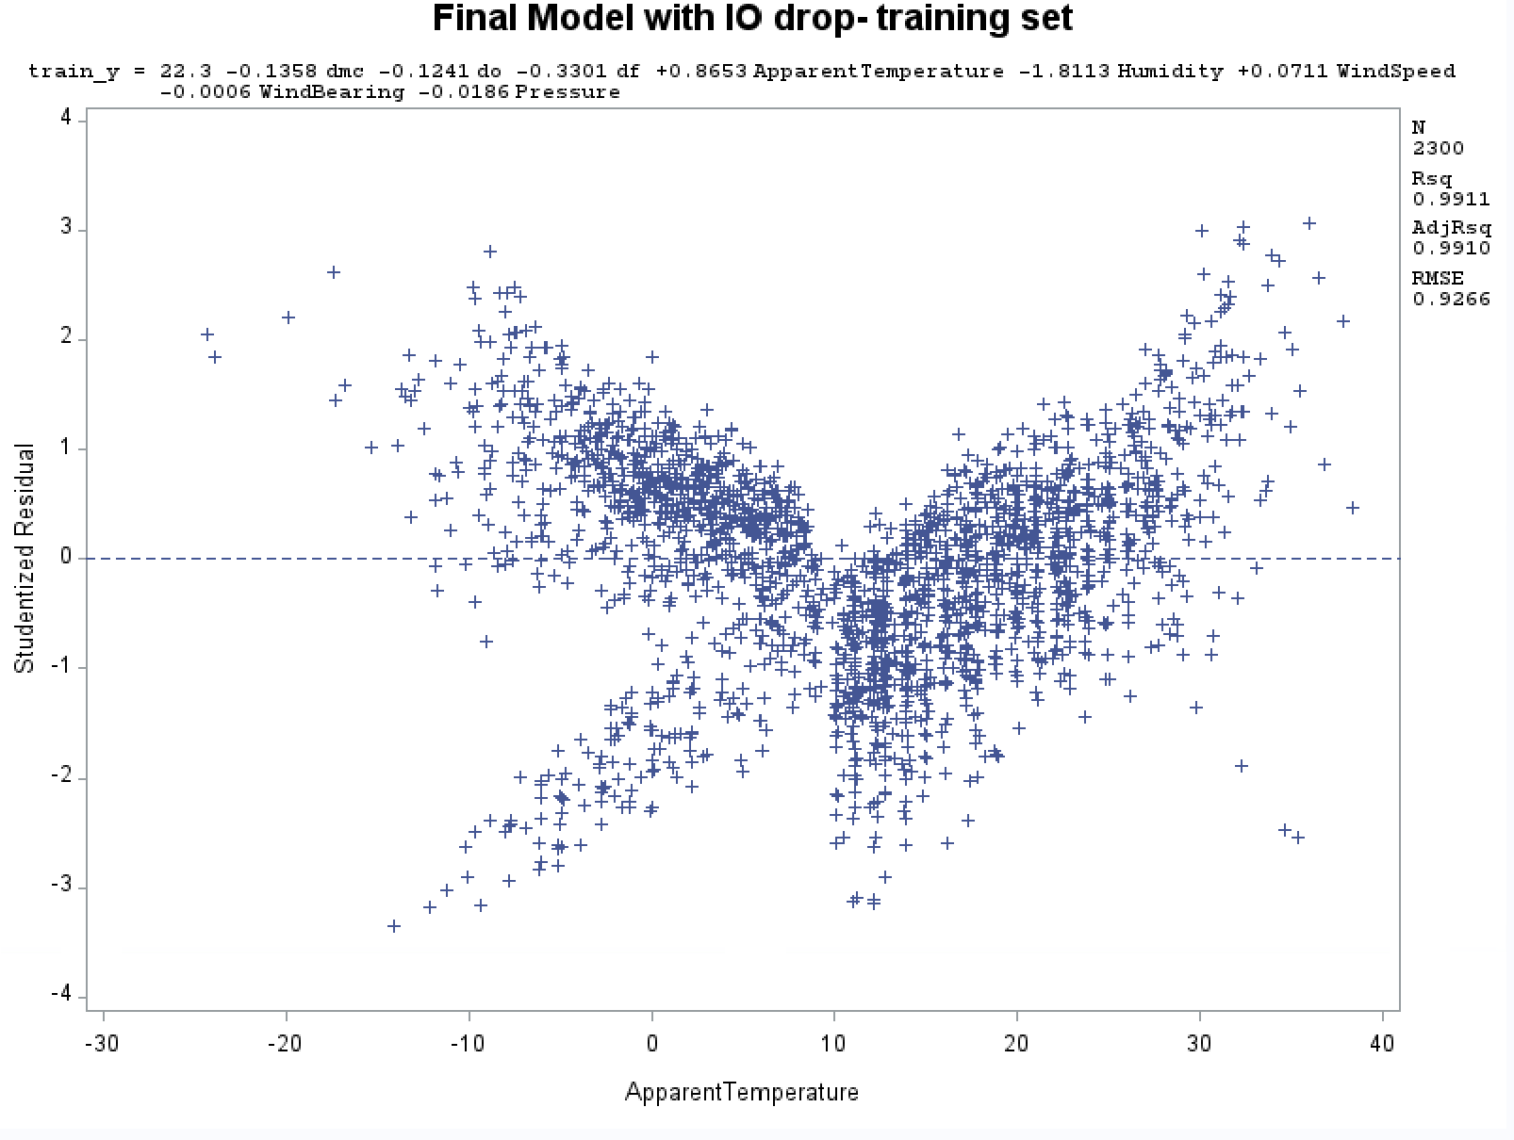

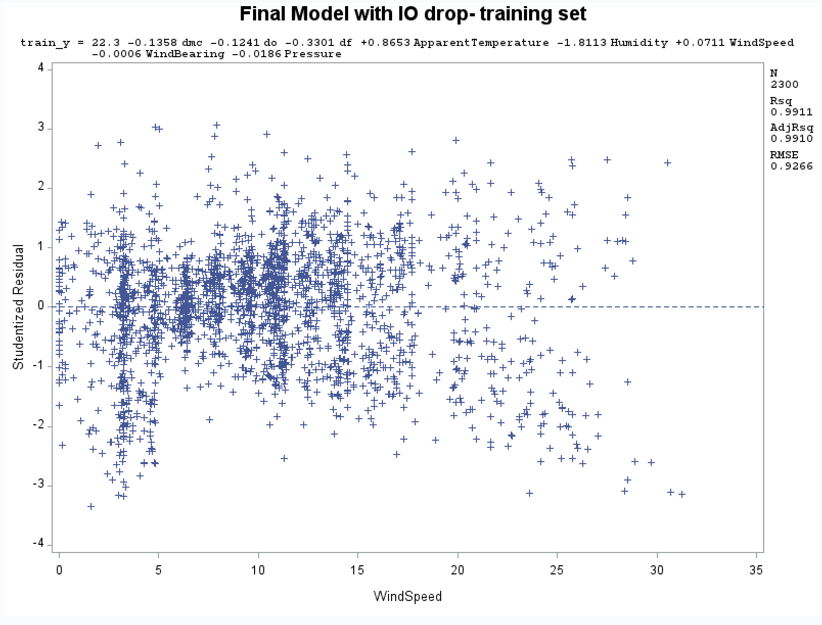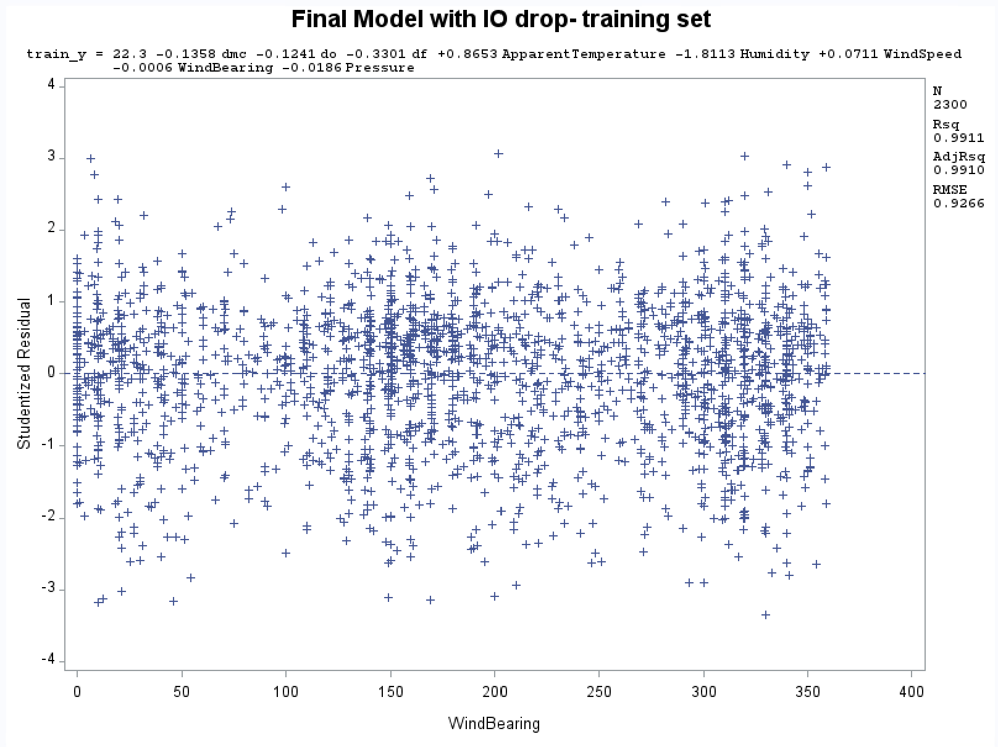

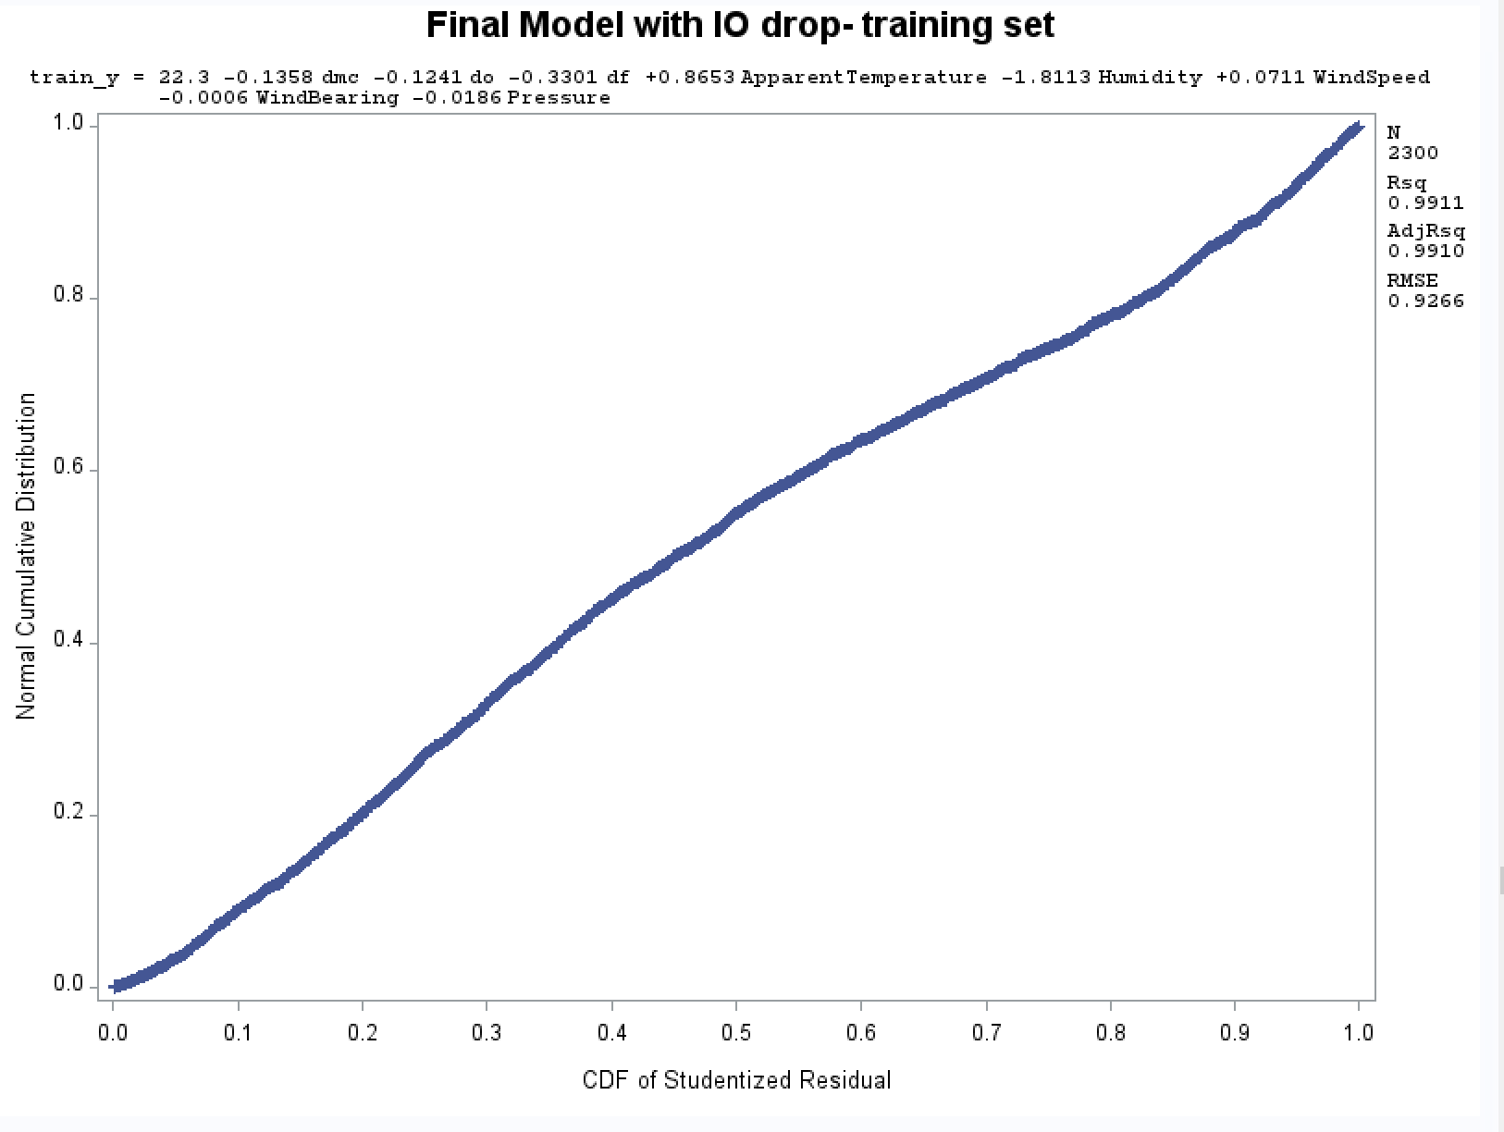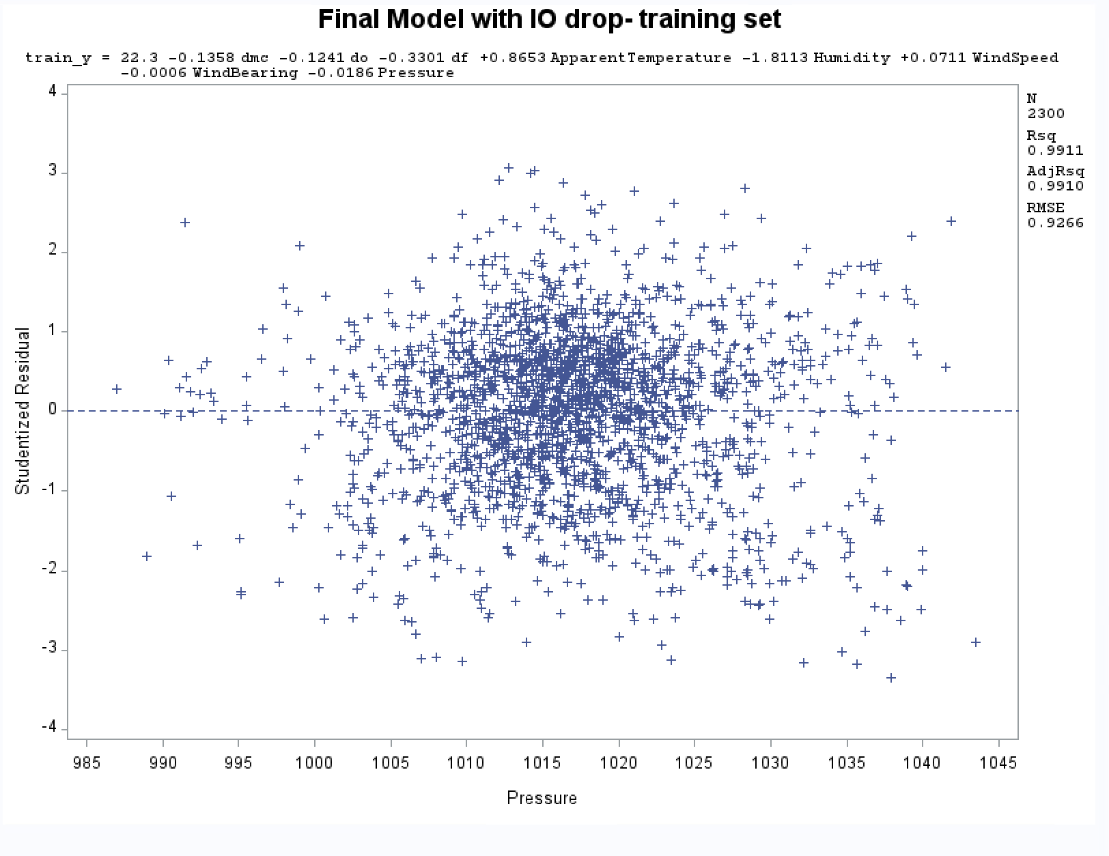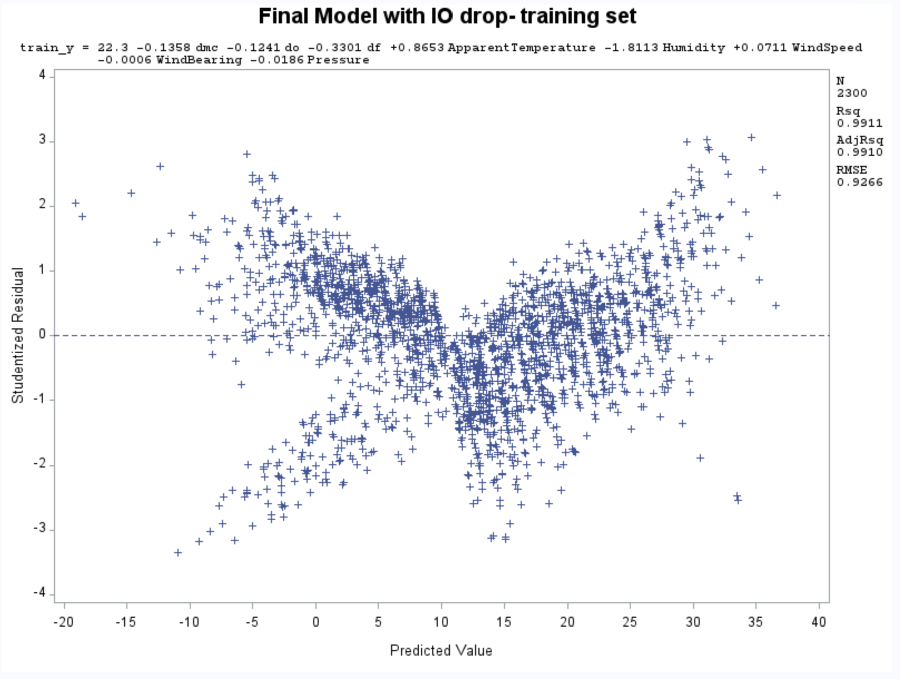

Appendix 2.9: Residual plot and normal probability plots for final fitted regression model

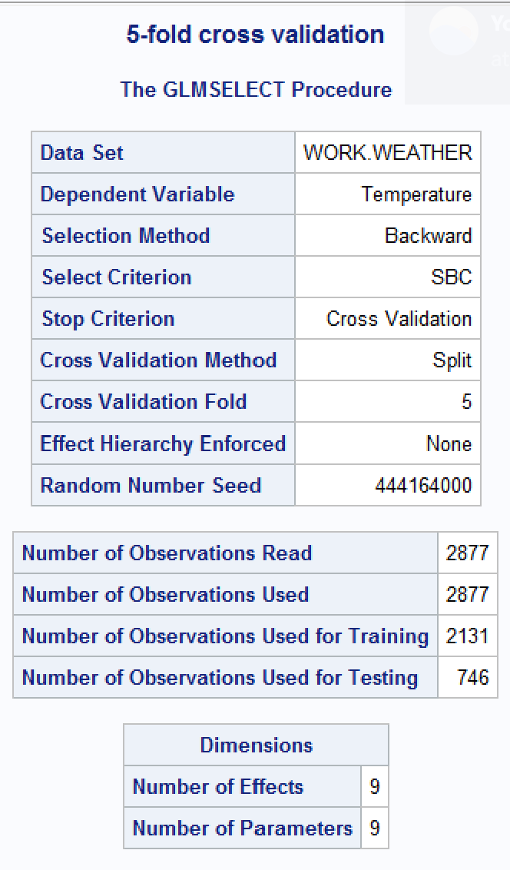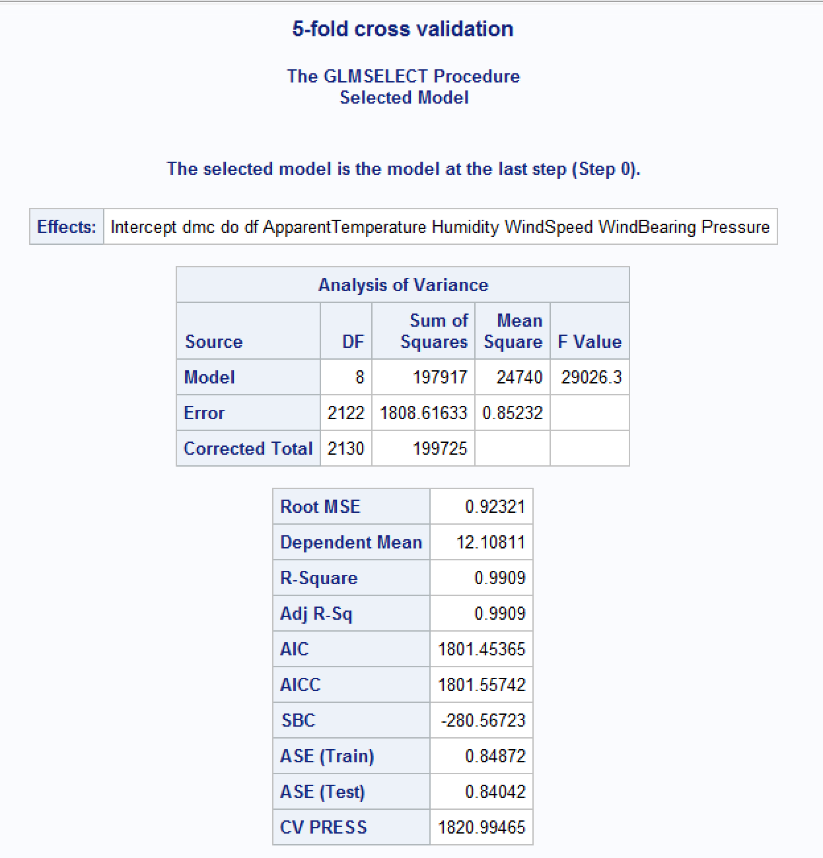

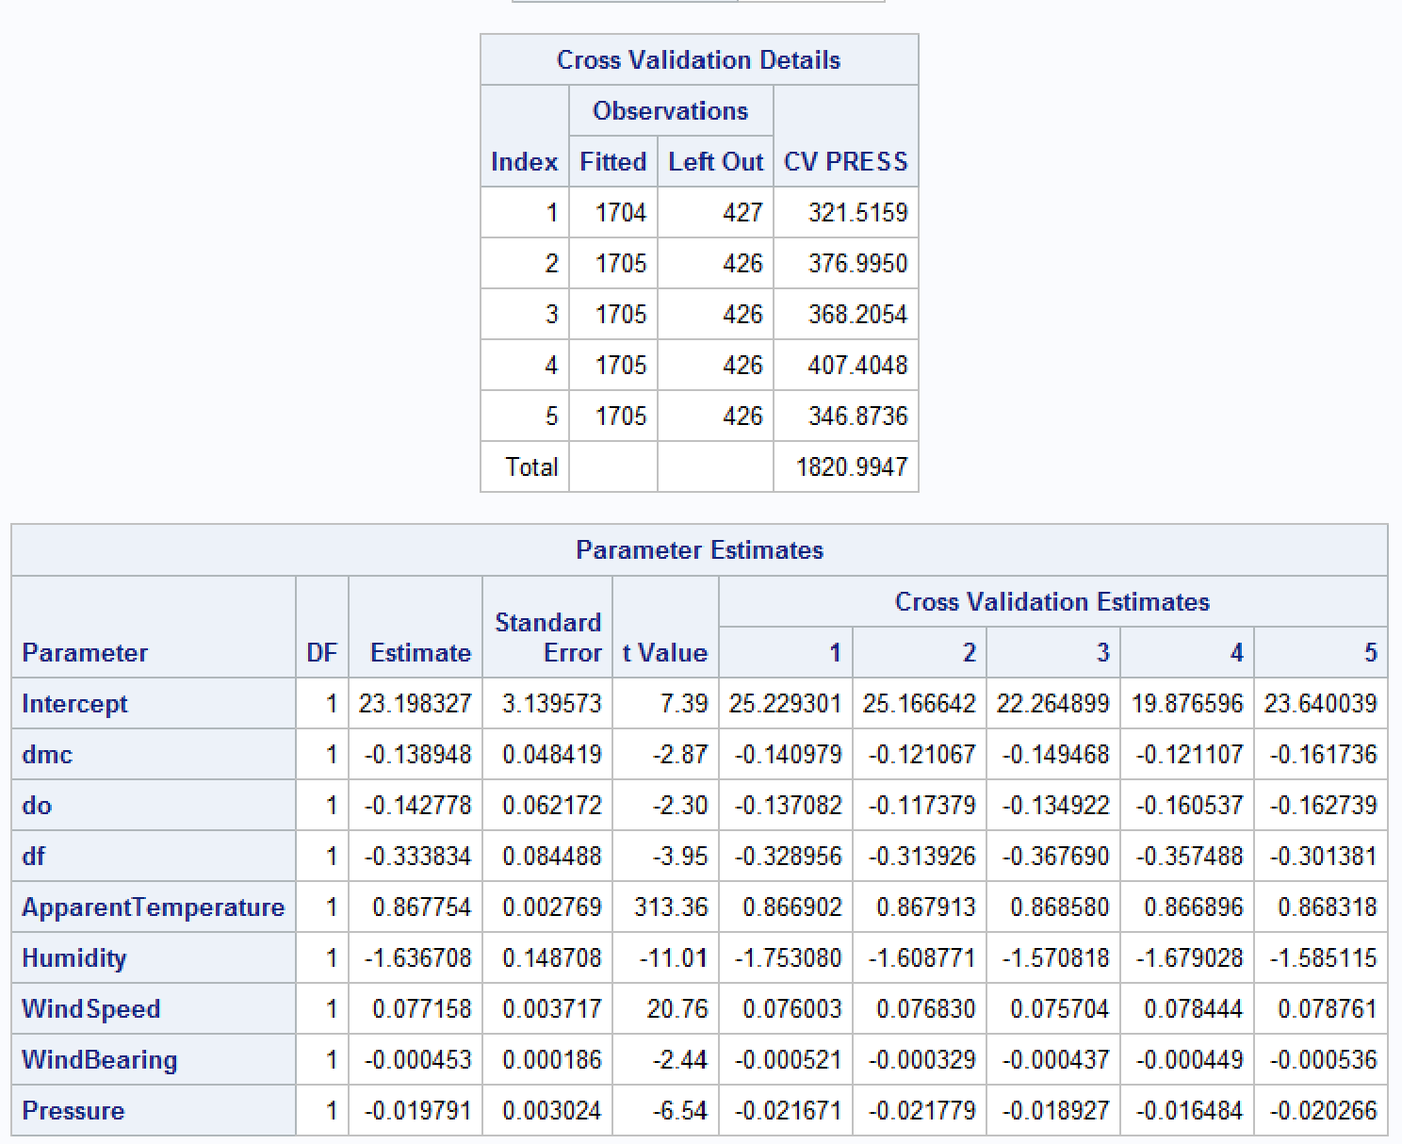

Appendix 2.10: Fivefold cross validation check for final regression model

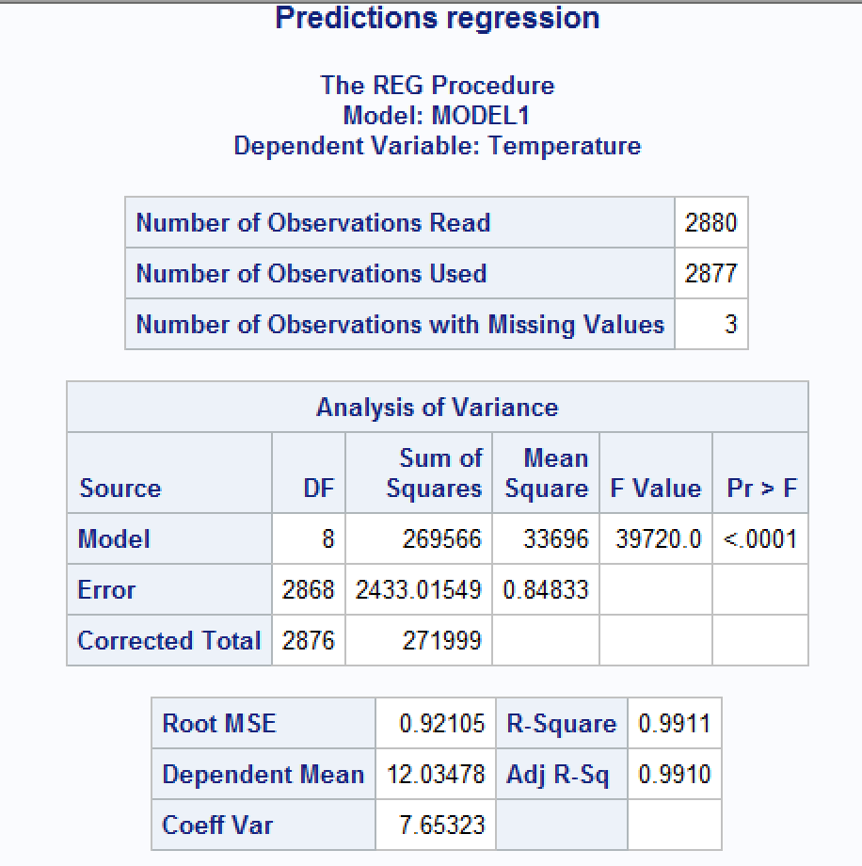

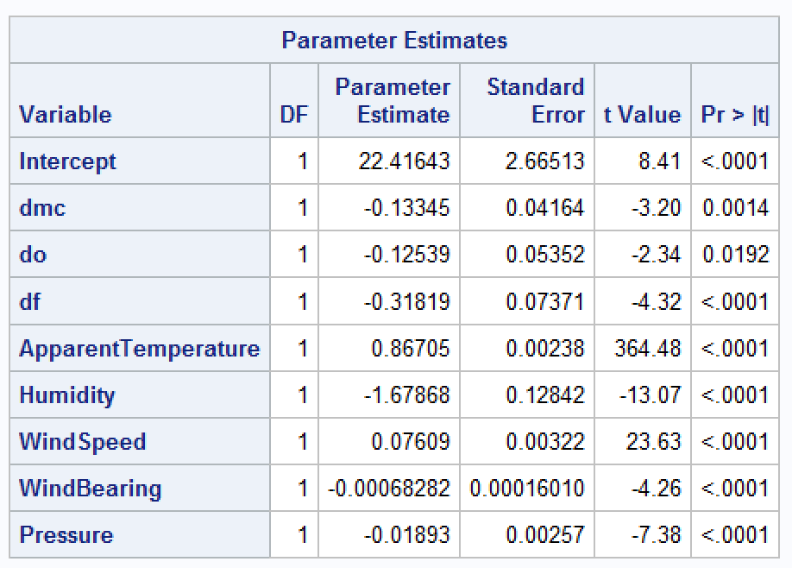

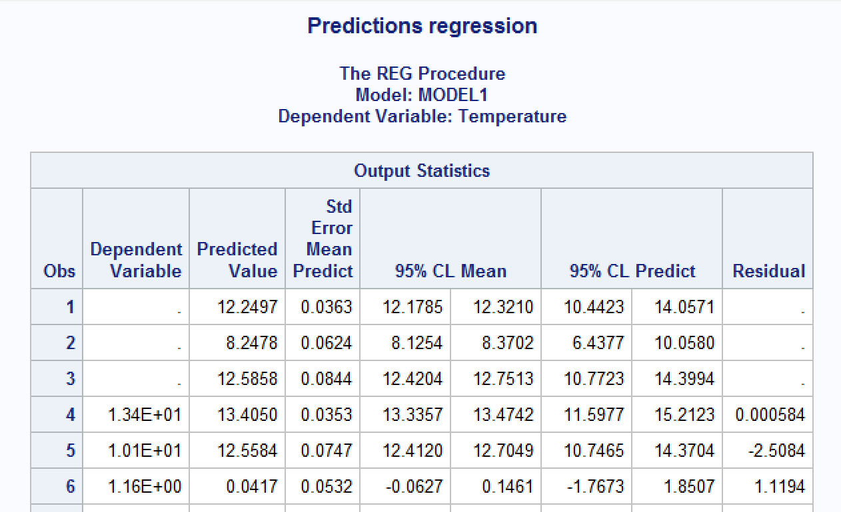

Appendix 2.11: Predictions generated from test cases along with confidence intervals

# 

# APPENDIX 3: Model 2 Output

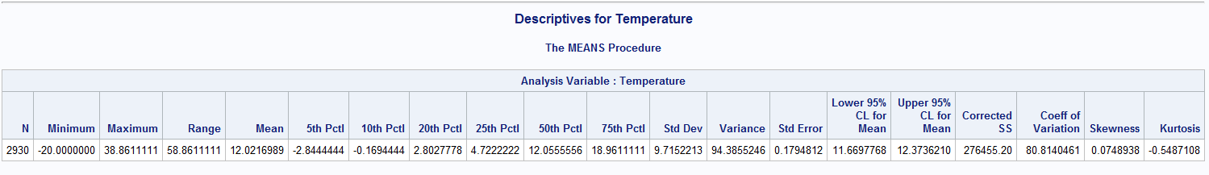

Appendix 3.1: Descriptives for Temperature

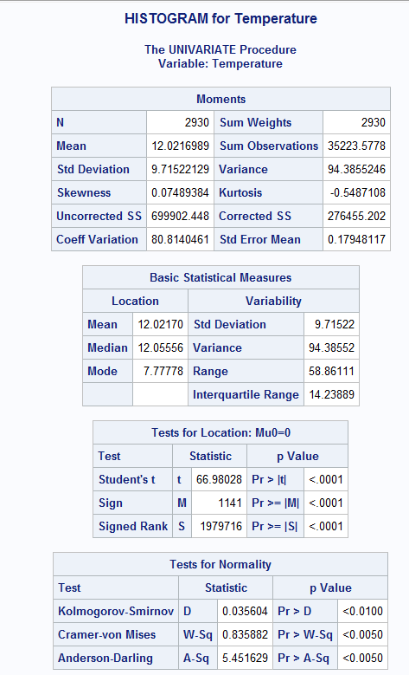

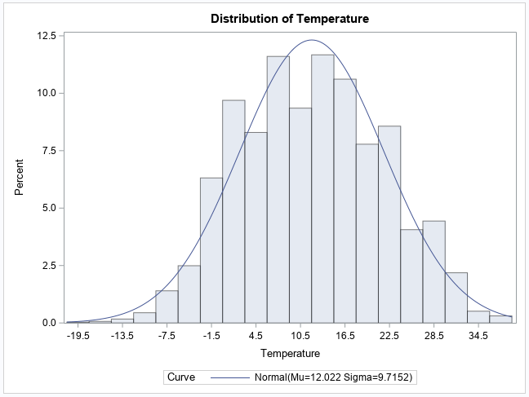

Appendix 3.2: Histogram

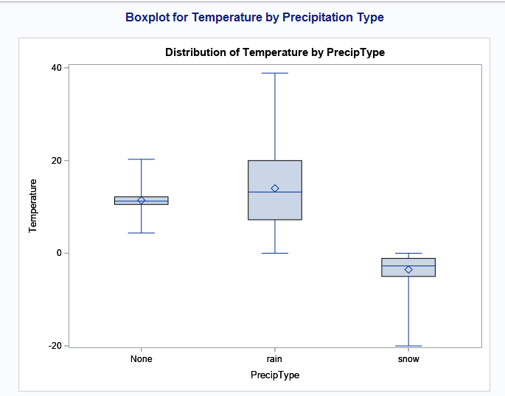

Appendix 3.3: Boxplot for Temperature for Precipitation Type

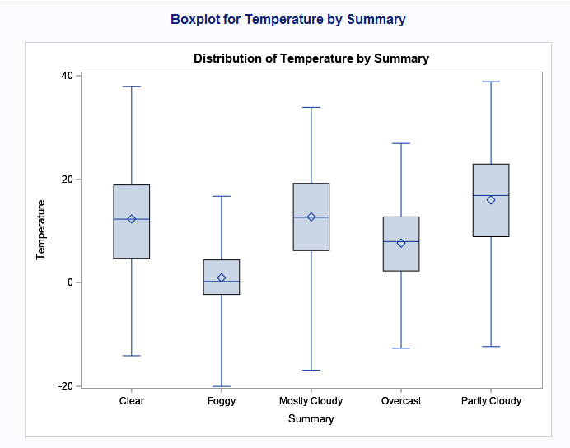

Appendix 3.4: Boxplot for Temperature by Summary

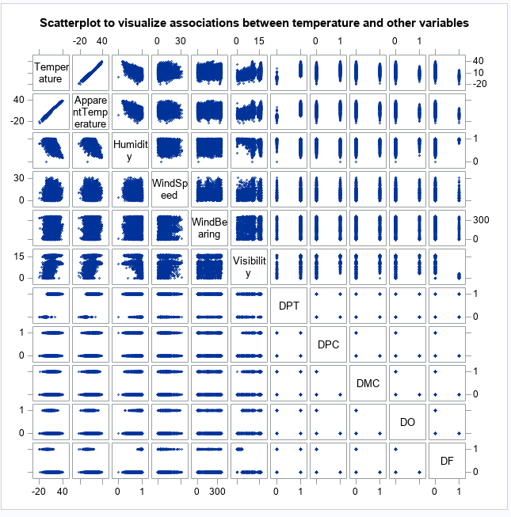

Appendix 3.5: Scatterplot for Temperature and the other variables

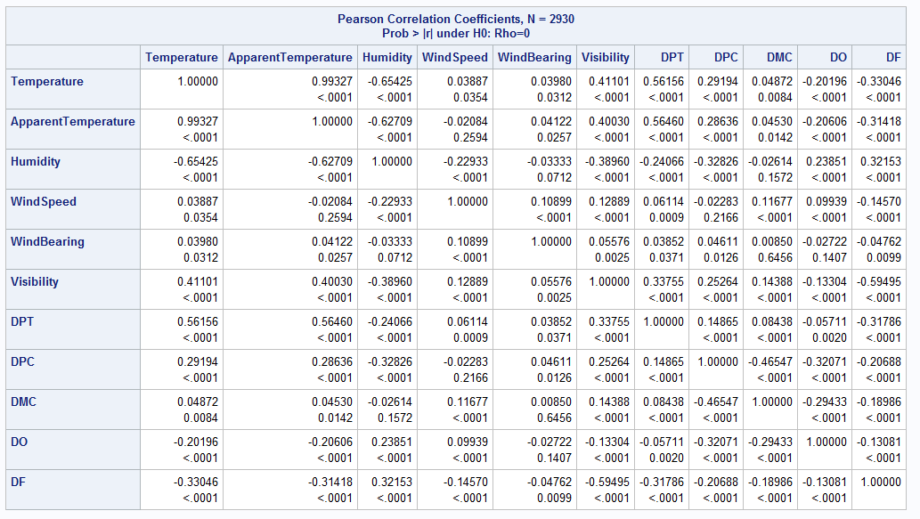

Appendix 3.6: The correlation between Temperature and the other Variables

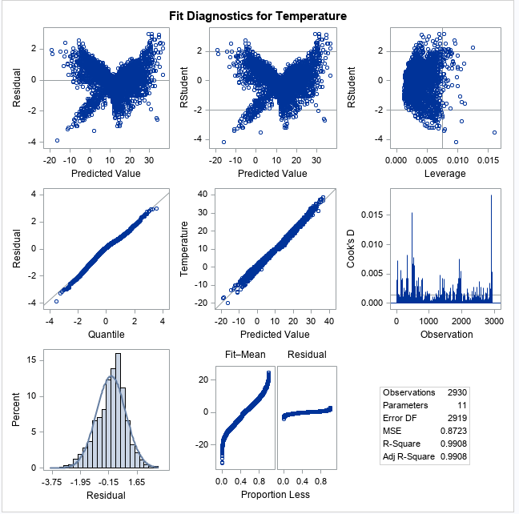

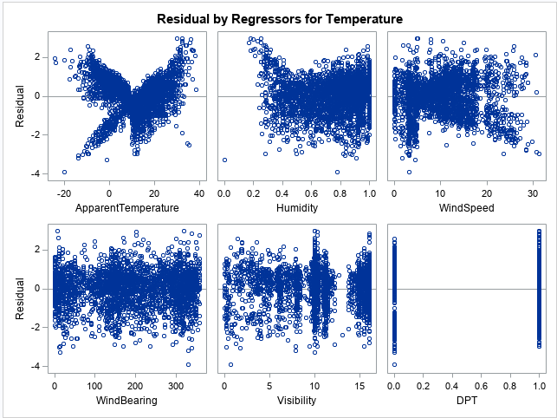

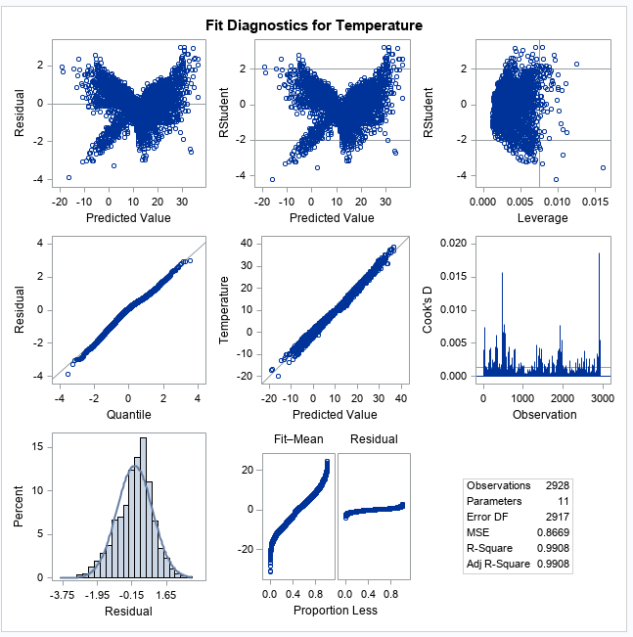

Appendix 3.7: Graphs of the Residuals

: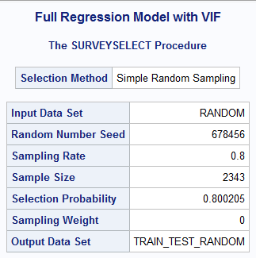

Appendix 3.7: Full Regression Model

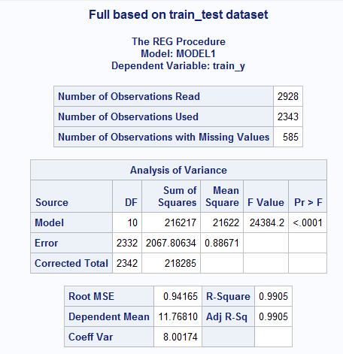

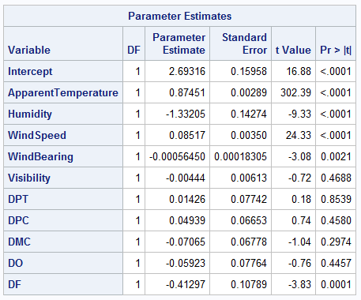

Appendix 3.8: Full model based on train_test dataset

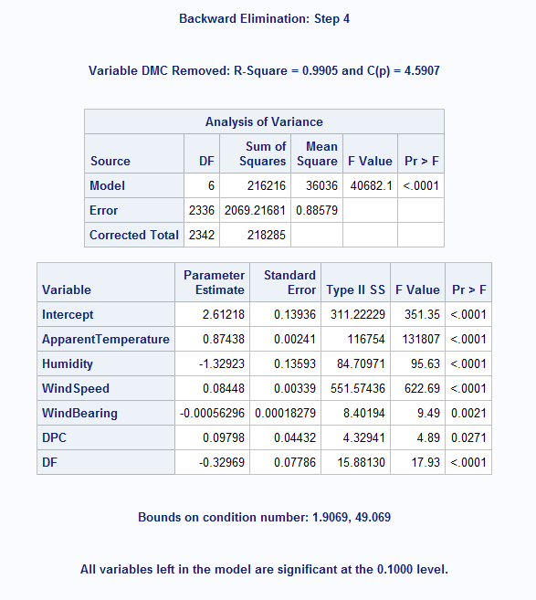

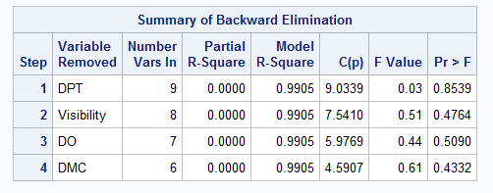

Appendix 3.9: Results from the Backward Selection Method along with Summary

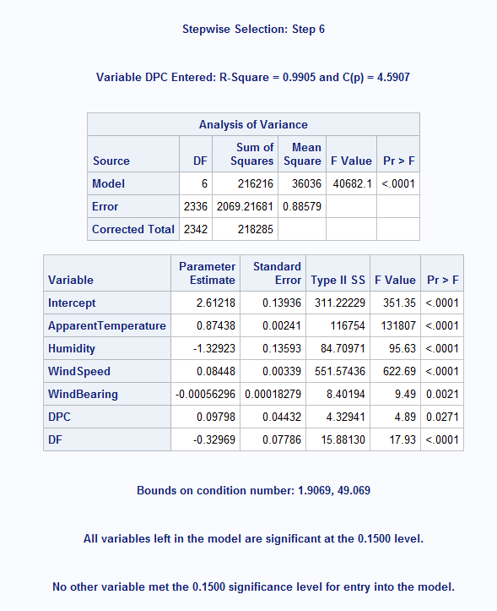

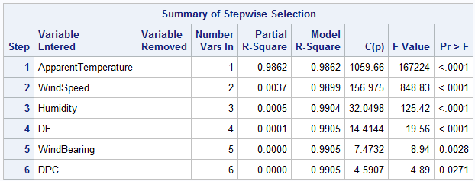

Appendix 3.10: Results from the Stepwise Selection Method along with Summary

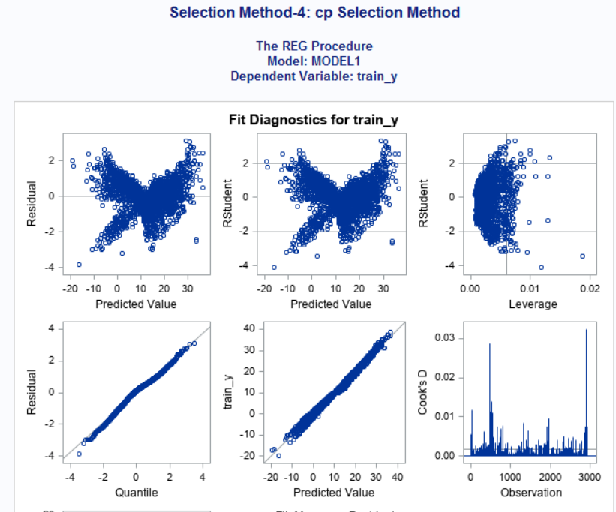

Appendix 3.11: Results from the CP Selection Method

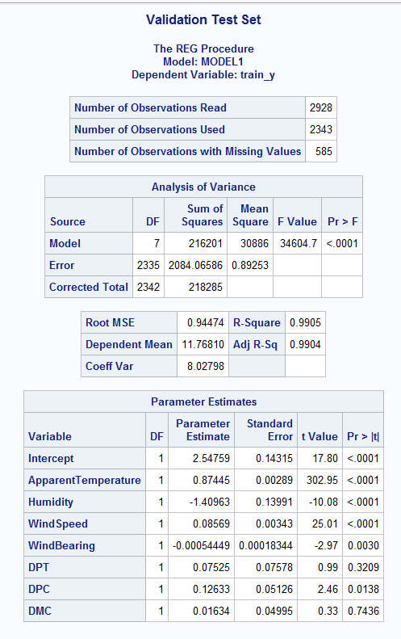

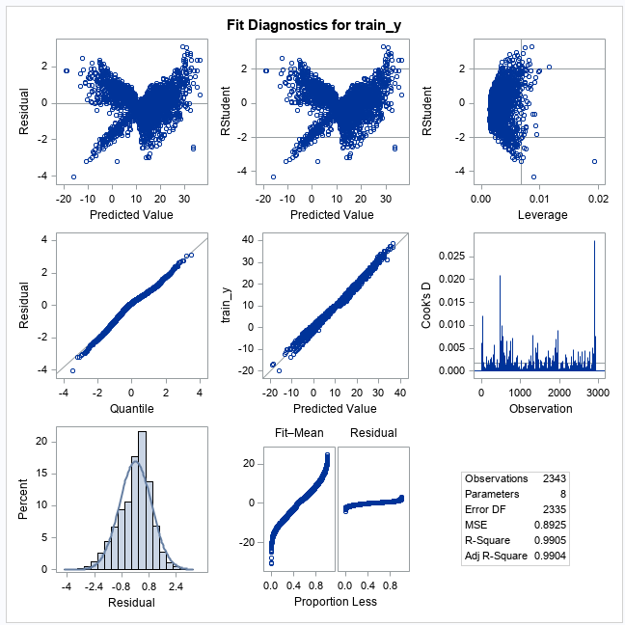

Appendix 3.12: Results of the Validation Testing

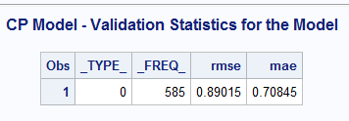

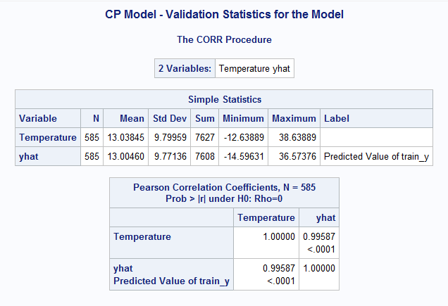

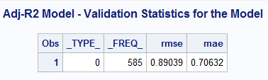

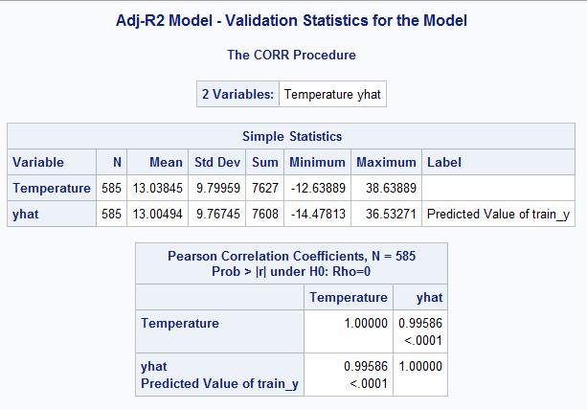

Appendix 3.13: Results of the CP-Validation Testing

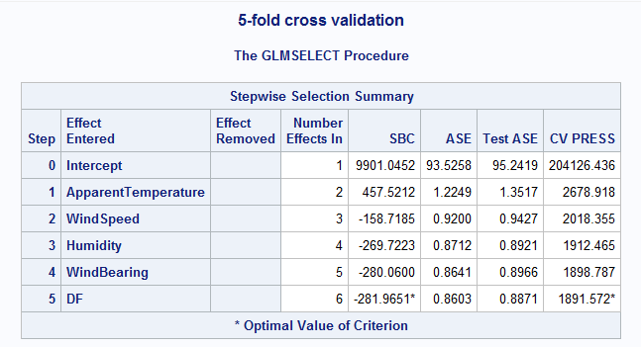

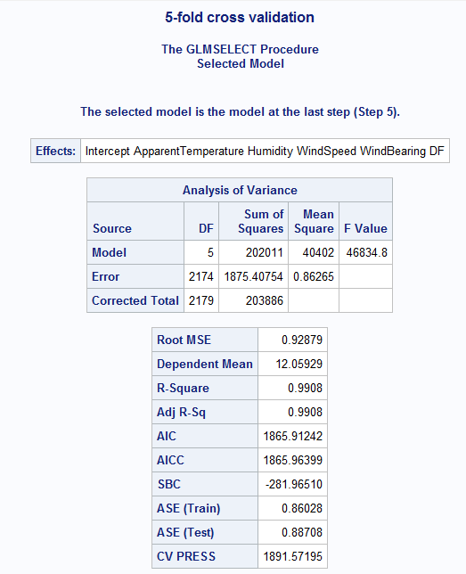

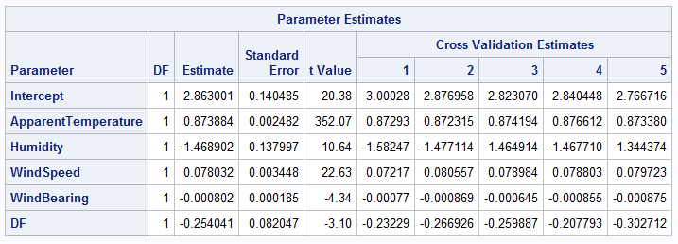

Appendix 3.14: Results of the 5-Fold Cross Validation

# APPENDIX 4: Model 3 Output

# 

Appendix 4.1: scatterplot output shows the linearity, strength, and direction of variables in correlation to each other.

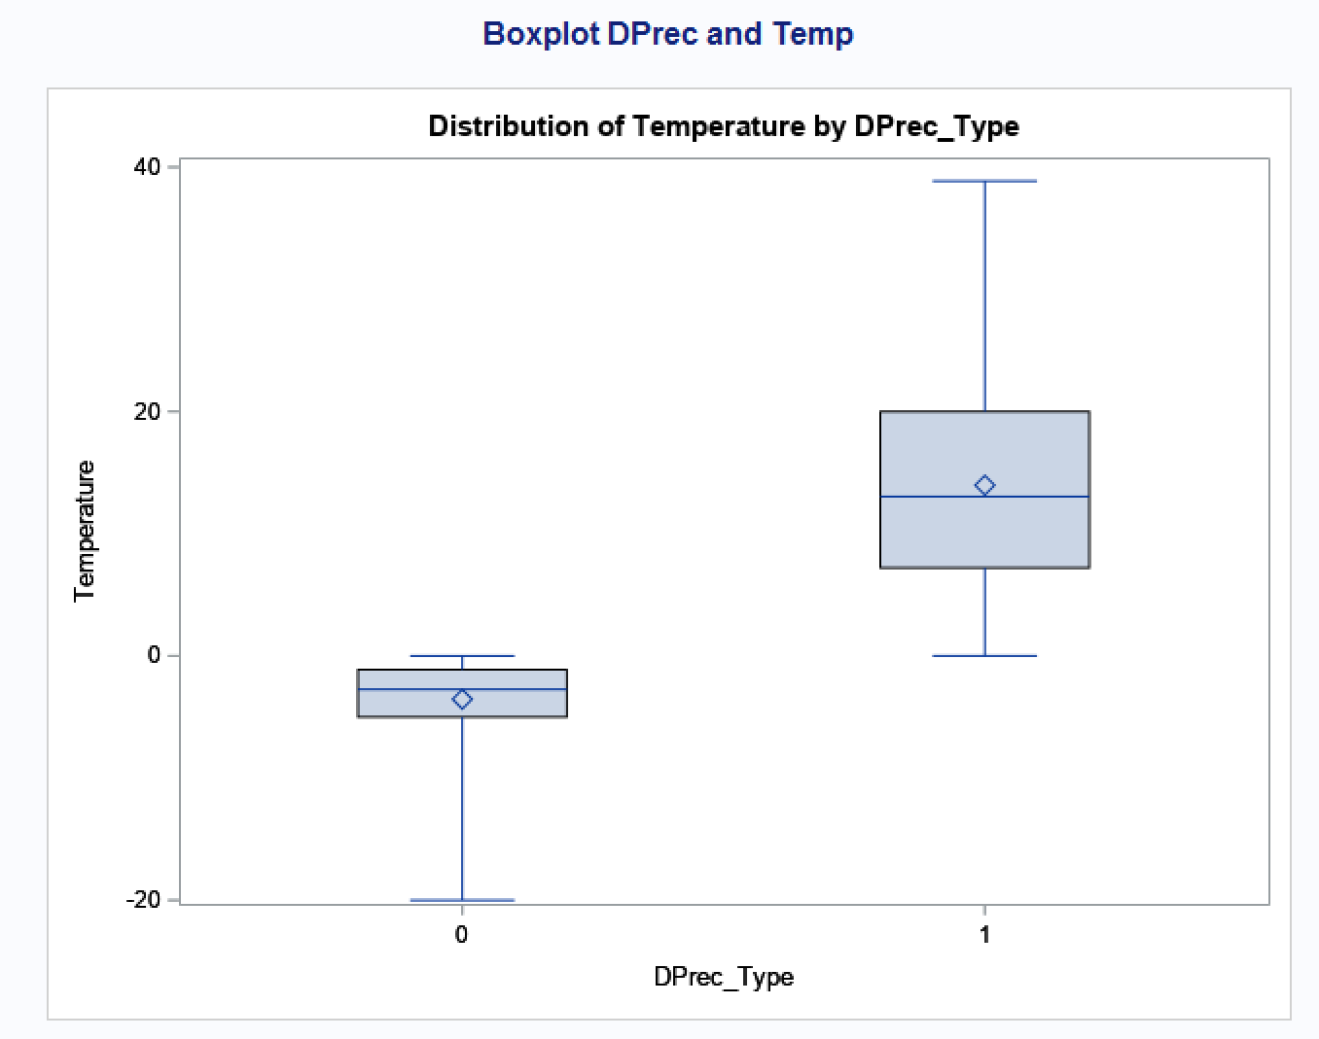

Appendix 4.2: Boxplot showing temperatures when snow (0) and rain (1) occurs.

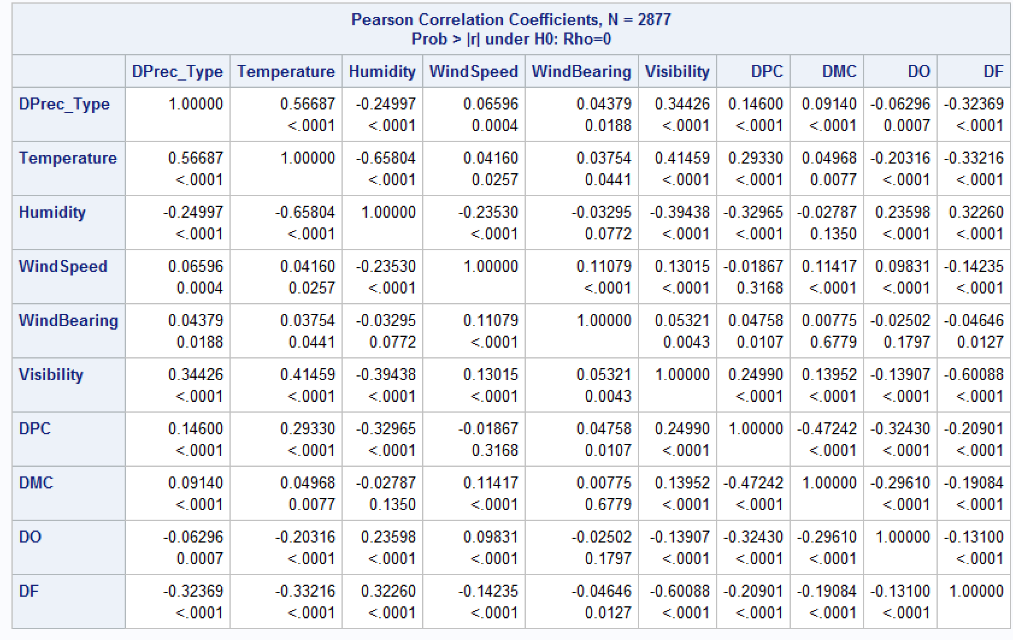

Appendix 4.3: Pearson correlation coefficients table for all variables

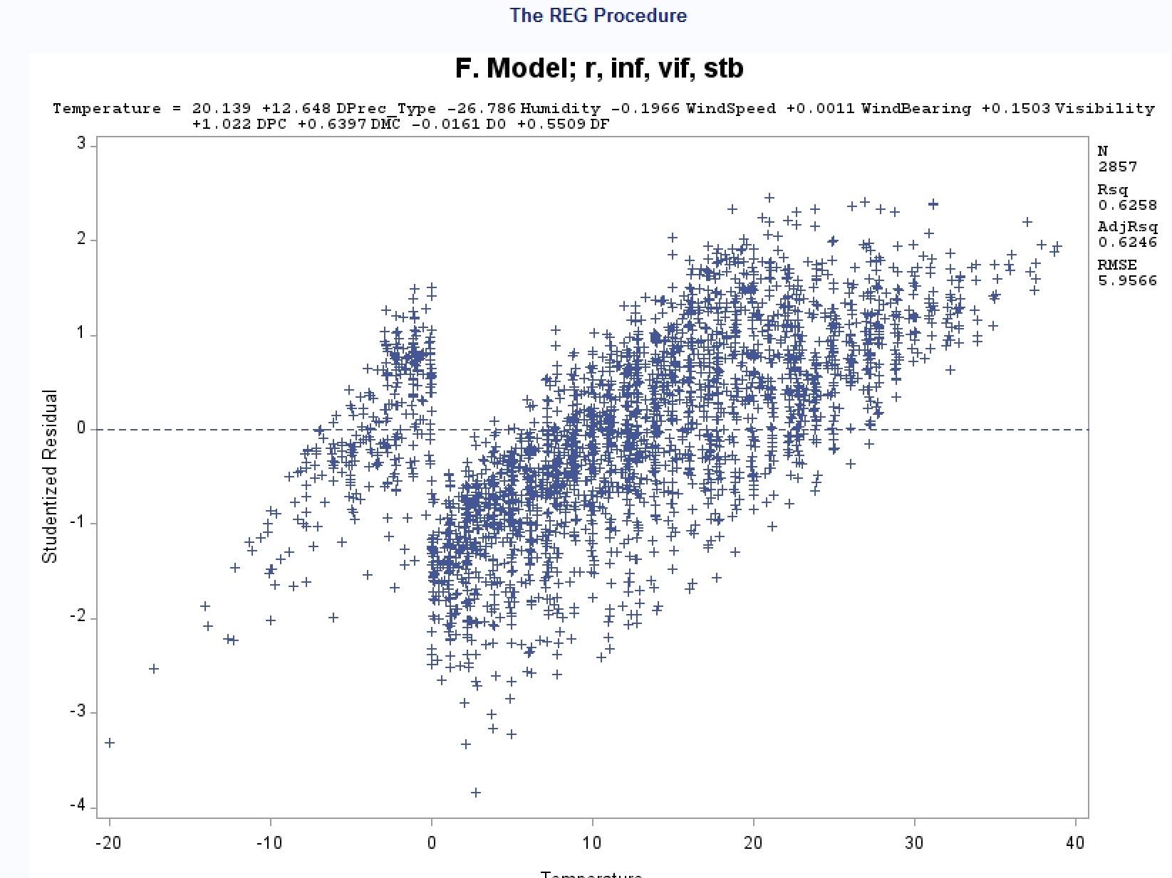Appendix 4.4: F Model

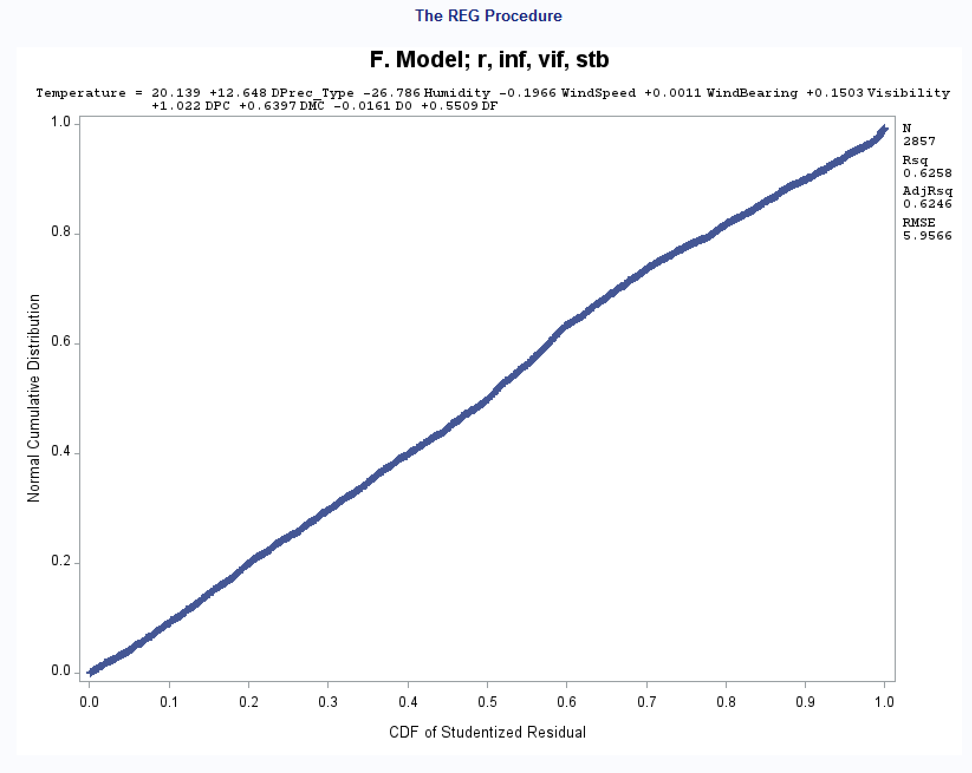

Appendix 4.5: cdf of residual vs normal distribution, r, adj r, and RMSE

Appendix 4.6: cp selection method for train_y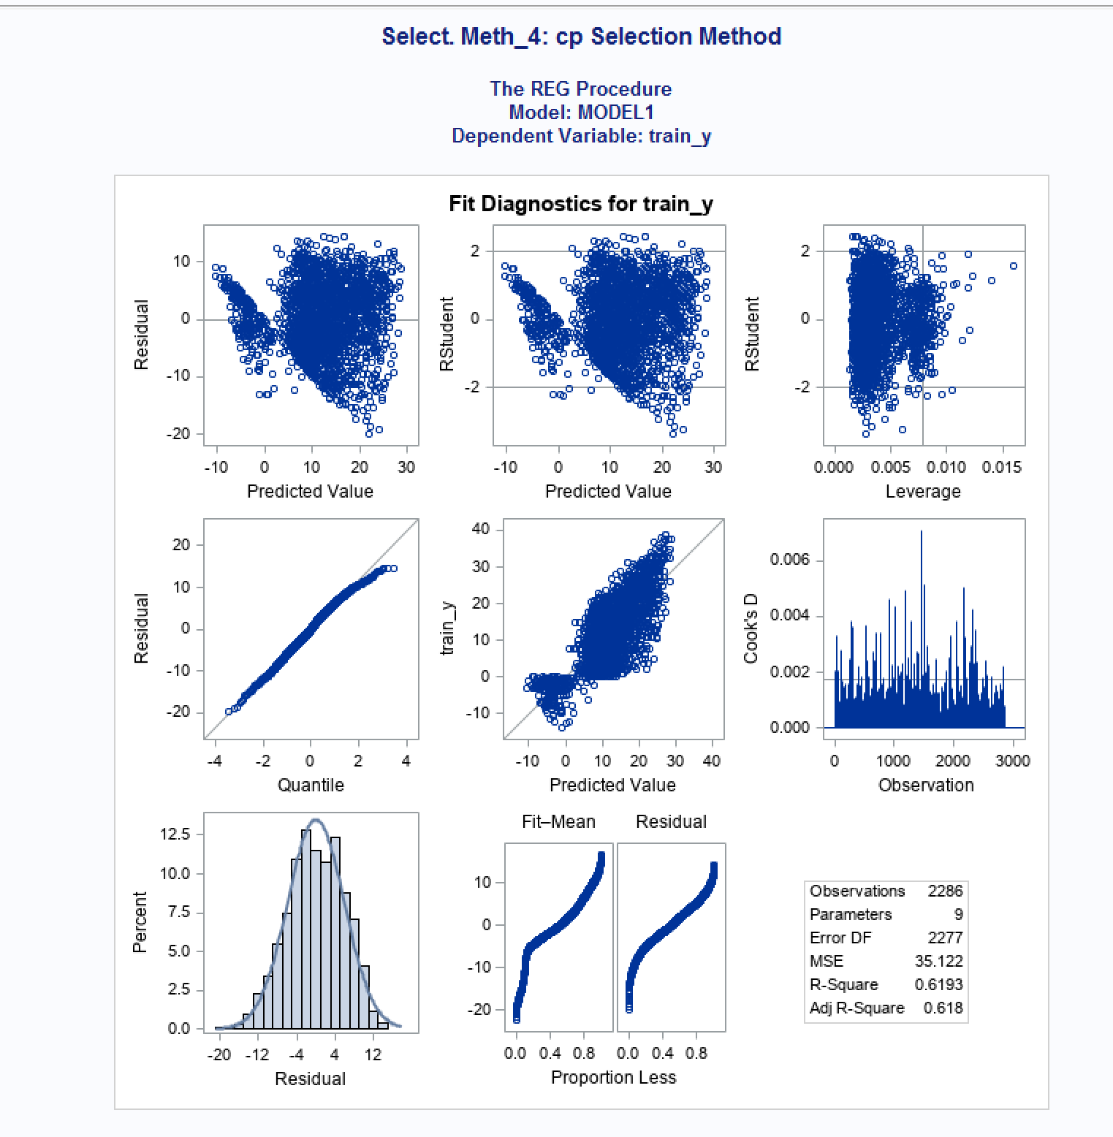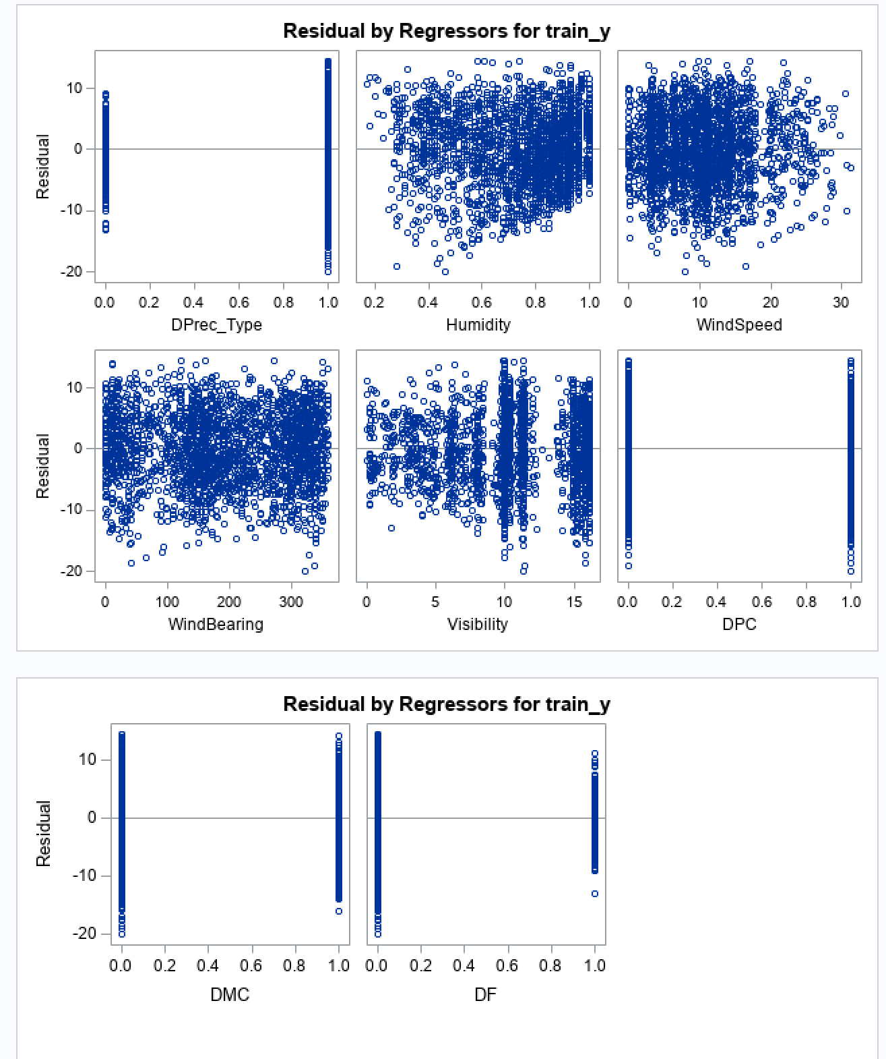

Appendix 4.7: residual by regressors for train_y for variables

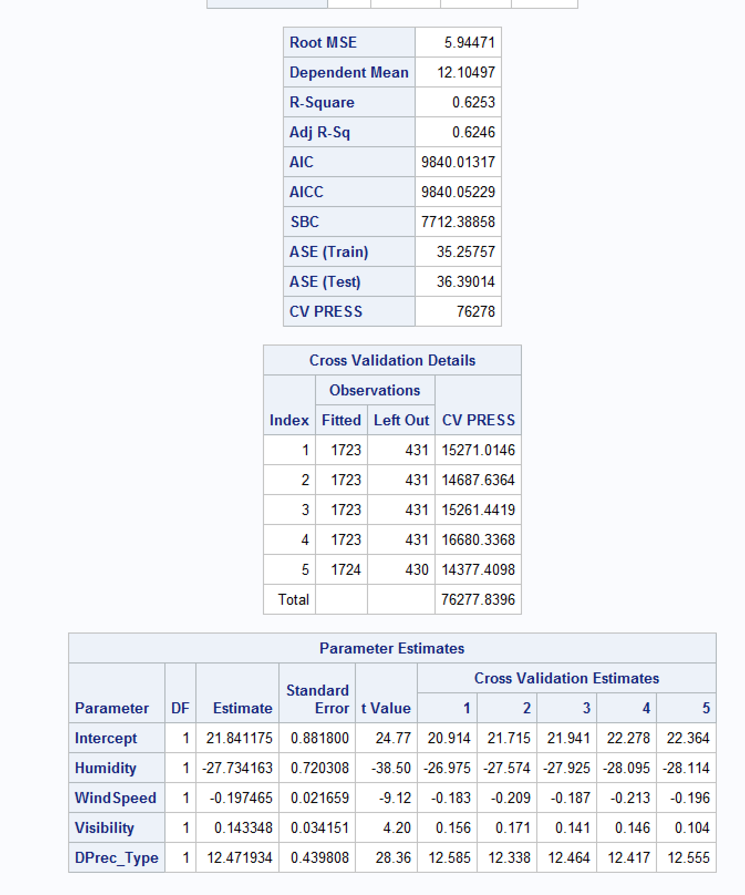

Appendix 4.8: 5-fold output with cross validations, parameter estimates, r and RMSE values

# 

# 

# APPENDIX 5: General



Appendix 5.1: Szeged, Hungary geographic location

# APPENDIX 6: Model 4 Output

6.1 Freq Table of PrecipType with added None placeholder

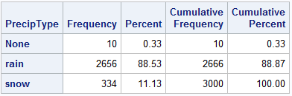

6.2 Freq Table of Summary with all 14 options

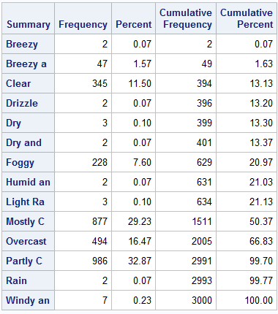

6.3 Histogram of Months

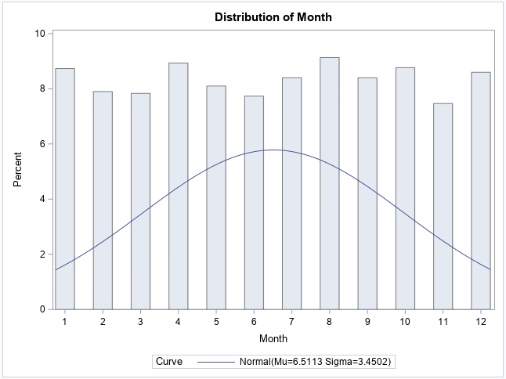

6.4 Histogram of Years

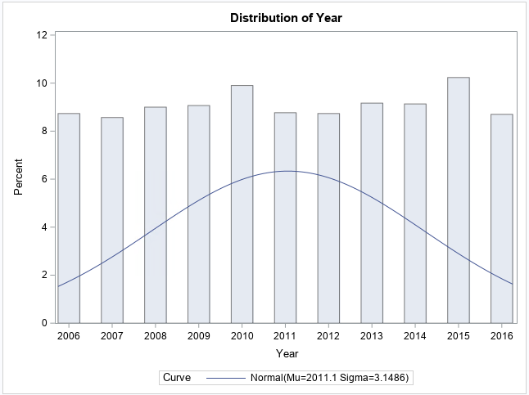

6.5 Descriptives of Numeric Variables with all 3000 observations

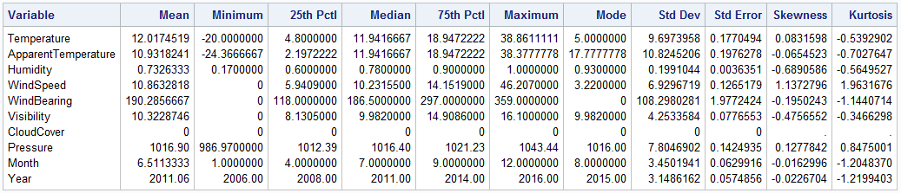

6.6 Freq of Daily Summary with all 3000 Observations

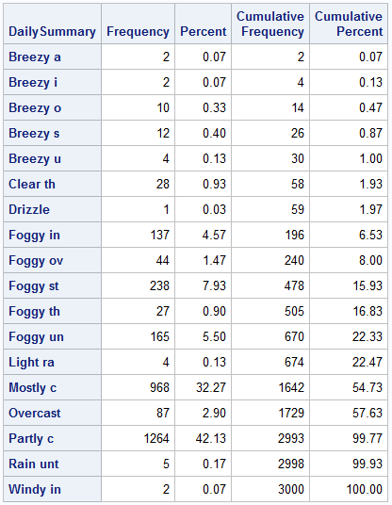

6.7 Histogram of Humidity

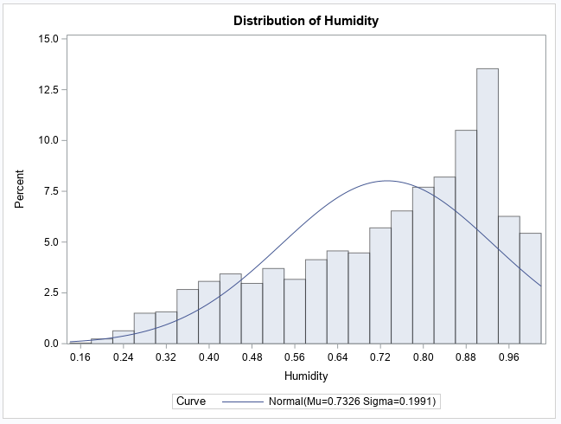

6.8 Histogram of WindSpeed

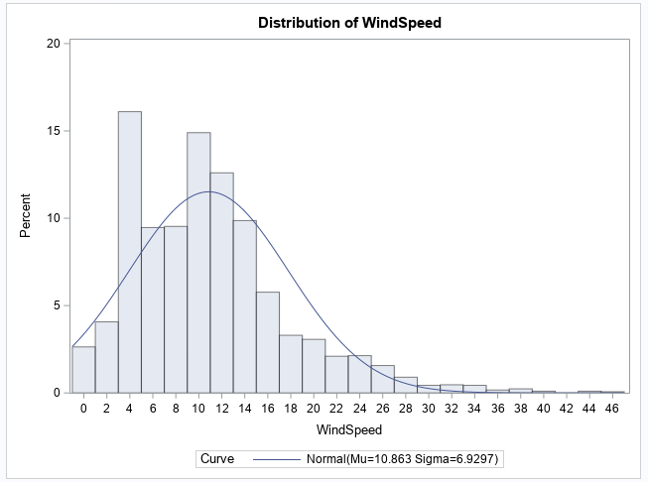

6.9 Histogram of Visibility

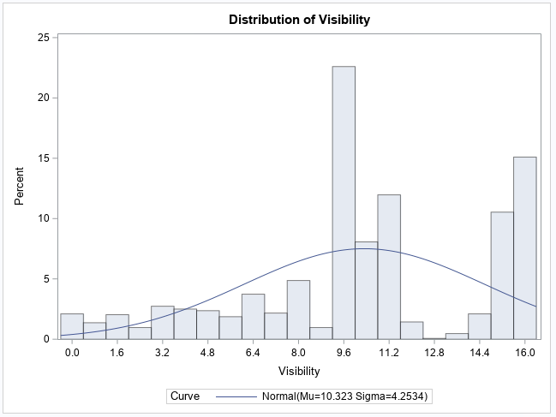

6.10 Histogram of Sqrt of Arcsine of Humidity

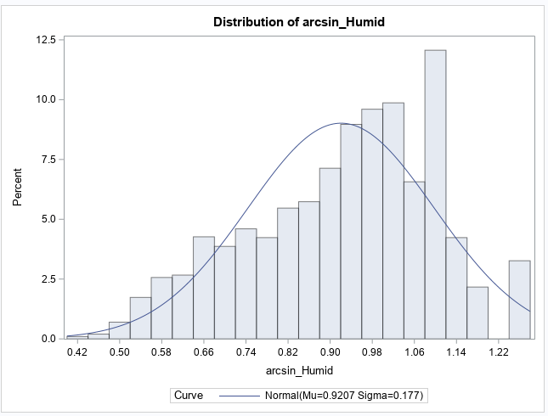

6.11 Histogram of Sqrt of WindSpeed

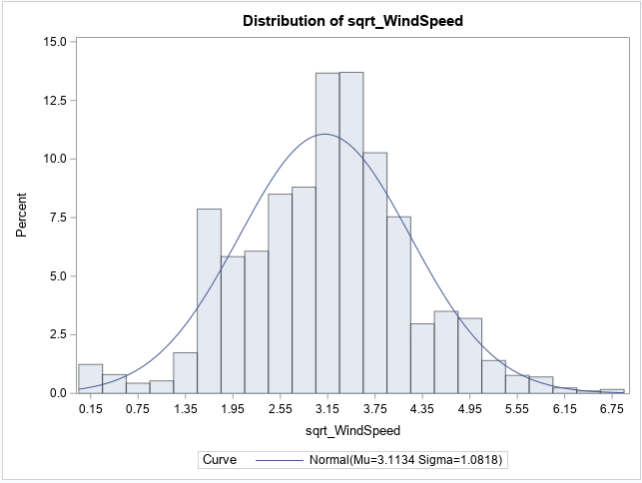

6.12 Boxplot of Temp by Summary

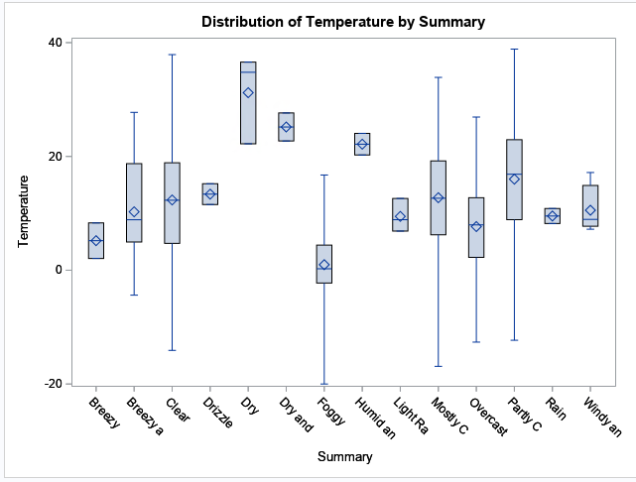

6.13 Box Plot of Temp by PrecipType

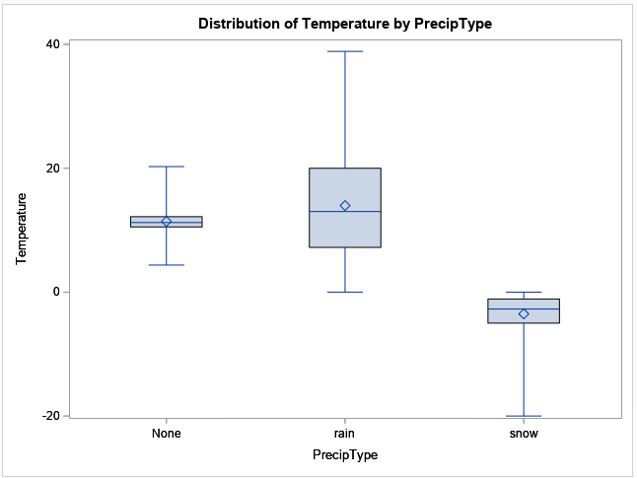

6.14 Boxplot of Temp by Month

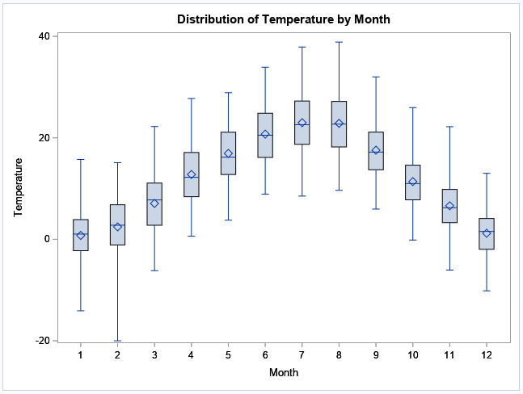

6.15 Dataset at that point

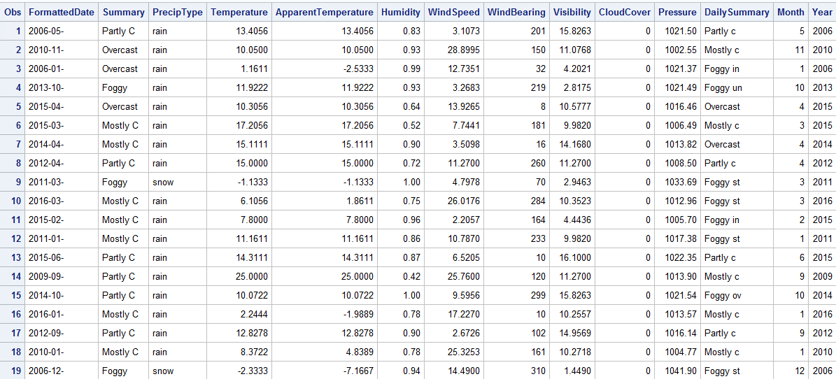

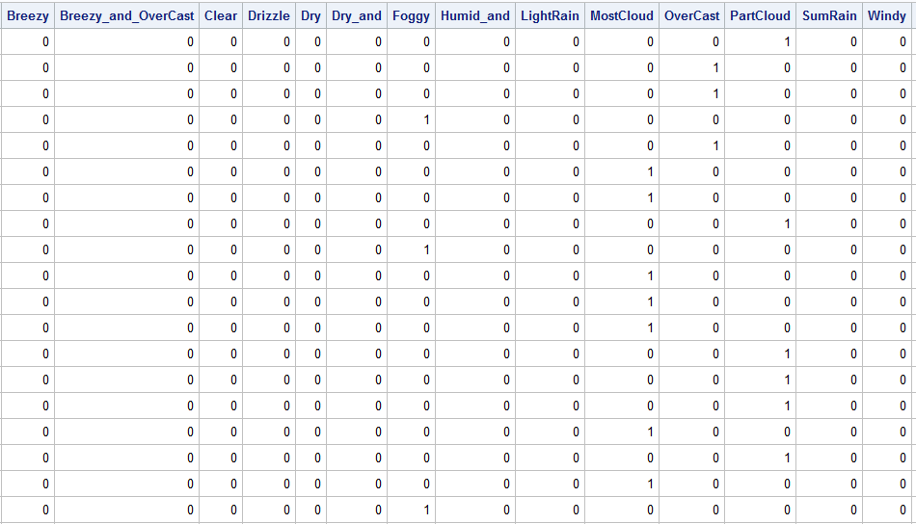

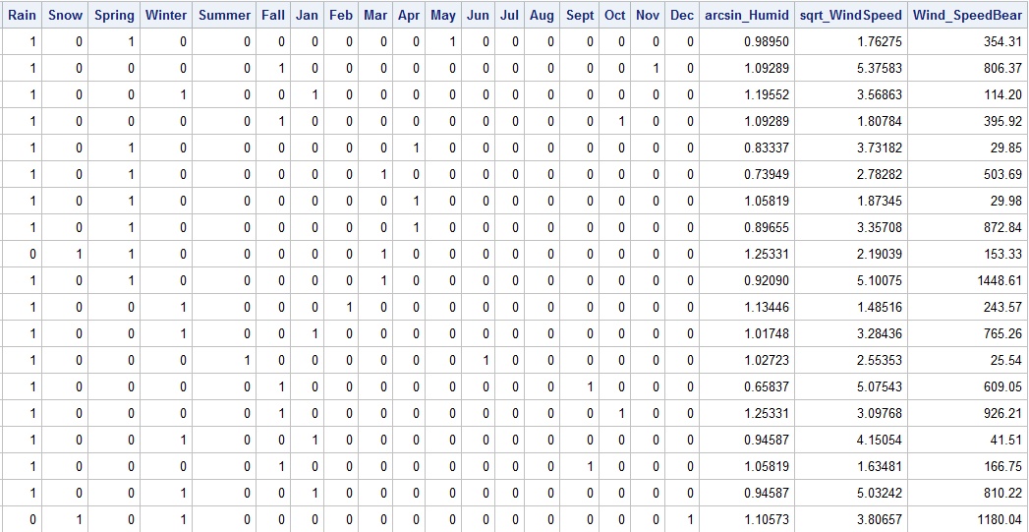

6.16 Pearson Corr of Temp and Apparent Temp

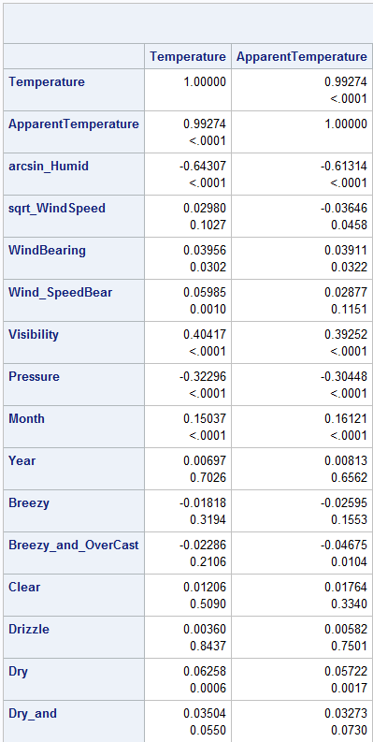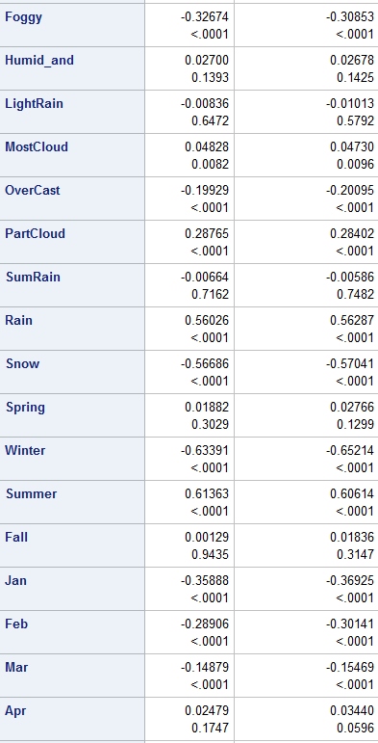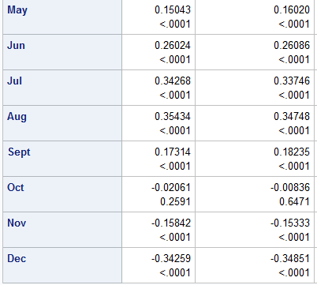

6.17 Sgsscatter matrix of all Numerical Variables

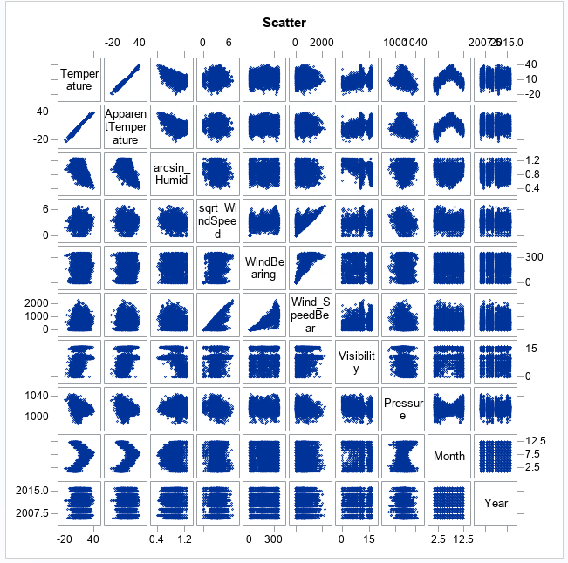

6.18 Equation to determine Apparent Temp and Histogram of Difference of Temp and A Temp

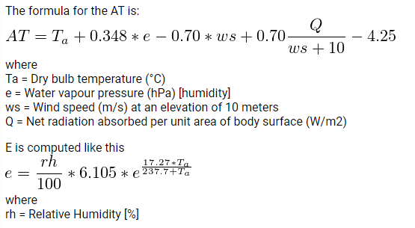

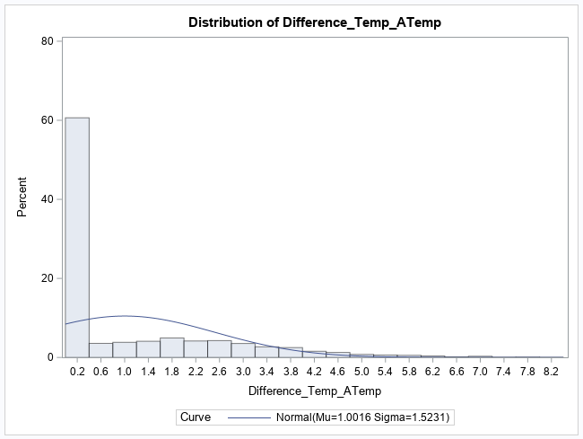

6.19 Histogram of Sqrt of Difference

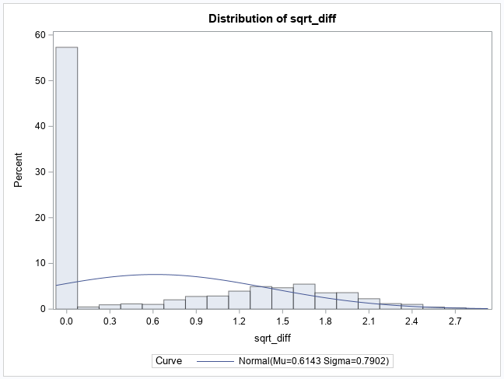

6.20 Scatter Plot of Sqrt Diff by Temp

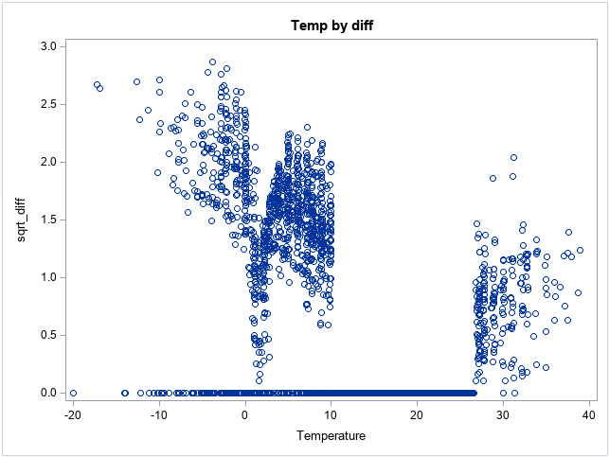

6.21 Dataset at that point

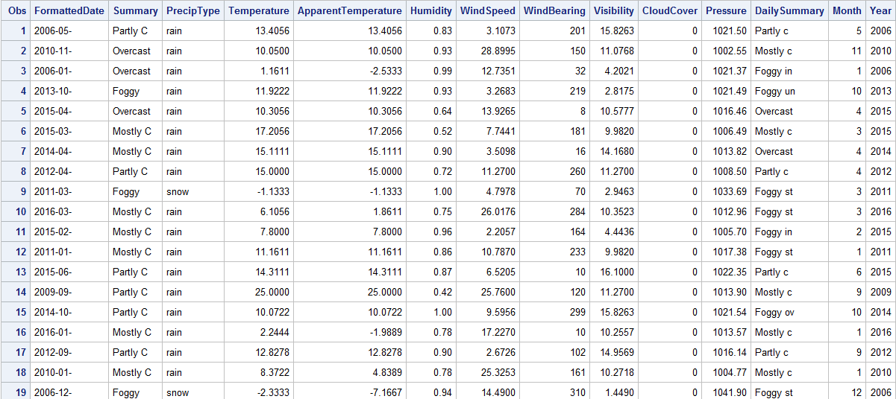

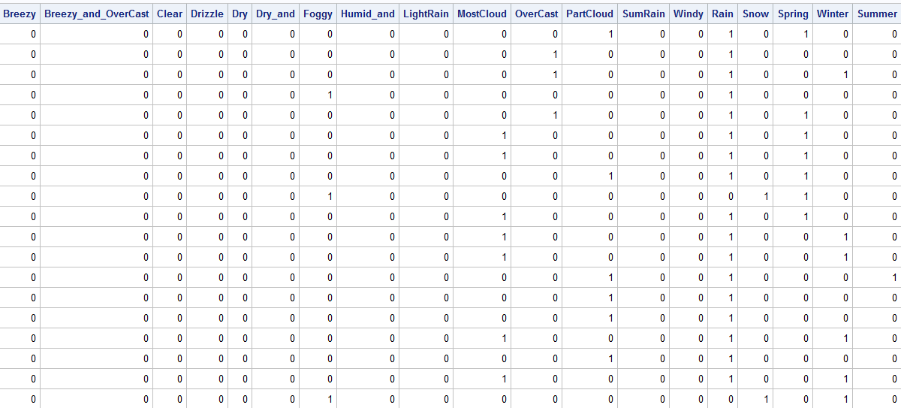

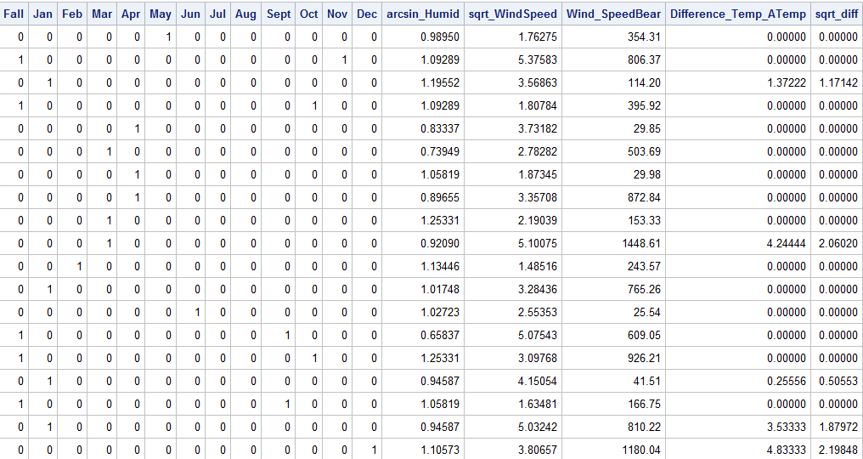

6.22 Relevant Outputs from the Model

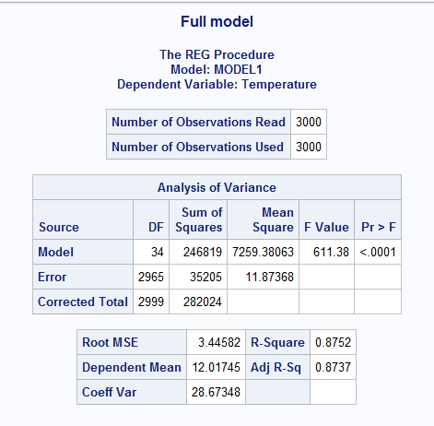

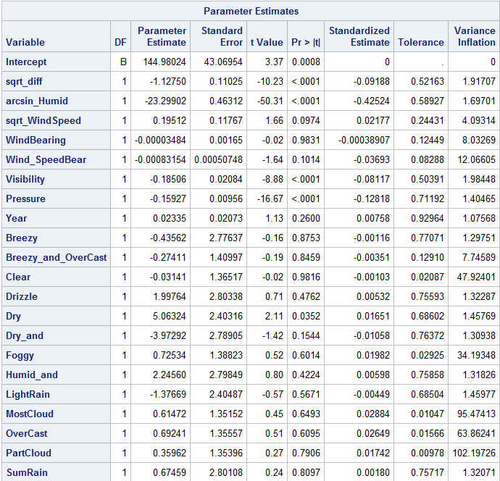

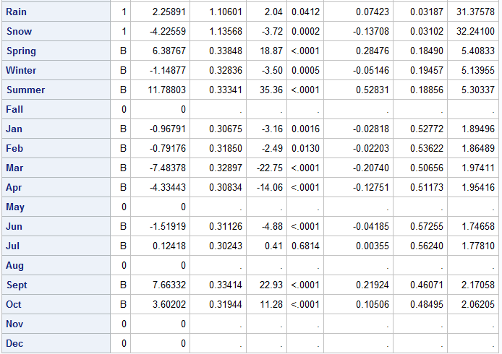

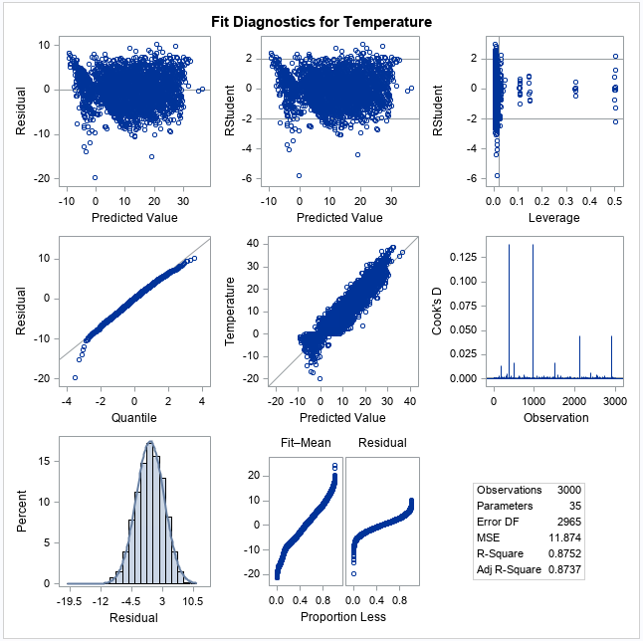

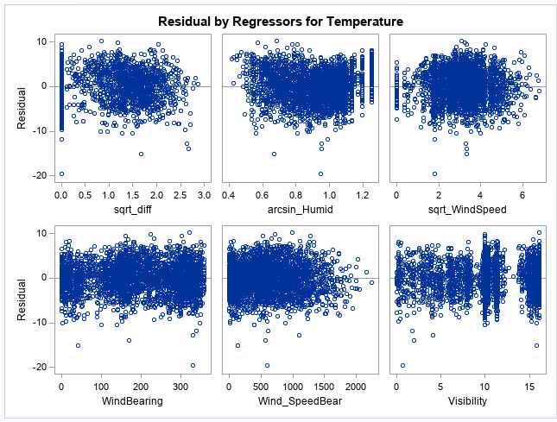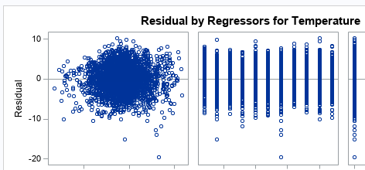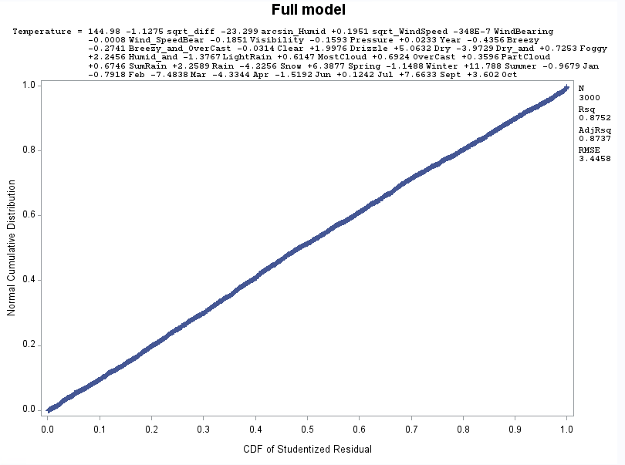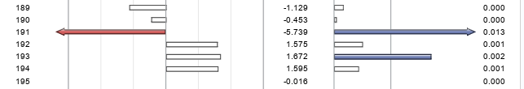

6.23 Relevant Outputs from the model

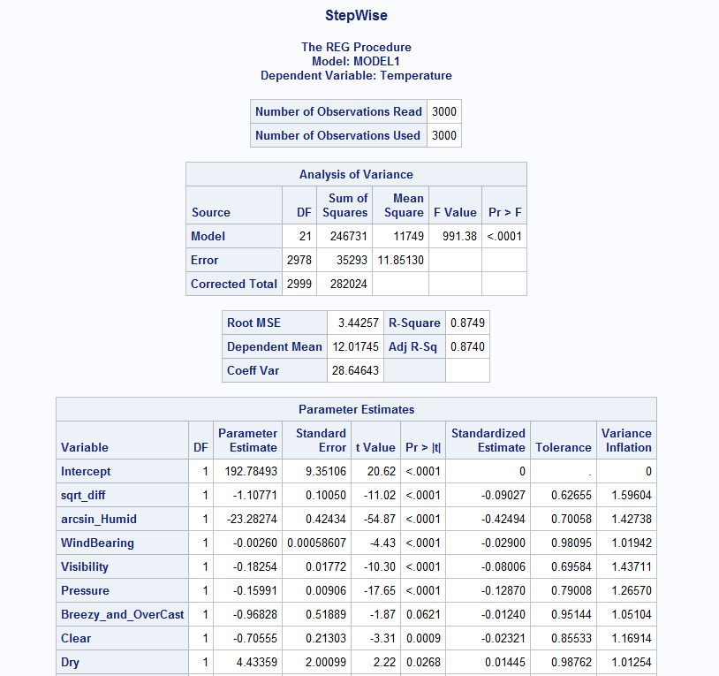

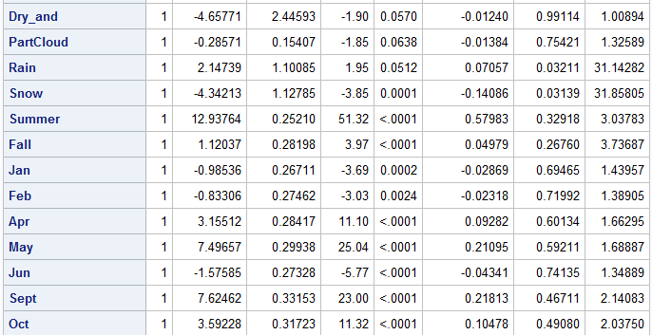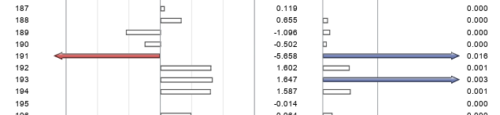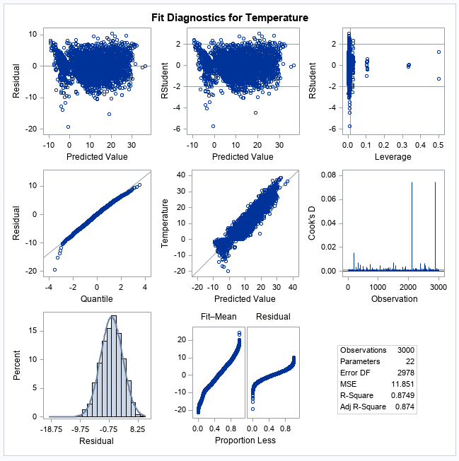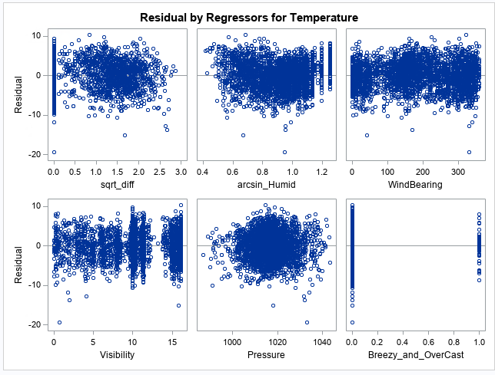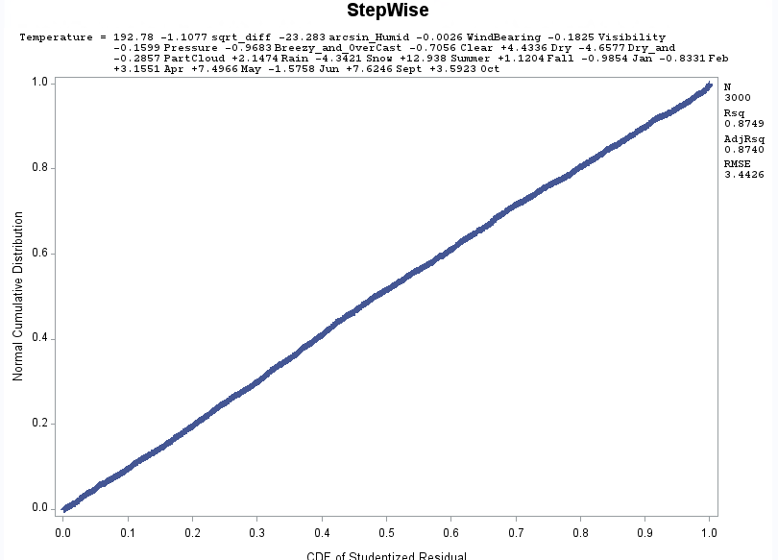

6.24 Relevant Outputs from the Model

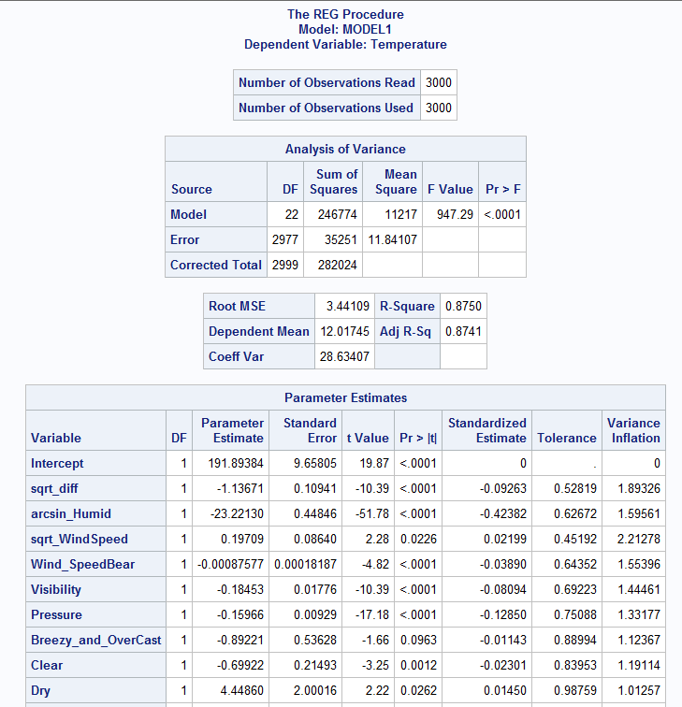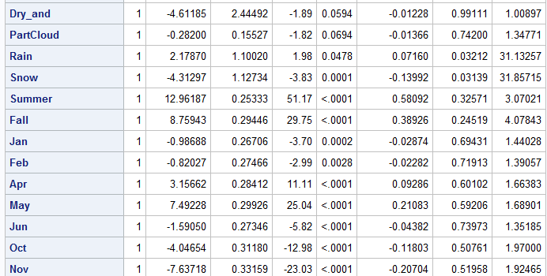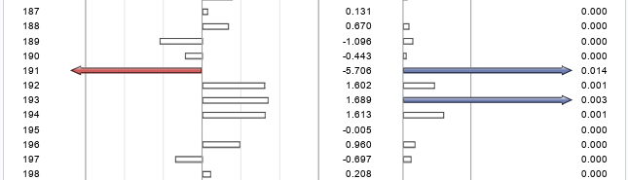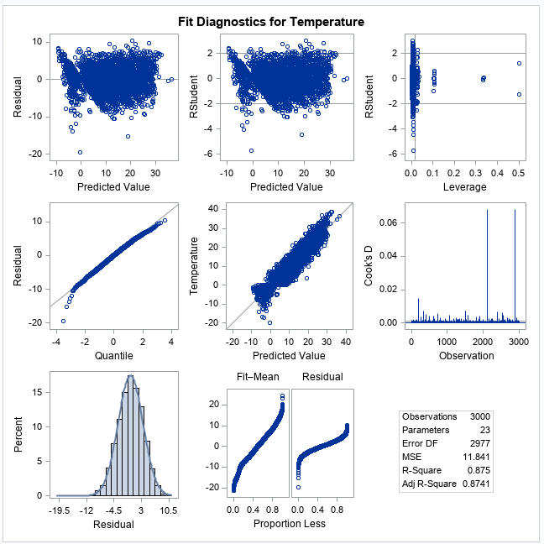

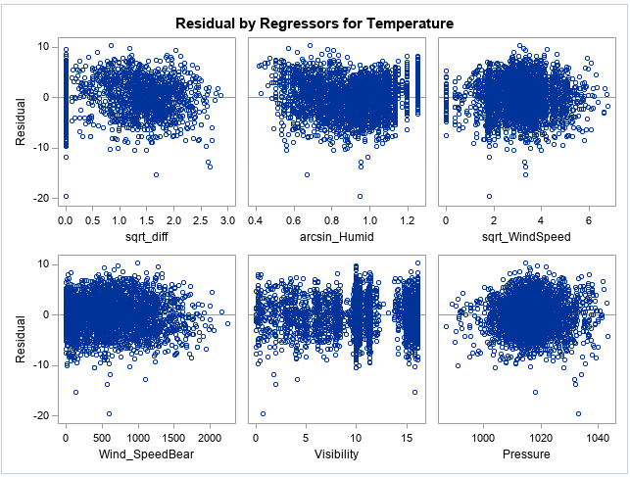

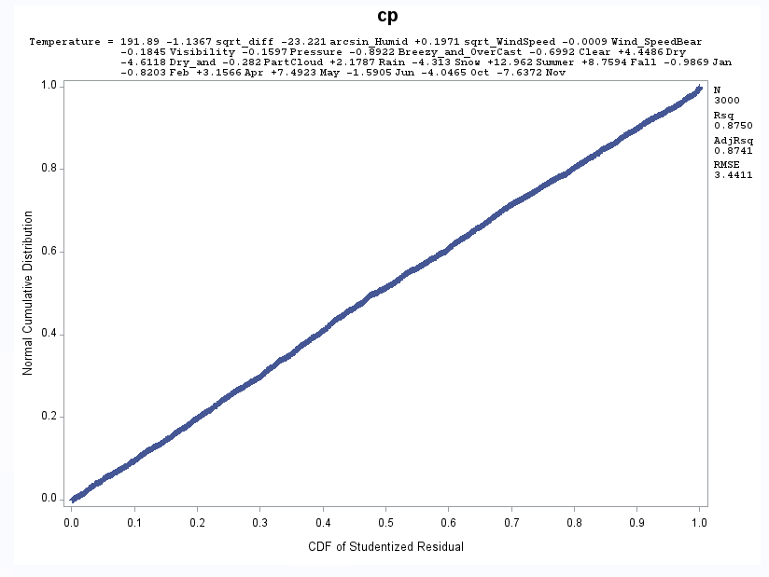

6.25 Relevant Outputs from Model

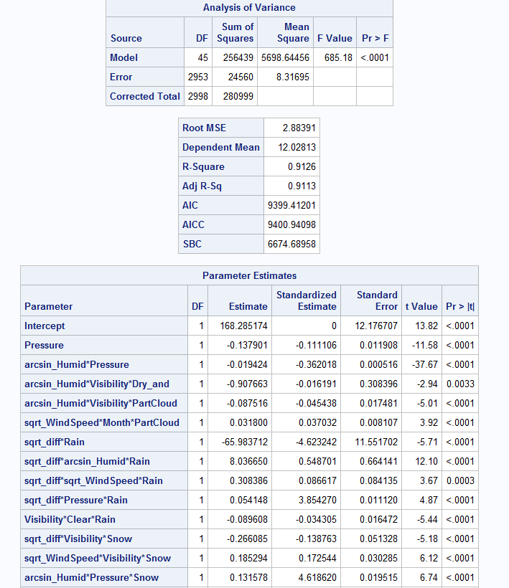

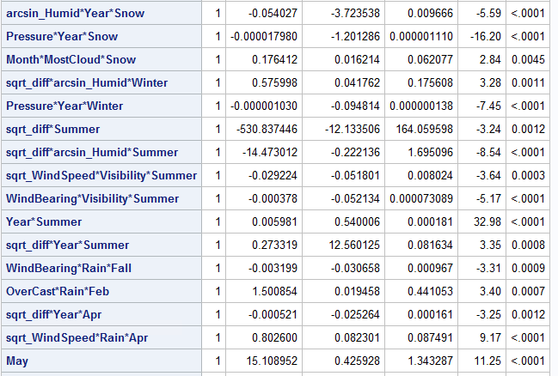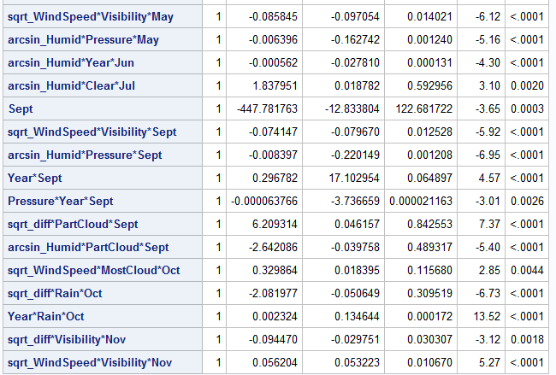

6.26 Relevant Outputs from Final Model

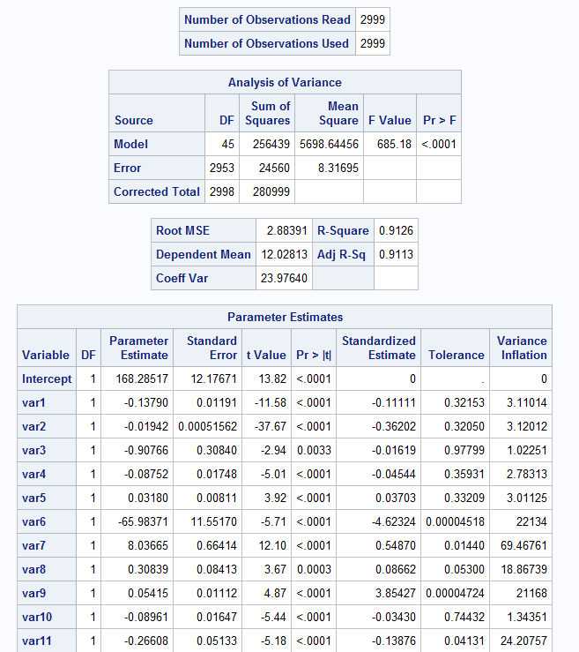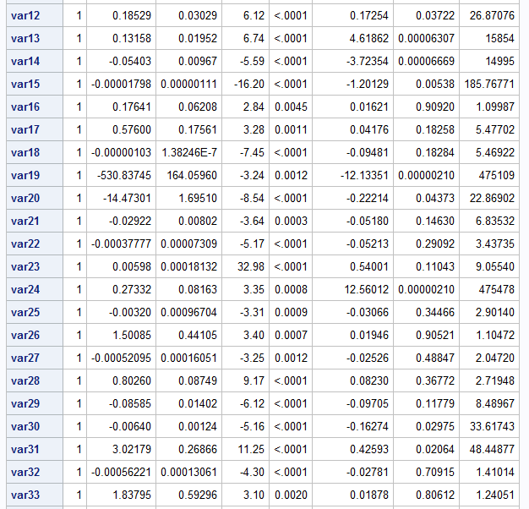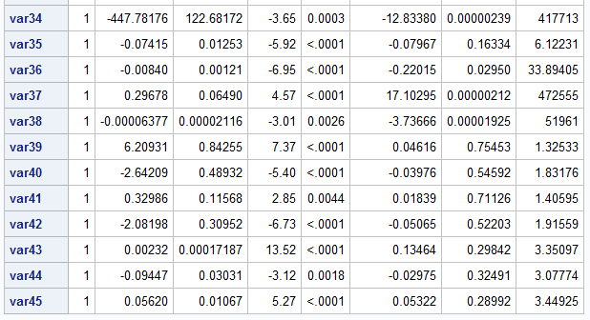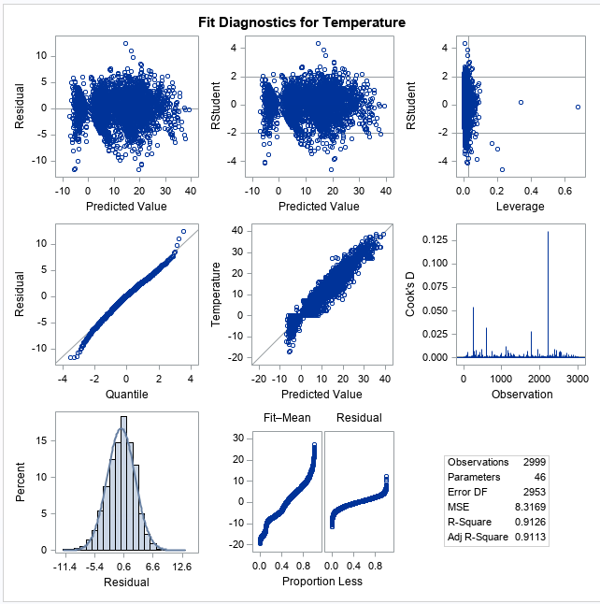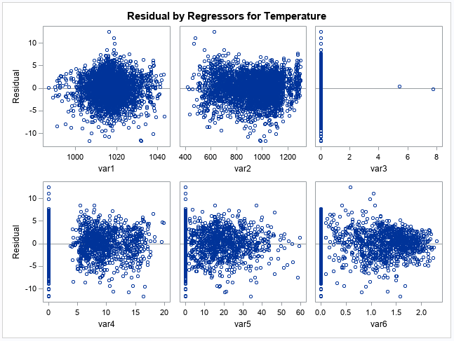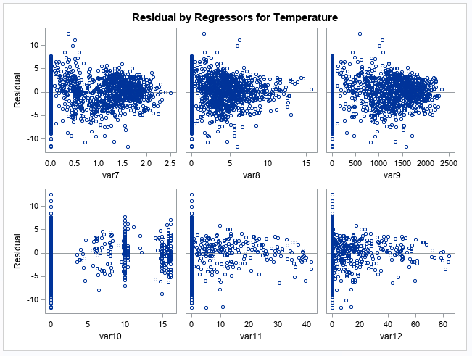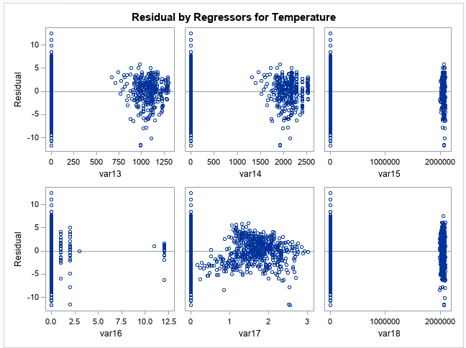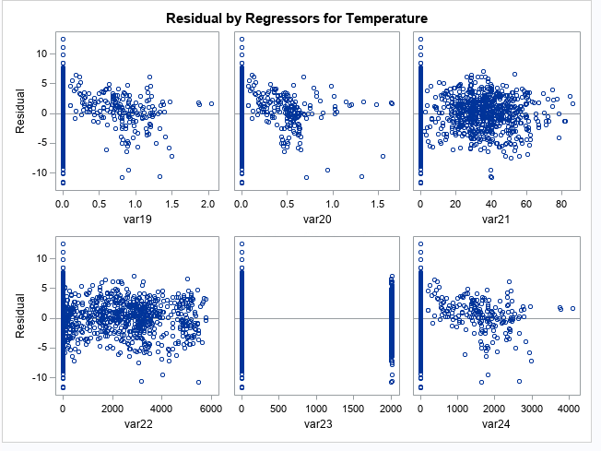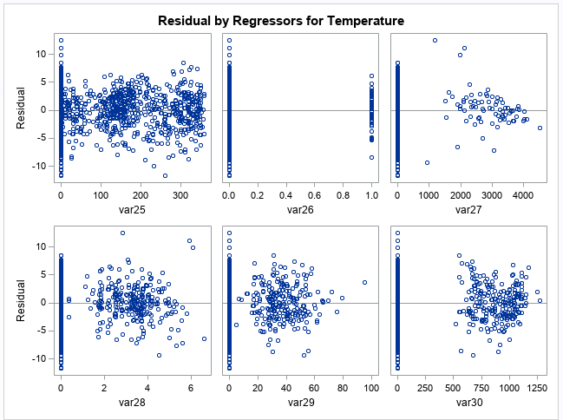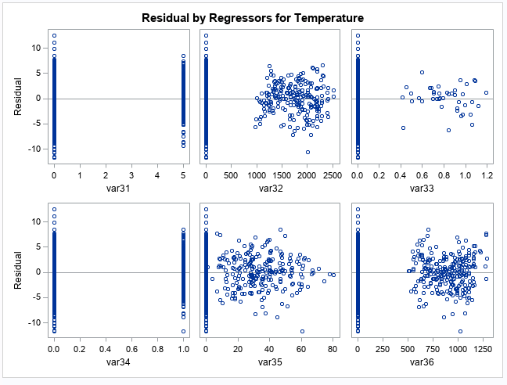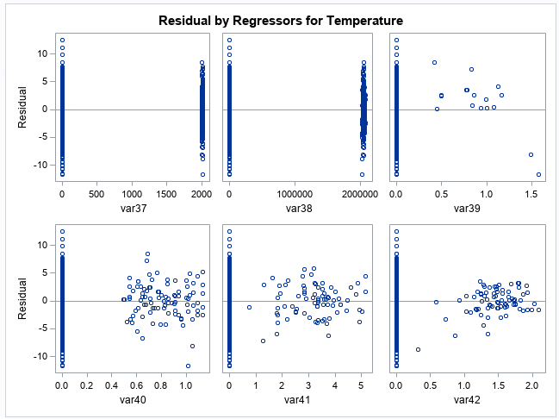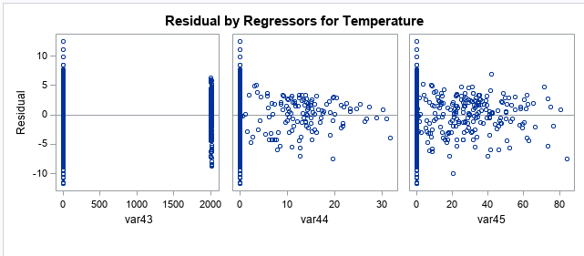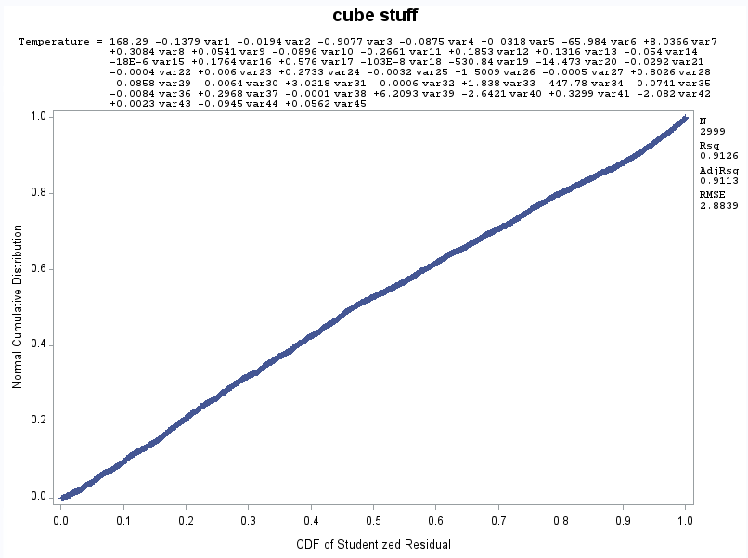

6.27 Output from Train Model

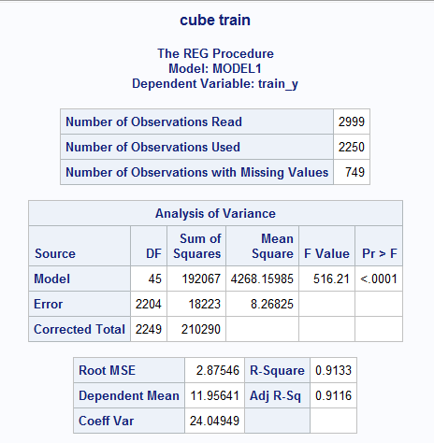

6.28 Outputs from Test Model

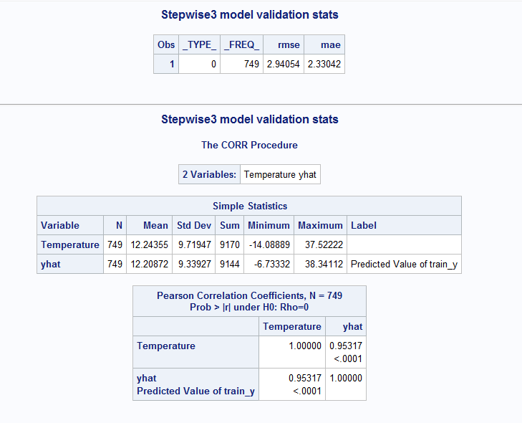

6. FinalEquation

